**1) Access control**

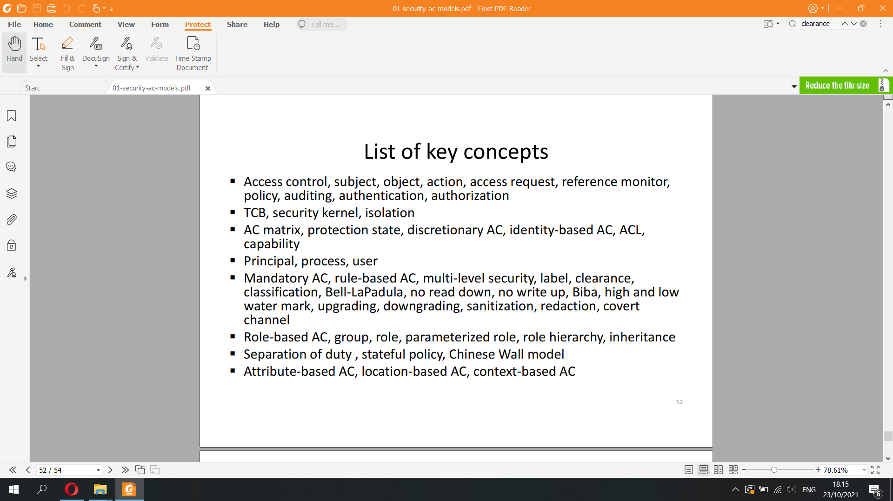

* Authentication = verifying subject identity (implies identification of the subject)

* Authorization = checking that the subject has the right to request the action on the object  
* Access control (AC) = authentication + authorization

* Reference monitor controls access by subjects to objects

– Grants i.e. allows or denies access requests

– Follows the policy (i.e. rules) set by administrators

– Logs events to audit trail

* Trusted computing base (TCB) = all system components that need to be trusted to implement access control

– Includes hardware, firmware, OS, other software

– Security kernel = implementation of reference monitor in an OS

– Isolation of subjects from each other is needed to prevent them from

circumventing the AC policy

* Access control matrix is the simplest, most general AC model

M : Subjects × Objects → P(AcƟons)

Subject S is allowed to request action A on object O iff A M(S,O)

AC matrix represents the protection state of a system

* Access control list (ACL) = list of the access rights associated with an object

ACLs are a practical way to represent the AC matrix: one column of the matrix is stored for each object

– file1.txt ACL:

Alice: { read, write }; Bob: { read };

Carol: { read, write }; David: { append }.

– file2.txt ACL:

Alice: { write }; Bob: { read }

* Capability = an access right associated with the subject. Capabilities are another way to represent the AC matrix: one row is stored for each subject

– Alice’s capabilities:

file1.txt: { read, write }; file2.txt: { write }.

– Bob’s capabilities:

file1.txt: { read }; file2.txt: { read }

* Principal is an authenticated identity, e.g. user account. Subjects act on behalf of principals

– Process (subject) runs as as a specific user account (principal)

– User’s process running as admin or as normal user act on behalf of different principals and, thus, have different access rights

* Discretionary access control (DAC): Data owner, usually a user, sets the access rights. Subjects can share their access rights to others

– File owner or creator decides who can access it

– User or process that can read a secret file can also copy and share it

Typical in commercial and consumer systems

Commonly implemented with ACLs or capabilities

* Mandatory access control (MAC): Access control is based on rules (policy) set by administrator. AC policy is enforced by the reference monitor and cannot be changed by users. Subjects cannot leak access rights to others, e.g.

– User can read a secret file but cannot copy, print or email it

– Process can download data from the Internet or write to the file system, but not both users cannot download malware

* MAC is also called rule-based AC

* Mandatory access control policy is often based on security labels

– Subject clearance: identity can be proven, thus cleared of “doubt” and can gain AC

– Object classification: which layer of security it is on

(Subjects and Objects) → Labels: Top secret, secret, confidential, unclassified

Simple security property: S can read O iff l(S) ≥ l(O)

MAC based on clearance and classification levels is called multi-level security (MLS)  
* Biba model: No read down, no write up  
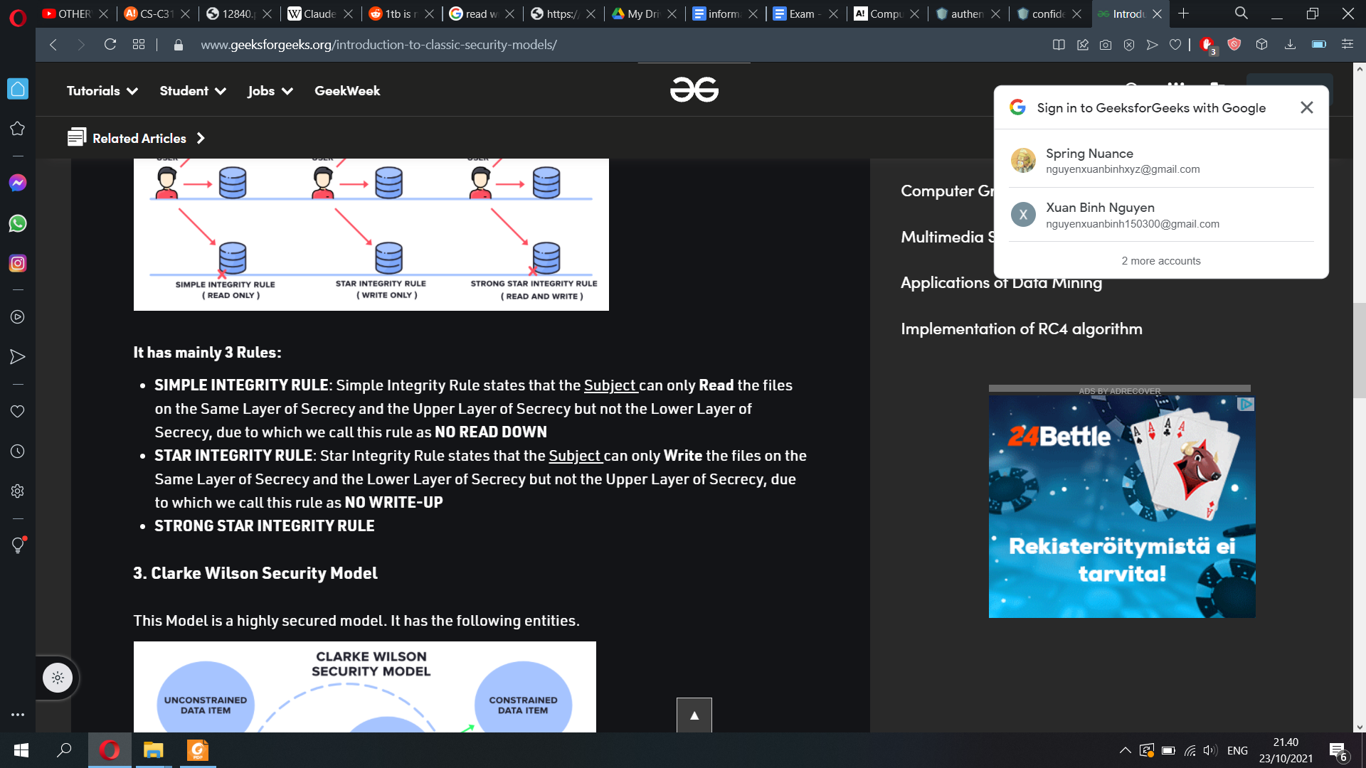

* Bell-LaPadula: No write down, no read up

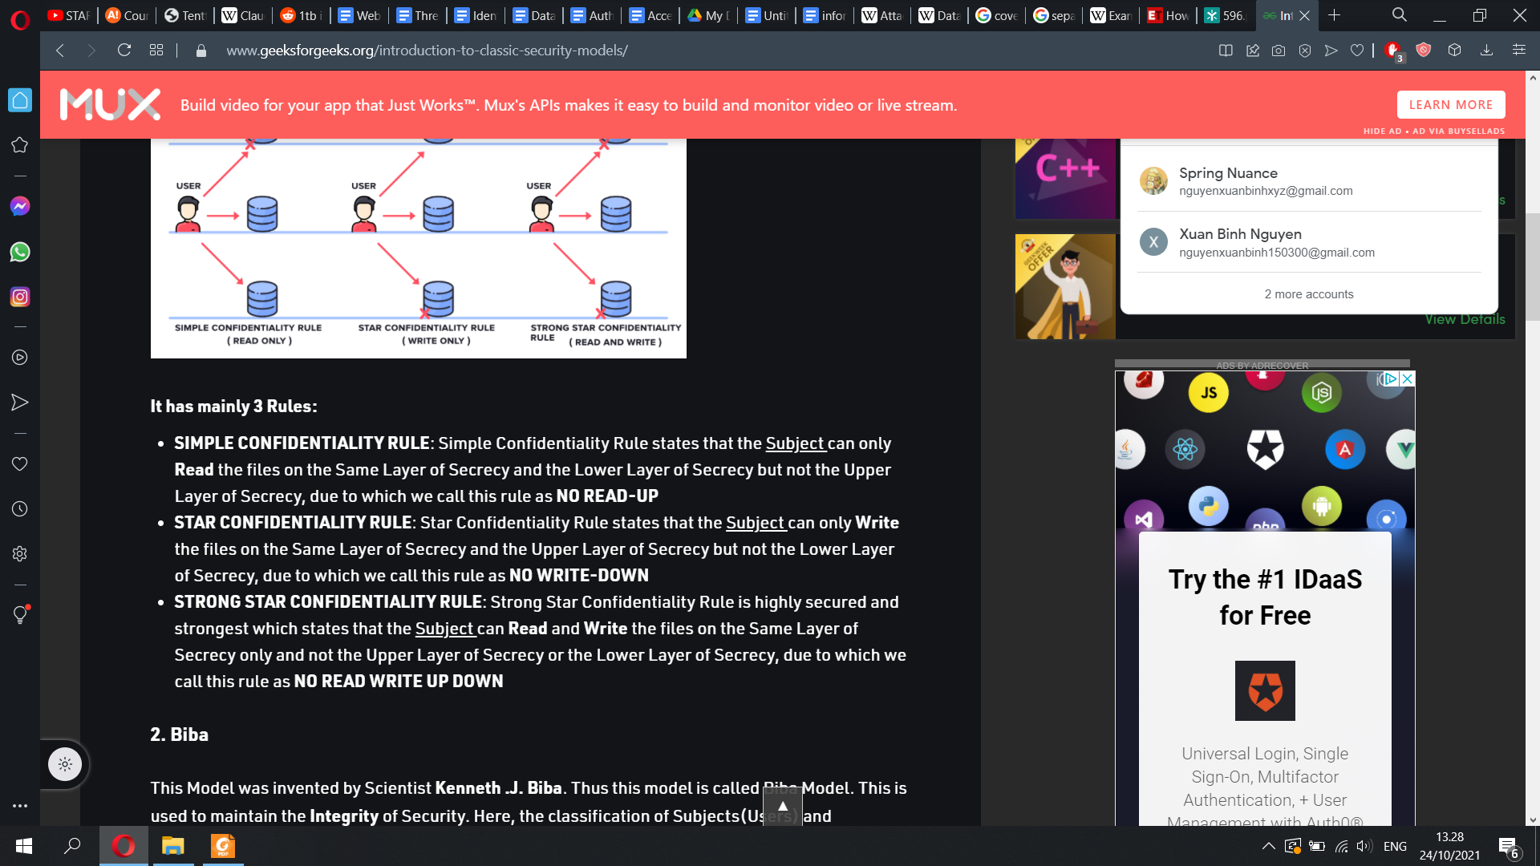

* BLP and Biba are information flow policies

– BLP prevents flow of information from high to low

– Biba prevents flow of information from low to high

* Information flow policies are the basis for many security proofs. Typical proofs show non-interference:

– view of one subject is not affected by the data of the other

– low output does not depend on high input (secrets), or high output (integrity) does not depend on low input

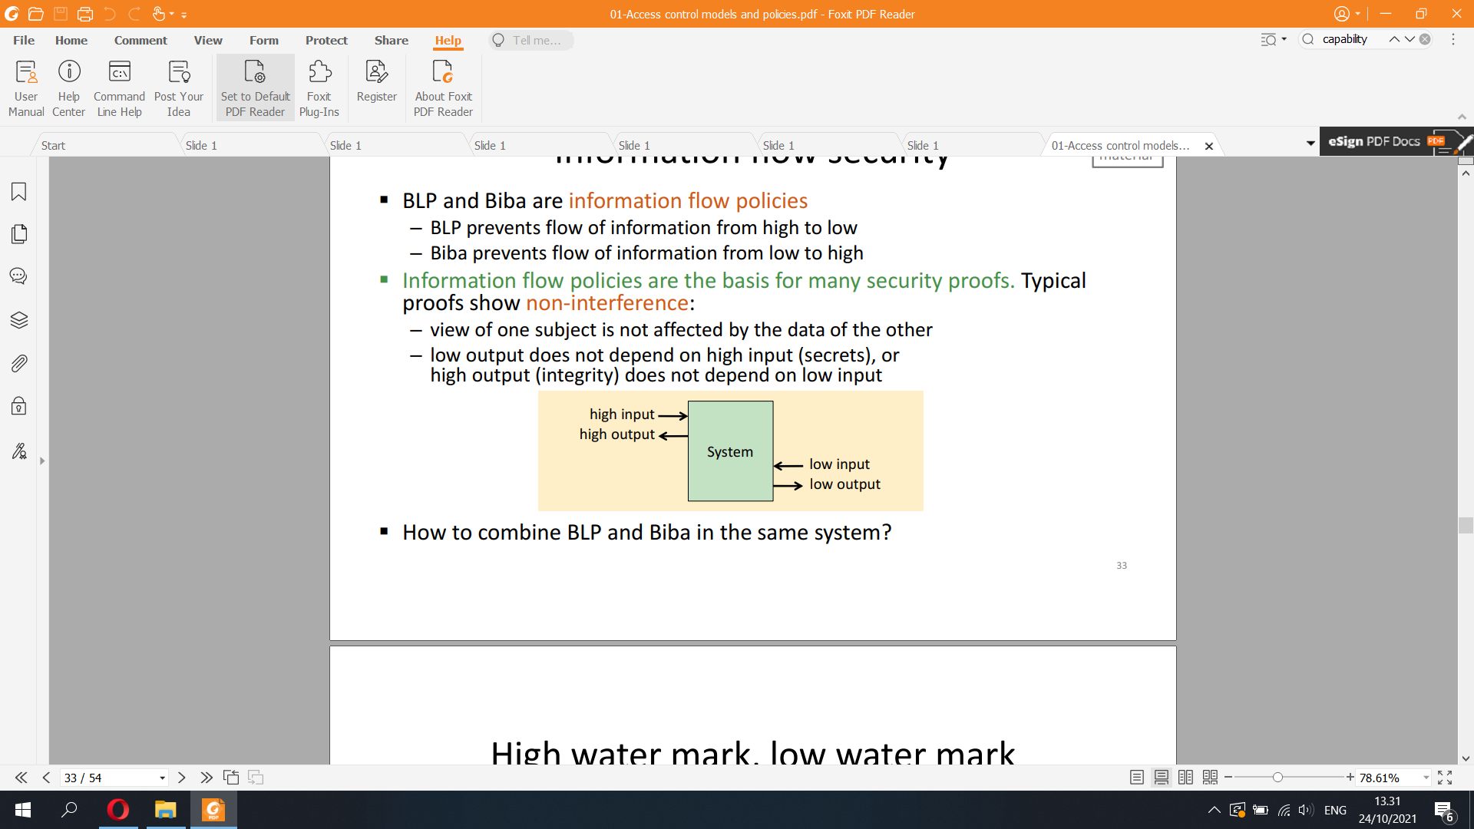

* High water mark, low water mark: How to classify an object that combines low and high inputs?

High water mark policy for secrecy: highest input level

Low water mark policy for integrity: lowest input level  
* Under high-water mark, any object less than the user's security level can be opened, but the object is relabeled to reflect the highest security level currently open, hence the name.

The practical effect of the high-water mark was a gradual movement of all objects towards the highest security level in the system. If user A is writing a CONFIDENTIAL document, and checks the unclassified dictionary, the dictionary becomes CONFIDENTIAL. Then, when user B is writing a SECRET report and checks the spelling of a word, the dictionary becomes SECRET. Finally, if user C is assigned to assemble the daily intelligence briefing at the TOP SECRET level, reference to the dictionary makes the dictionary TOP SECRET, too.

* Low-water mark is an extension to Biba Model. In the Biba model, no-write-up and no-read-down rules are enforced. In this model the rules are exactly opposite of the rules in Bell-La Padula model. In the low-water mark model, read down is permitted, but the subject label, after reading, will be degraded to object label. It can be classified in floating label security models

* In practice, security levels need to be changed by humans

– E.g. downgrading intelligence data to enable broader access

– E.g. upgrading intelligence reports based on open data

Declassification = downgrading to unclassified level

* Data sanitization: Documents may need to be sanitized i.e. redacted before downgrading or declassification

– E.g. removing names of personnel before publication

* Covert channels: Uncontrolled channels used for circumventing access control

Used by a high-level subject to intentionally leak data from high to low level in violation of the no write-down policy

Examples: modulating processor, disk or network load to communicate bits; leaking secret bits in data fields that should be random numbers. Often refers to low-bitrate channels within multi-level operating systems

* Steganography: Hiding the existence of covert communication by embedding it into another (overt) communication

Examples: hiding data in photo files, character spacing in text documents

* Side channels: Channels that leak information from high to low without the intention of high-level subjects

Examples: processor power consumption variation may leak a secret key; increase in pizza deliveries to Pentagon predicts war

In computer systems security, role-based access control (RBAC)[1][2] or role-based security[3] is an approach to restricting system access to authorized users. It is an approach to implement mandatory access control (MAC) or discretionary access control (DAC).

Role-based access control (RBAC) is a policy-neutral access-control mechanism defined around roles and privileges. The components of RBAC such as role-permissions, user-role and role-role relationships make it simple to perform user assignments

* Role-based AC (RBAC):

Group = set of subjects

– E.g. Administrators, CS-C3130-students

– Object’s ACL can list groups in addition to individual users

– Both group membership and ACLs change over time

Role = set of permissions (=set of actions on objects)

– E.g. Administrator, CS-C3130-teacher, SCI-professor

– Roles are usually static; only assignment to users

* Roles are often parameterized

– Treating-doctor of patient S. Smith,

Manager or employee 784499,

Lecturer of CS-C3130,  
* Roles may form a hierarchy with rights inheritance

– E.g. Lecturer and Teaching-assistant are Teaching-staff and they have rights of teaching-staff

* Attribute-based access control (ABAC): Access control is based in subject attributes (properties) instead of subject identity

ABAC = attribute verification + authorization

* Separation of duty: two or more persons are required to complete a task

Common in business and public administration:

– Employees cannot approve their own expense claims

– Financial auditors of large companies must be from outside the company

– Safe may have two locks with keys held by two different persons

– Lecturers issue grades to students, but only admin staff can enter them

into the study register

Unlike BLP and Biba, separation-of-duty policies are often

stateful, i.e.Chinese Wall model

* Chinese Wall model for accounting and consulting companies to avoid conflicts of interest

Generalized Chinese Wall model:

– If subject S has previously accessed an object O1 and the objects O1 and

O2 are in a conflict of interest, then S may not access O2

– Idea: subject can fall to either side of the wall but cannot change sides later

It is a separation-of-duty policy, they must have a memory of past events

**2) Access control in OS**

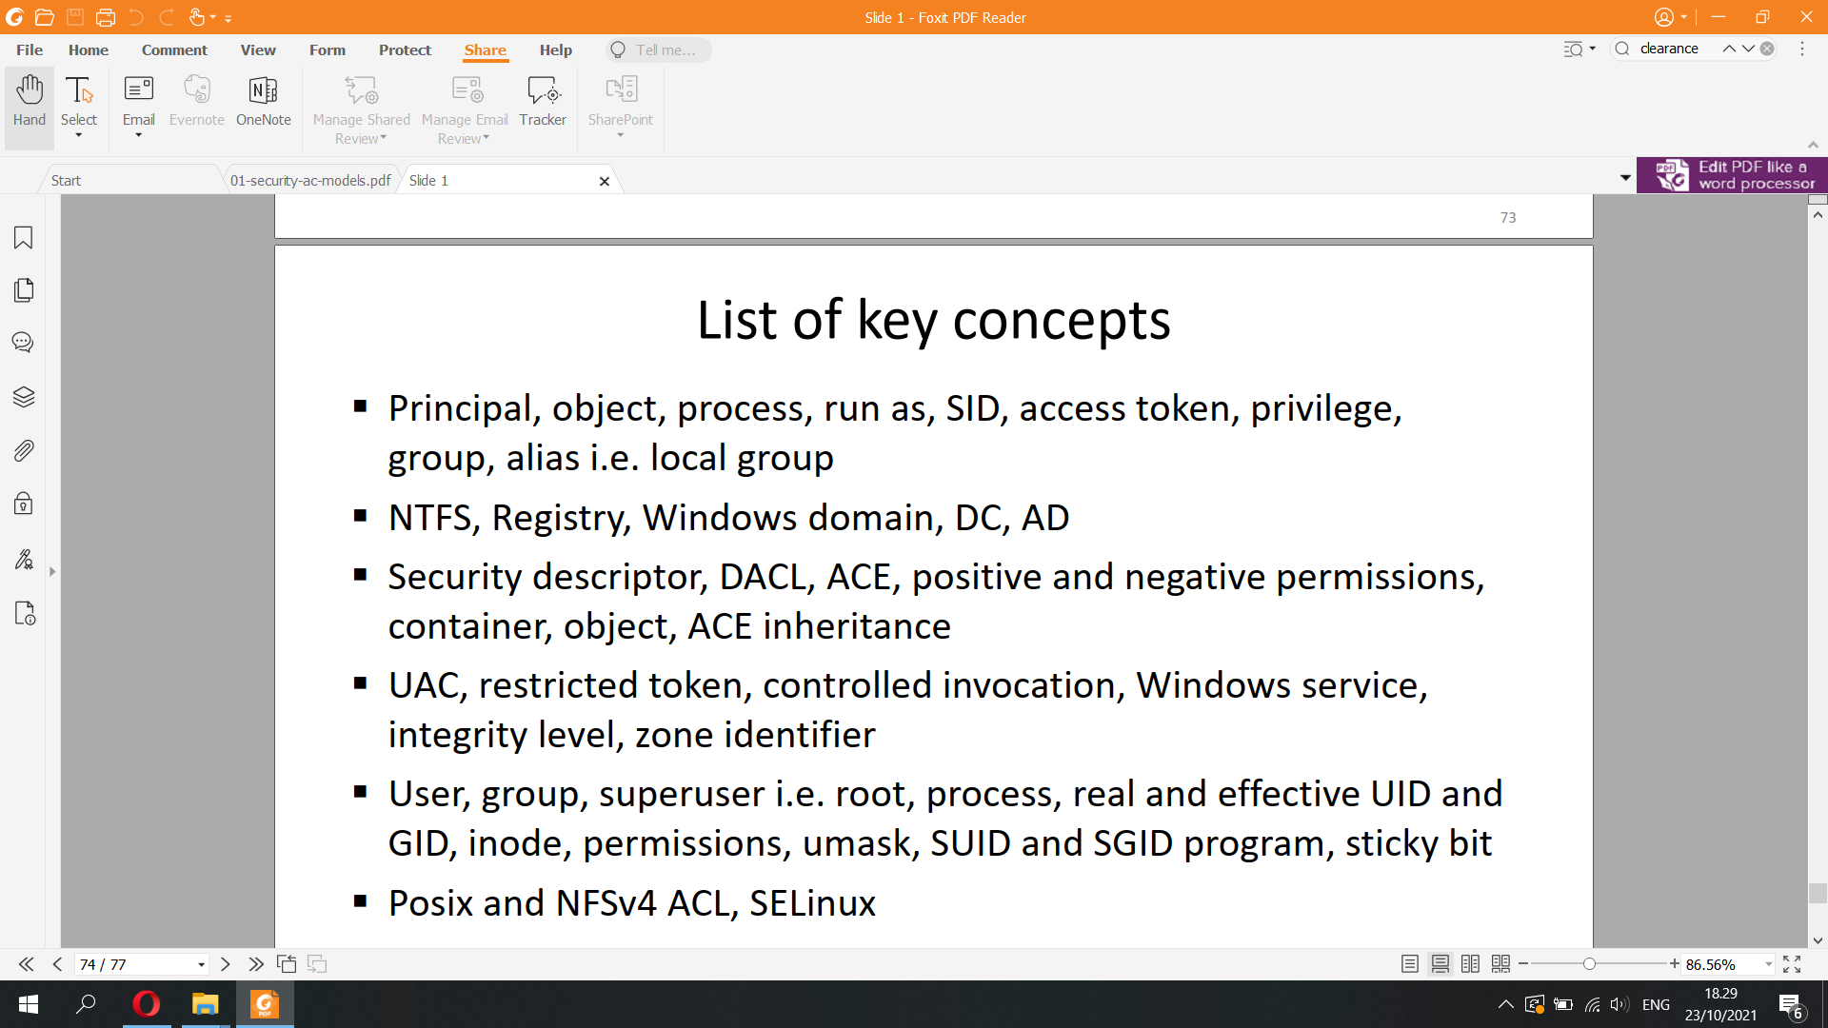

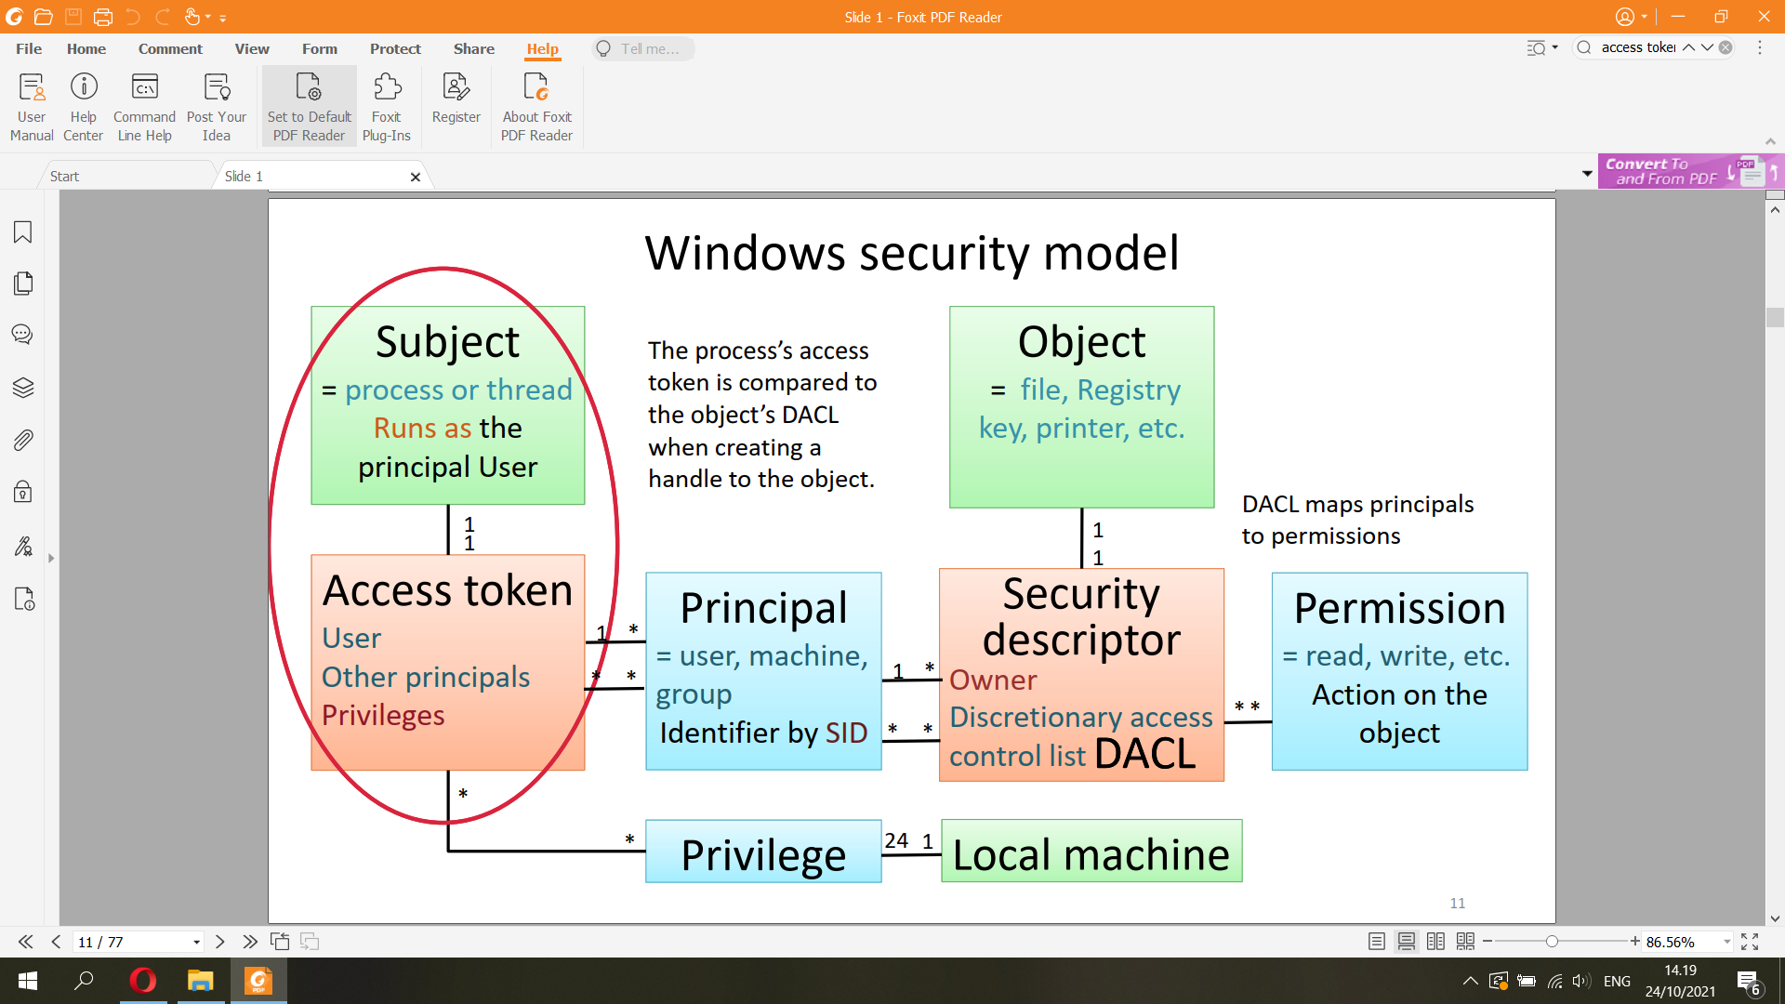

▪ Principals = users, machines, groups,…

– Something that can be authenticated

▪ Objects = files, Registry keys, printers, …

– Each object has a discretionary access control list (DACL)

▪ Subjects = processes or threads

– Process (or thread) runs as a principal

– Each process (or thread) has an access token, which is privileges or principals

▪ When is a process allowed to access an object?

– The object’s DACL is compared with the process’s access token when creating a handle to the object

▪ Principal names: machine\principal or domain\principal

T30500-LR064\Tuomas, AALTO\aura

▪ Principal has a unique security identifier (SID)

S-1-5-21-961468069-954667678-1722769278-1002

▪ Name can be changed; SID is permanent

▪ Windows computer has a Local Security Authority (LSA), which stores local users and local groups (=aliases) in a hierarchical database called Registry

T30500-LR064\Tuomas

▪ Windows domain has a Domain Controller (DC), which stores domain users, domain computers (=machines) and groups centrally in a hierarchical database called Active Directory (AD)

– Names: domain\principal or principal@domain

AALTO\aura, [aura@org.aalto.fi](mailto:aura@org.aalto.fi)

▪ Process has an access token (=security token), which contains:

– Login user account SID (the process runs as this user)

– SIDs of all groups where the login user is a member (recursively!)

– All privileges assigned to these users and groups on the local computer

▪ Token never changes after it has been created

– Better reliability and efficiency but slower revocation of access rights

▪ Privileges are special rights on the local machine

– Backup, audit security log, take ownership, trusted for delegation,

debugging, performance profiling, shutdown, …

▪ Objects: files, folders, Registry and AD objects, processes...

– Some objects are containers for other objects → hierarchy

▪ Object has a security descriptor, which includes the

discretionary access control list (DACL)

▪ Object also has an owner (identified by SID), who has the

implicit right to read and write the DACL

▪ Permissions are actions that apply to an object

▪ Generic and standard permissions are defined for all objects: Read, Write, Execute, All, Delete, WriteDACL, …

– although different names are used for different object classes (e.g. Read for file and List for directory)

▪ Each object class has object-specific permissions:

Append (for file), AddSubDir (for folder), CreateThread (for

process), …

▪ DACL is a list of access control entries (ACE)  
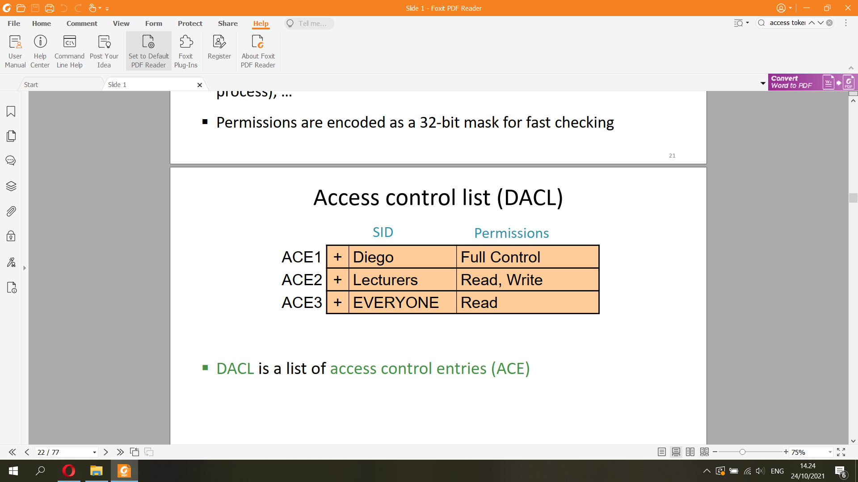

▪ Negative ACEs are placed before positive ones

– DACL above grants read but no write access to the user

Tuomaura  
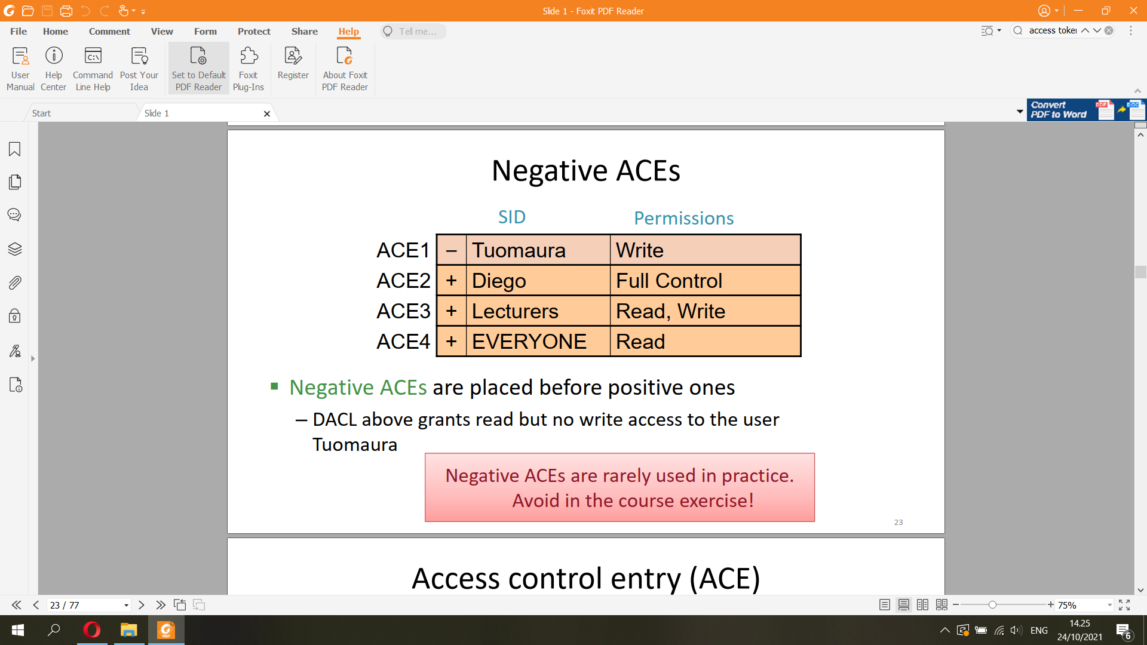  
* NTFS is a proprietary journaling file system of Microsoft  
* The Windows Registry is a hierarchical database that stores low-level settings for the Microsoft Windows operating system and for applications that opt to use the registry.

▪ Container objects can have inheritable ACEs

▪ Inheritable ACEs are copied down the hierarchy

▪ Directly assigned ACEs override the inherited ones

▪ Principle of least privilege: only run with admin rights when needed

▪ Windows user account control (UAC)

Interactive user has two security tokens:

1. Restricted token with Administrator group denied (and medium integrity level)

2. Unrestricted token with all the Administrators group rights (and high integrity level)

▪ Process elevation:

– Right click and select Run as Administrator

– In PowerShell (similar to Linux sudo):

> Start-Process -Verb runas notepad.exe

▪ Controlled invocation: allow user to invoke operations that require system privileges, but in a controlled way

▪ Windows does not have the equivalent of Linux SUID programs (see the Linux part of this lecture) that run with root privileges but are invoked by ordinary users. Why?

– Home users belong to Administrators local group on their machine and can run a process as administrator if needed (UAC)

– Software for non-admin users is written to not require elevated privileges

– Professional administration of Windows computers is done by domain admins; thus, controlled invocation

of local admin rights makes only limited sense

– Remote users (e.g. on another machine in the same domain) should be treated the same as locally logged in users, and that leads to a different architectural solution than SUID

▪ Windows service can run as admin and handle requests from applications

– The user application needs to communicate with the service: inter-process communication with Windows

Communication Foundation (WCF) and named pipes (NetNamedPipeBinding)

– Service can learn the client identity from WCF (see ServiceSecurityContext)

– More commonly, the service switches between the service user’s and the client user’s access rights by impersonating the client

▪ In addition to DACL, object has a SACL

▪ System ACL (SACL) specifies

– Integrity level

– Rules for generation of audit messages for granted and denied access

requests (see Event Viewer / Windows Logs / Security)

▪ Windows also labels files with Zone Identifier

0 My Computer

1 Local Intranet Zone

2 Trusted sites Zone

3 Internet Zone

4 Restricted Sites Zone

▪ Stored in an alternate data stream in NTFS  
* Linux  
▪ The principals in Unix are users and groups

▪ Users have username and user identifier (UID)

▪ Groups have group name and group identifier (GID)

▪ UID and GID are usually 16-bit numbers, now 32 bits in Linux

0 = root

19057 = aura

▪ Both names and identifiers are permanent; difficult to change

– UID values often differ from system to system  
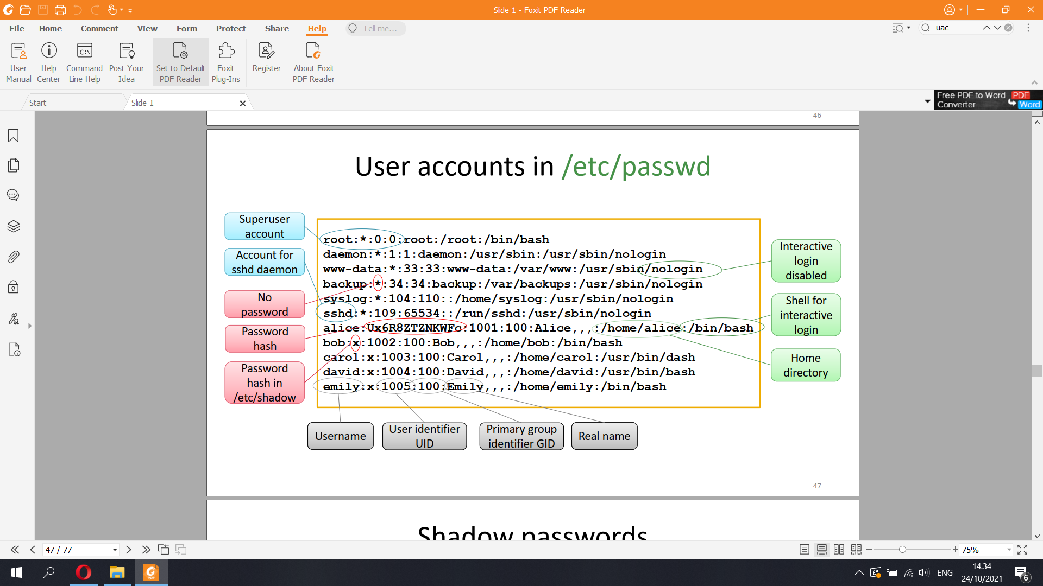

▪ The superuser is a special privileged principal with UID zero

and the user name root

▪ All security checks are turned off for the superuser

– Only minor limitations:

• The superuser cannot write to a read-only file system but can remount it as writeable

• The superuser cannot decrypt passwords (because they are hash values) but can reset them

▪ The superuser can become any other user

Subjects

▪ Subjects in Unix are processes with a process ID (PID)

– Processes can create new processes with fork(2)

▪ Processes have a real UID/GID

– Inherited from the parent process

– Typically the UID/GID of the user logged in

▪ Processes also have an effective UID/GID

Objects

▪ Objects of access control are files, directories and devices

– Organized in a tree-structured file system

▪ Inode data structure stores information about the object’s

owner user and group, and permissions

▪ Directory is a file containing file names and pointers to inodes

– Filename is stored in the directory, not in inode, so that many names

can be linked to the same inode

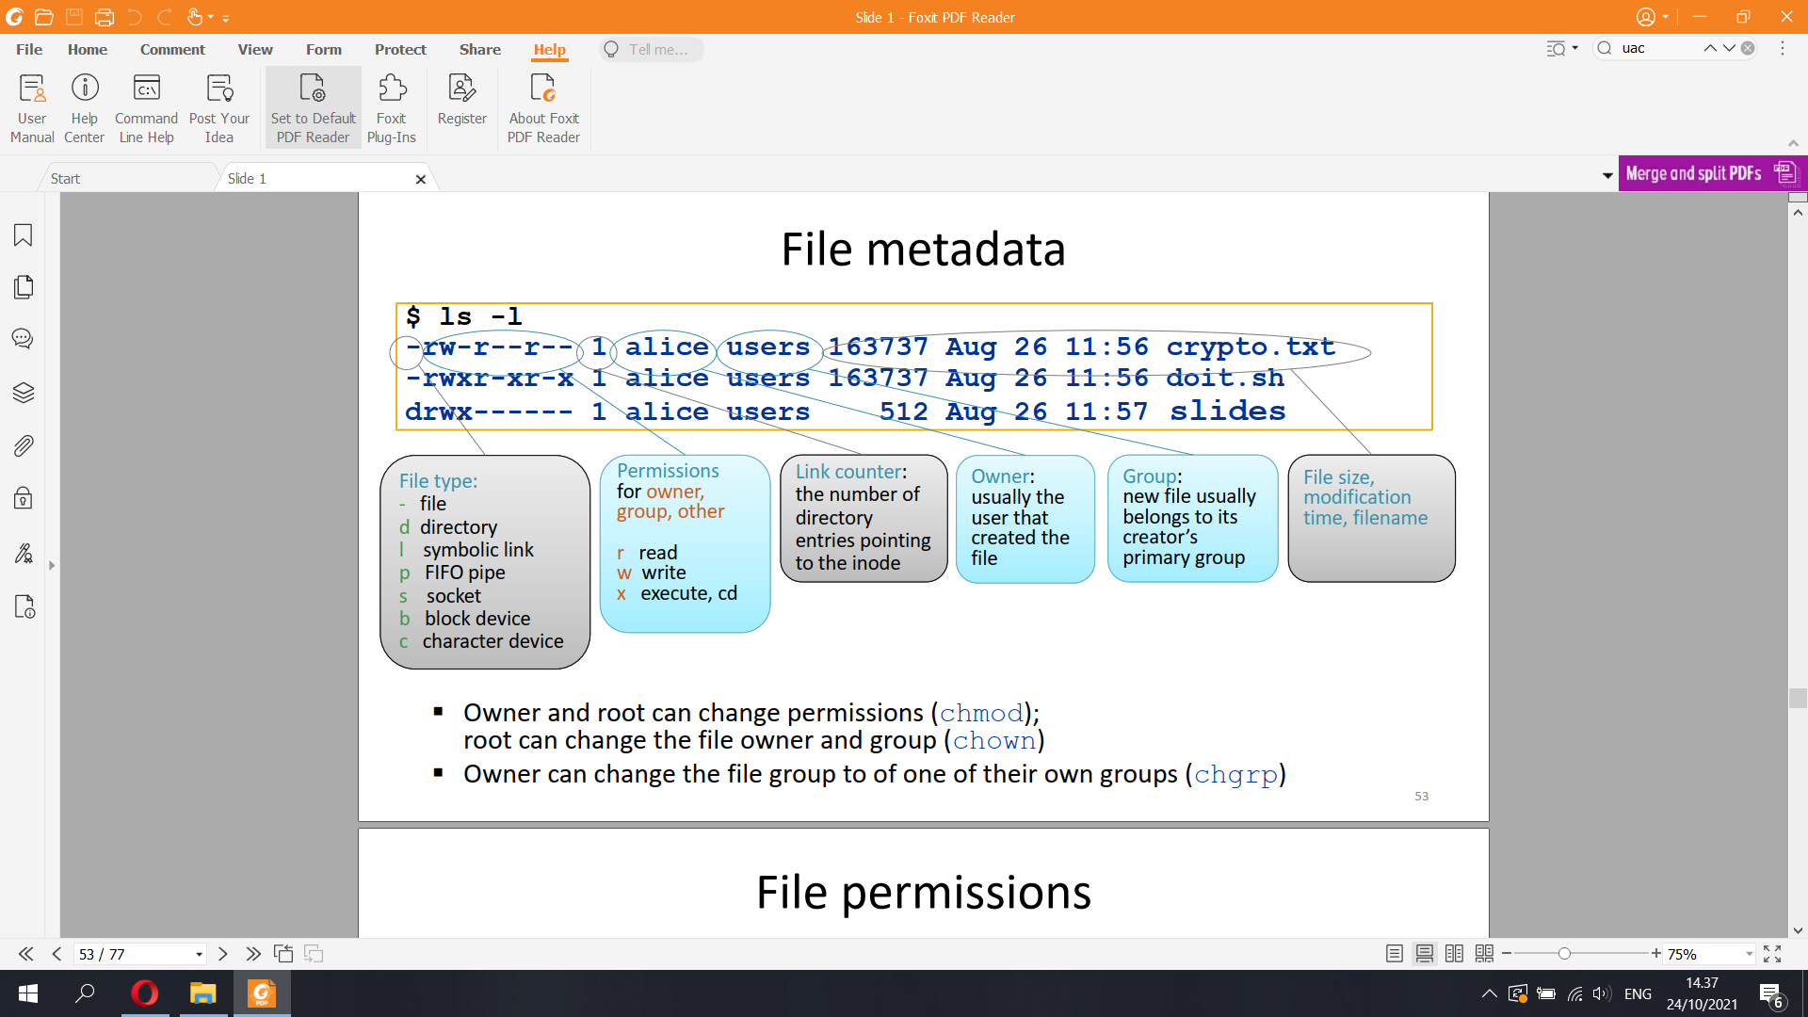

▪ Owner and root can change permissions (chmod);

root can change the file owner and group (chown)

▪ Owner can change the file group to of one of their own groups (chgrp)

▪ Permission bits are grouped in three triples that define read, write, and

execute access for owner, group, and other (i.e. world)

▪ rw-r--r-- read and write access for owner, read access for group

and other

▪ rwxr-xr-x read, write and execute access for owner, read and

execute for other

▪ rwx------ read, write and execute (cd) access for owner only

– For directory, x means ability to cd to the directory

▪ Access control uses the effective UID/GID:

– If the process’s effective UID = file owner, check owner permissions

– Otherwise, if process’s effective GID = file owner, check group

permissions

– Otherwise, check other (=world) permissions

▪ The owner can always change the permissions (discretionary

access control)

▪ Sticky bit on an executable file historically indicated that the

process should not be swapped to disk

▪ Sticky bit on a directory restricts the deletion of files in the

directory only to the file owners (and root)

– Job queues for printing etc. are implemented as a world-writable

directories; anyone can add a file but not delete the files of others

ls -ld /tmp

▪ SGID bit on a directory means that new files inherit their group

from the directory, not from the user who creates the file

– Avoid running the print daemon as root: create a special group for the

print daemon process and the print queue directory

– Implement project directory where members can share files

SUID and SGID programs

▪ Controlled invocation: normal user can invoke operations that

require superuser privileges, in a controlled way

▪ SUID programs run with effective UID of the owner of the

executable file

– Execute permission of the owner is shown as s instead of x:

-rwsr-xr-x 1 root root 68208 May 28 09:37 /usr/bin/passwd

▪ SGID programs run with effective GID of the owner of the

executable file

– Execute permission of the group is shown as s instead of x

**3) User authentication**

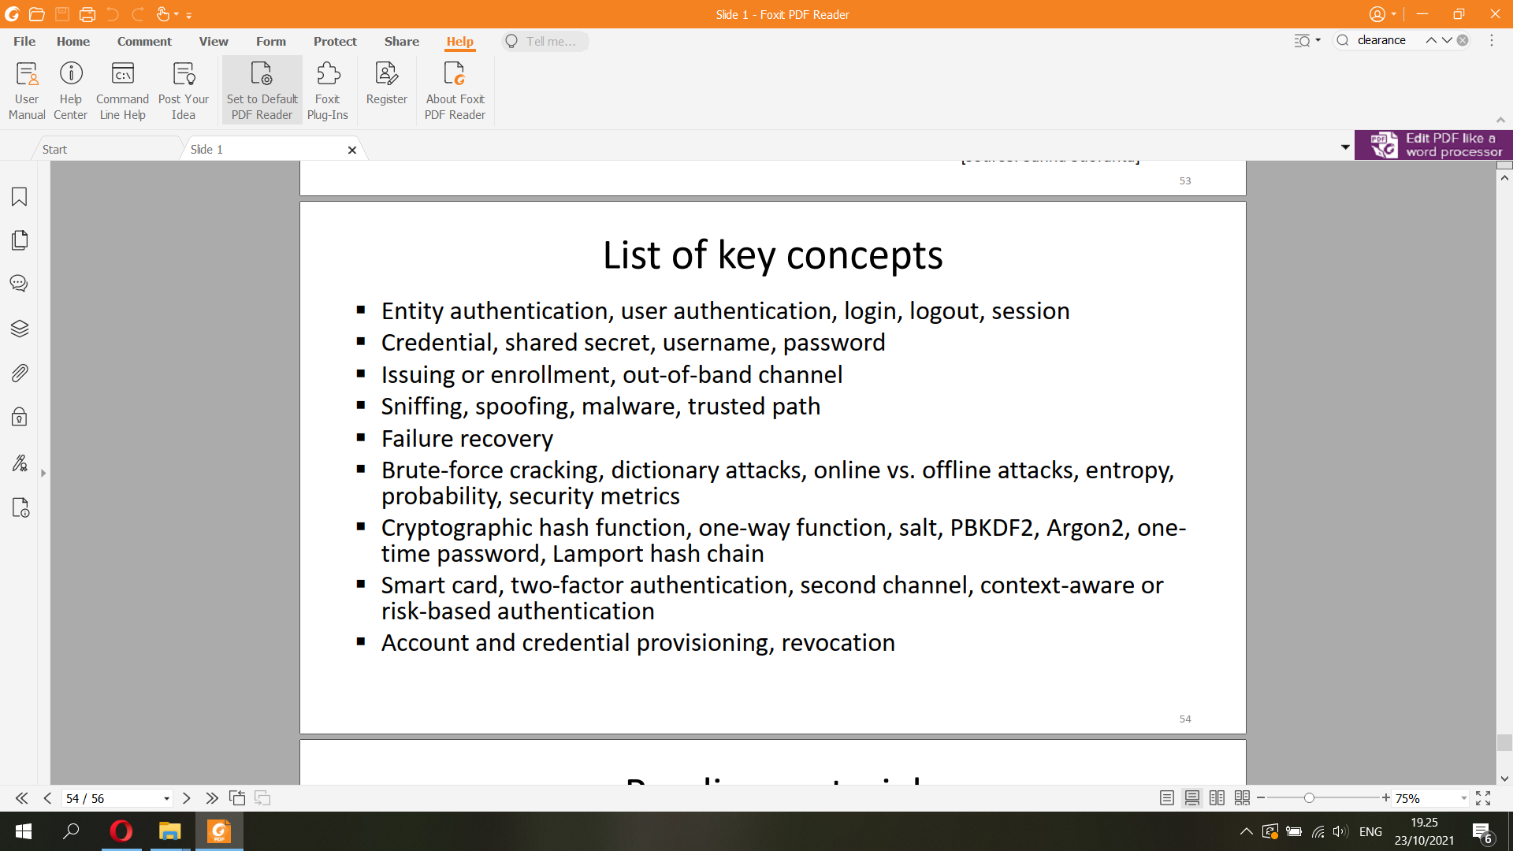

User authentication

▪ Verifying user identity

▪ Needed for access control and auditing

access control = authentication + authorization

▪ User authentication is based on credentials

– Password, key, smart card etc.

Something you know,

something you have, or

something you are  
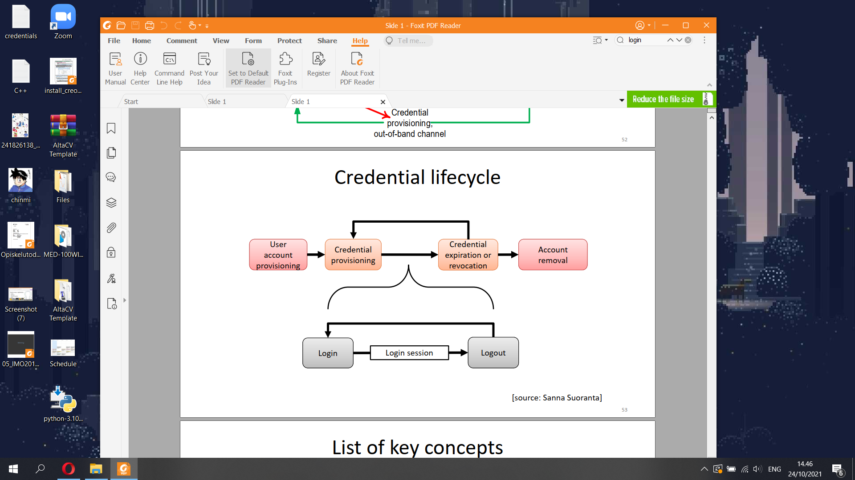

▪ Password and PIN code are the most common types of

authentication credentials

▪ Password is a shared secret between the user and computer

system

– Limitations arise from the reliance on human memory and input

methods, and from the lack of cryptographic computing capability in

humans

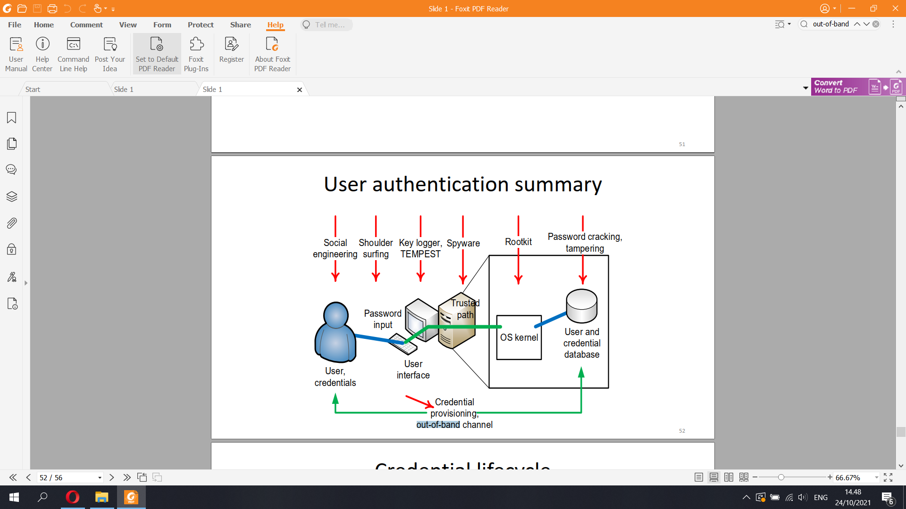

Sniffing is **a process of monitoring and capturing all data packets passing through given network**

Spoofing is the **act of disguising a communication from an unknown source as being from a known, trusted source**

Out-of-band (OOB) refers to **a separate communication channel severed from the primary in-band channel over which the actual network communication occurs**

▪ Trusted path is any mechanism that ensures direct and secure

communication between user and a trusted part of the system

▪ Context-aware or risk-based authentication:

– Require additional authentication only when the user is suspicious or

requested action requires stronger security

– Online services can do this intelligently to avoid annoying the user

▪ Smart card is a typical physical security token

– Stores cryptographic keys to prove its identity

– Tamperproof: secret keys will stay inside

▪ Two-factor authentication = require both a physical token and a PIN or password

– Attacker needs to both steal the physical device and learn the PIN

→ clear qualitative increase in security

Offline cracking

▪ Attacker obtains the password hashes or other data for verifying password guesses, then starts guessing

▪ Brute-force attacks vs. intelligent dictionary attacks

– Most password crackers combine both strategies

▪ Attacker has great advantages:

– Unlimited number of guesses

– Can rent elastic computing capacity for quick results

▪ To resist cracking, passwords must have cryptographic

strength (~128 bits of entropy)

Easy to crack some passwords; hard to crack them all. Why?

Online trials – much harder

▪ Online trials: attacker tries to login many times

– Try PIN codes on a phone or cash machine

– Guess passwords for a web site

– Port scan ssh servers and guess root password

▪ System can limit the number or rate of login attempts

– Possible in online services, smartcards, phone, Microsoft account

– Huge improvement in security: success probability

≈ number of allowed guesses / number of possible passwords

– Denial of service (DoS) is a danger, e.g. bricking a phone; use delay

rather than a fixed limit on the number of trials when possible

▪ Many possible metrics for password strength:

– Number of possible passwords

– Entropy = amount of missing information

– Average/median cost to crack a specific password / any one password

– Success probability / number of cracked passwords as function of cost

▪ Metrics are useful for system designers and setting policies

▪ Measuring strength of user-chosen passwords is impossible  
One-way function

▪ Cryptographic hash functions have the one-way property:

Easy to compute the hash h(M) for a given message M, but

difficult to compute M given h(M)

– Attacker can only guess M and compare the hashes

▪ Examples: SHA-256, SHA-3 (old ones: SHA-1, MD5)  
Slow hash function

▪ Standards hash functions are unnecessarily fast!

▪ Iterative hash:

– hash(pw|hash(pw|salt)) takes twice as long as hash(pw|salt)

– Iterate N times (N > 100 000) for desired delay

▪ Why? Not a significant cost when verifying user login, but

increases a brute-force attacker’s work by factor N

▪ Slow functions designed specifically for password hashing: PBKDF2, Argon2, bcrypt  
Salt in password hash

▪ Why salt?

username, salt, slow_hash( password | salt)

▪ Salt prevents

– Simultaneous brute-force cracking of many passwords

– Pre-computation attacks including rainbow tables

– Equality comparison between passwords  
Credential stuffing is a type of cyberattack in which stolen account credentials, typically consisting of lists of usernames and/or email addresses and the corresponding passwords (often from a data breach), are used to gain unauthorized access to user accounts through large-scale automated login requests directed against a web application

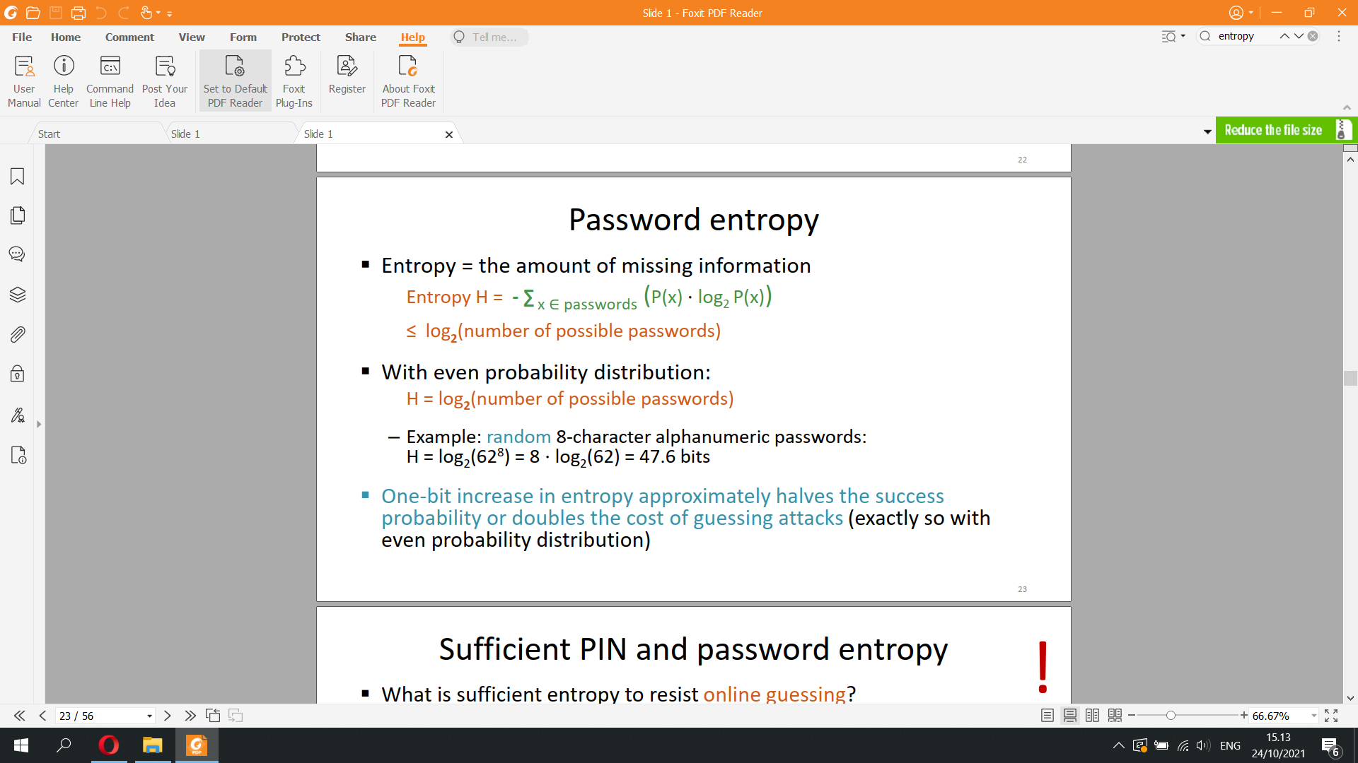

**4) Software security**

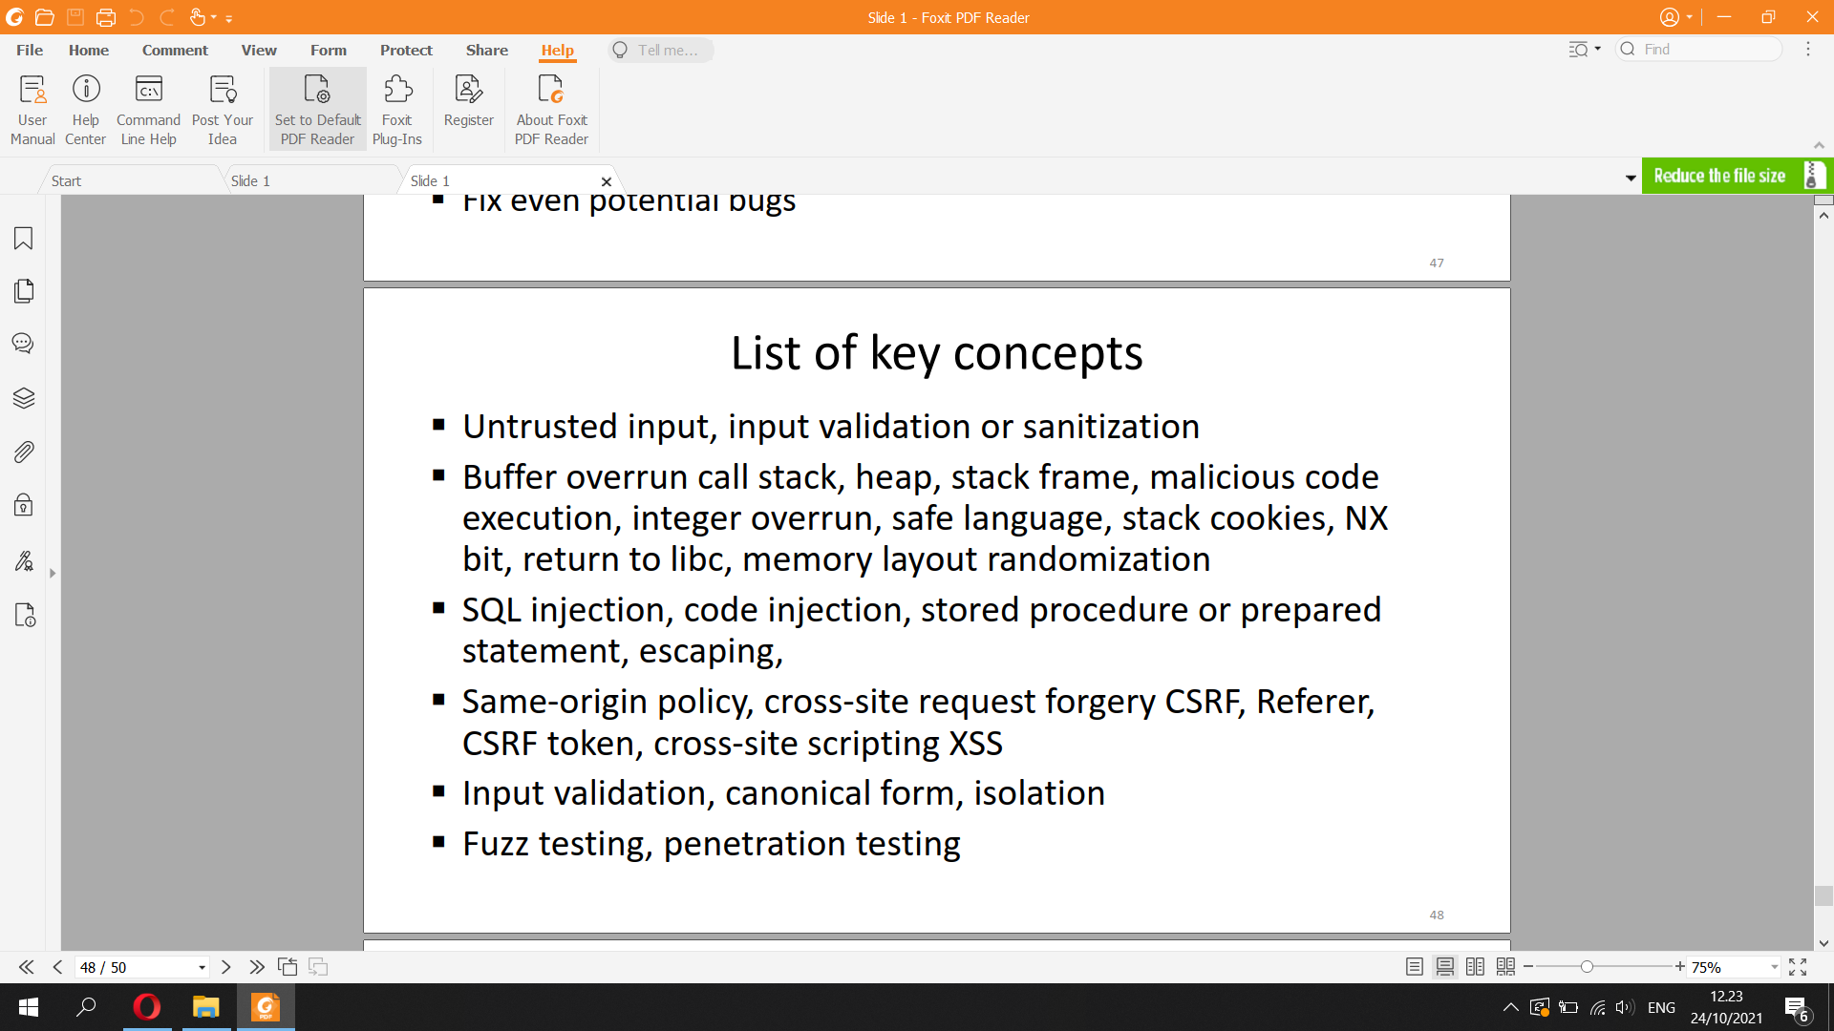

▪ User and network input is untrusted

▪ Does my software get input from the Internet?

– Documents, streams, messages, photos may all be untrusted

– All modern applications are Internet clients or servers

– Intranet hosts, backend databases, office appliances etc. are directly

or indirectly exposed to input from the Internet

→ All software must be able to handle malformed and malicious input safely

▪ Minimum privilege: set tables as read-only; run different services as different users

▪ Sanitize input: allow only the necessary characters and string formats – but it is hard to do correctly!

▪ Escape input strings with safe library functions, e.g.

– mysql_real_escape_string() in PHP

– MySQLdb.escape_string(), MySQLdb.execute(), sqlalchemy.text() in Python

Mitigating SQL injection

▪ Prepared statements and stored procedures:

precompiled SQL queries that can be executed many

times with different parameter values

▪ Disable SQL error messages to normal users

→ harder to build exploits

▪ Jonne heard prepared statements are good for security:

$stmt = $conn->prepare("SELECT * FROM users WHERE username = '" + input + "';"); $stmt->execute();

▪ Why is this wrong?

- buffer overrun, is an anomaly where a program, while writing data to a buffer, overruns the buffer's boundary and overwrites adjacent memory locations.

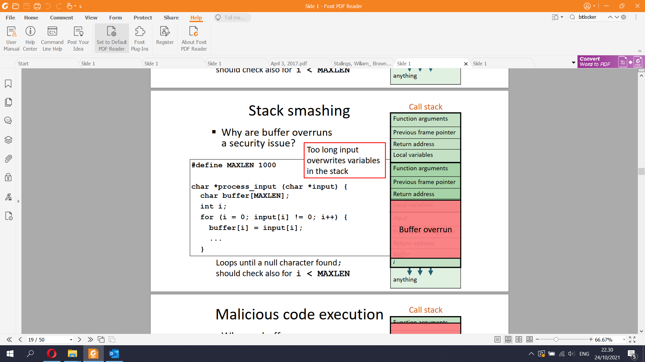

When the function returns, execution will jump to the new return address, which points to attack code → malicious code execution with the process’s permission

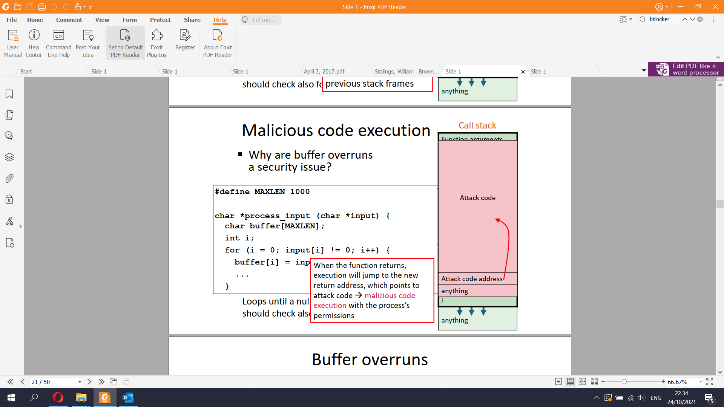

▪ Buffer overruns may cause

– data modification → unstable program behavior

– access violation “segmentation fault” → process crashing

– malicious data modification

– code injection → attacker gains full control of the process

▪ How attacker gains control:

– Stack overruns may overwrite function return address or exception

handler address

– Heap overruns may overwrite function pointer or virtual method

table

▪ How difficult is writing an exploit?

– Instructions and code widely available

– There are people and companies actively developing exploits

▪ Preventing buffer overruns:

– Type-safe languages (e.g. Java, C#)

– Programmer training, code reviews

– Avoiding unsafe and difficult-to-use libraries:

strcpy, gets, scanf, MultiByteToWideChar, etc.

– Fuzz testing

– Static code analysis, symbolic model checking: proving safety

▪ No reliable way to find all buffer overrun vulnerabilities

→ need to also mitigate consequences

▪ Stack canary

– Store an unguessable value on the top of the stack frame in function

prologue; check before returning

– GCC -fstack-protector-all, Visual Studio /GS

▪ Non-executable (NX) bit

– Set the stack and heap memory pages as non-executable

– Breaks some code, e.g. JIT compilation

– Often combined with memory layout randomization

Return to libc

▪ NX prevents machine code

insertion to stack

▪ However, there is another attack: return to libc, which uses existing executable code in the memory

– e.g. standard library functions in libc

Integer overflow

▪ Integers in programming

languages are not ideal

mathematical integers

▪ Integer overflow can cause buffer overrun

Cross-site request forgery (CSRF)

▪ Fictional example:

– Users on social.net stay logged in with a session cookie

– JavaScript on Bob’s web page bobs.org:

<script type="text/javascript">

frames['hidden'].window.location =

'http://social.net/AddFriend.php?name=Bob';

</script>

▪ Why possible? Interaction between web sites is usually

prevented by the same origin policy. However, web links and

HTTP GET and POST redirection to another site is allowed.

Cross-site scripting (XSS)

▪ User-posted content on web sites may contain malicious

JavaScript

▪ Fictional example:

– Social.net allows users to post comments. Bob’s comment:

<b onmouseover="$.get('

http://social.net/AddFriend.php?name=Bob’);">

Be my friend!<b>

– Another user reads the blog and moves mouse over the text

▪ This is stored XSS: malicious script stored on the server

Reflected XSS

▪ PHP code on a web server:

<html><body><?php

print "Page not found: ". urldecode($_SERVER["REQUEST_URI"]);

?></body></html>

▪ Typical output: Page not found: /foo.html

▪ Bob tricks Alice to follow this URL-encoded link:

http://social.net/%3Cscript%3E%3D%22%24.get%28%27http%3A%2F%2Fsoci

al.net%2FAddFriend.php%3Fname%3DBob%E2%80%99%29%3B%3C%2Fscript%3E

▪ The error page on social.net will contain this:

Page not found: /<script>="$.get('http://social.net/AddFriend.php

?name=Bob’);</script>

▪ This is reflected XSS: malicious script sent via the server but not stored there

What is untrusted input to web server?

▪ Inputs that may contain XSS or other malicious content:

– Input from web client or user, or REST API client

– Data read from database

– Messages between servers

▪ Should escape or validate all these inputs

Validation checks if the input meets a set of criteria (such as a string contains no standalone single quotation marks).

Sanitization modifies the input to ensure that it is valid (such as doubling single quotes).

- an escape character is a character that invokes an alternative interpretation on the following characters in a character sequence, like \’, \n, \t, ...

▪ Why does software have security failures?

– Greedy business sells dangerous products?

– Lack of professional pride and ethics?

▪ Software is specified with use cases that describe the desired

functionality. Security is about undesired functionality

▪ Market forces and software development practices encourage

releasing a minimum viable product (MVP) – security not

included

▪ Threats and attacks evolve. Software security is never ready45

Other types of security bugs

▪ Injection of untrusted input into the command line, JavaScript,

HTML, XML, format string, file path etc.

▪ Logical errors, e.g. time of check—time of use, use after free

▪ Integer overruns or signed/unsigned confusion

▪ Crypto mistakes, bad random numbers

▪ Insecure direct references

▪ Most software bugs first seem harmless but eventually

someone figures out how to build an exploitHow to produce secure code?

▪ Programming:

– Learn about bugs and vulnerabilities by example

– Adopt secure coding guidelines

– Use safe languages, libraries and tools

– Code reviews, static checkers

– Fuzz testing, penetration testing

▪ Software process:

– Threat modelling

– Define security requirements

– Define quality assurance process

46Security principles

▪ Keep it simple

▪ Minimize attack surface

▪ Sanitize input and output

▪ Least privilege

▪ Defense in depth

▪ Isolation

▪ Secure defaults

▪ Secure failure modes

▪ Separation of duties

▪ No security through obscurity

▪ Fix even potential bugs

**5) Cryptography**

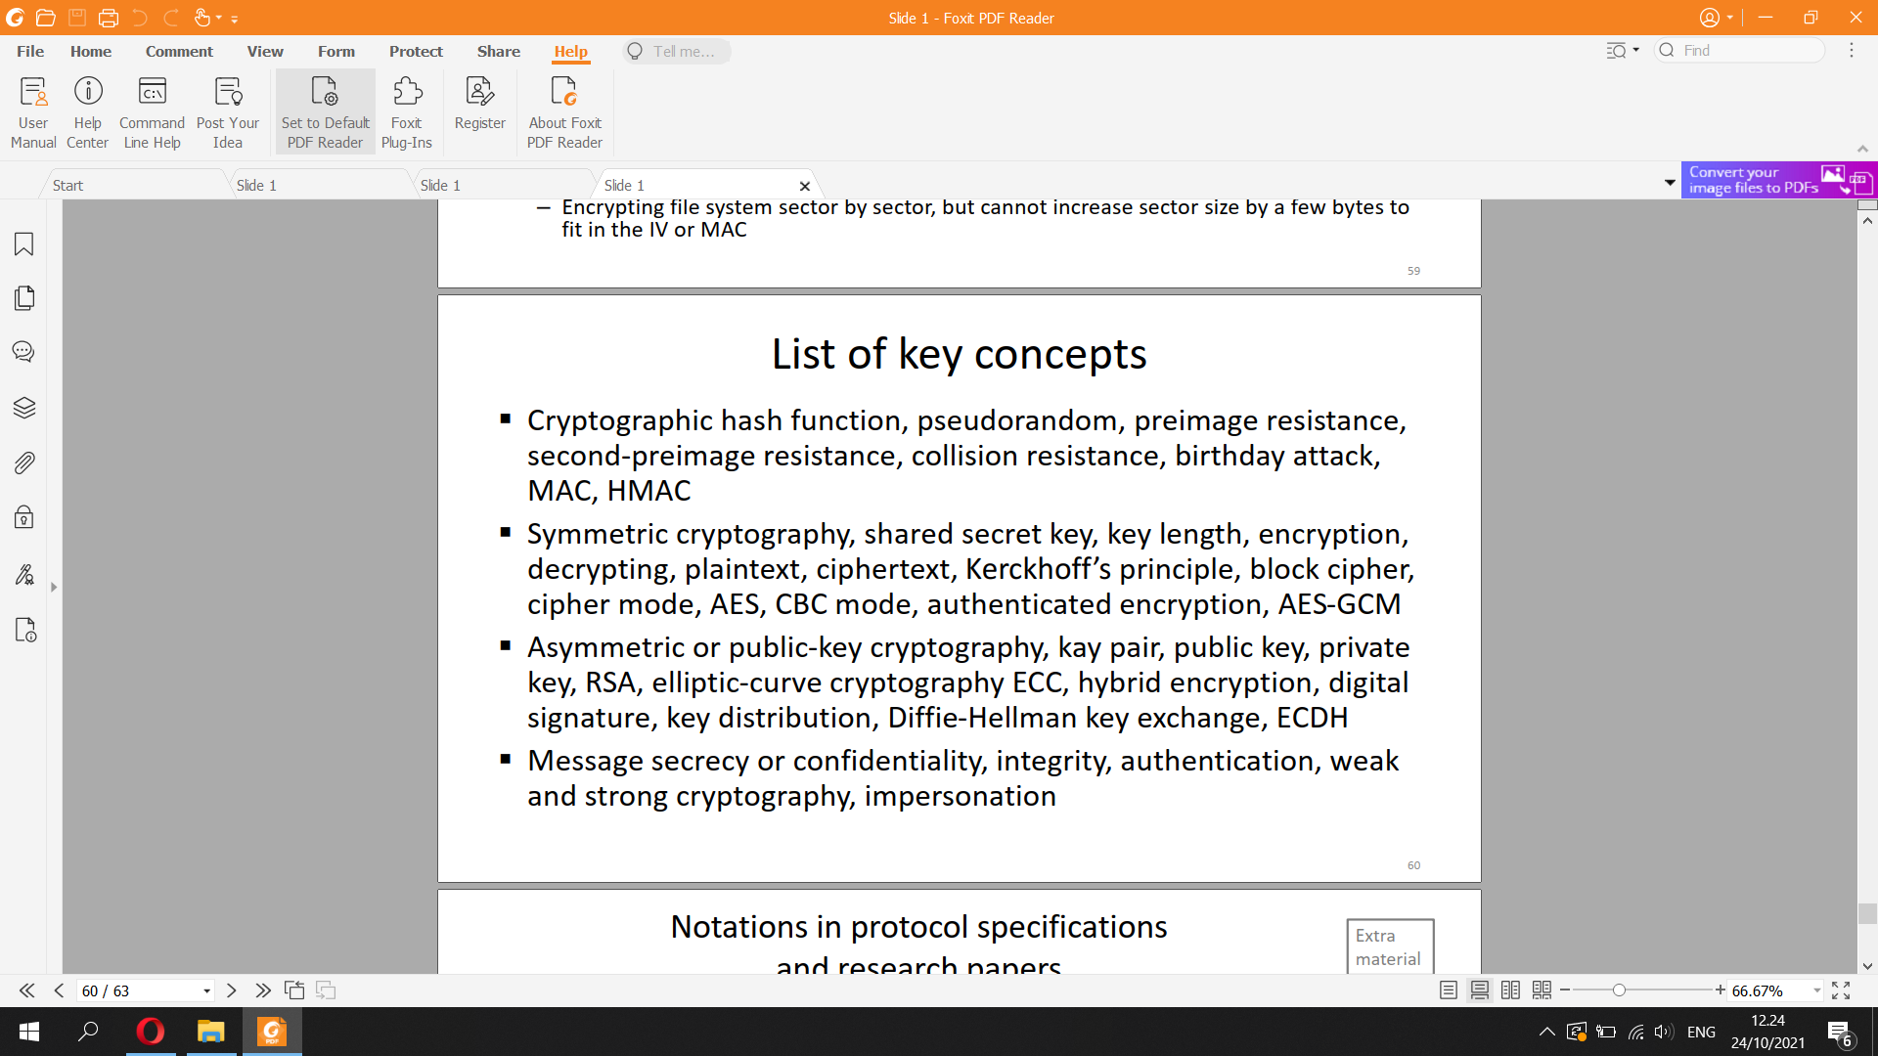

Cryptographic hash function

– The algorithm is public, no keys or other secrets needed

– Examples: SHA-256, SHA-512, SHA3-256

A cryptographic hash function (CHF) is a mathematical algorithm that maps data of an arbitrary size (often called the "message") to a bit array of a fixed size (the "hash value", "hash", or "message digest"). It is a one-way function, that is, a function for which it is practically infeasible to invert or reverse the computation.

Cryptographic hash: security requirements

▪ One-way = pre-image resistant: given only output, impossible to compute input, except by guessing. Preimage resistance is the property of a hash function that it is hard to invert, that is, given an element in the range of a hash function, it should be computationally infeasible to find an input that maps to that element

▪ Second-pre-image resistant: given one input, impossible to find a second input that produces the same output

▪ Collision-resistant: impossible to find any two inputs with the same output

– Old hash functions with broken collision resistance: MD5, SHA-1

▪ Practical hash function is pseudorandom: deterministic algorithm, but output looks random

Message authentication code (MAC)

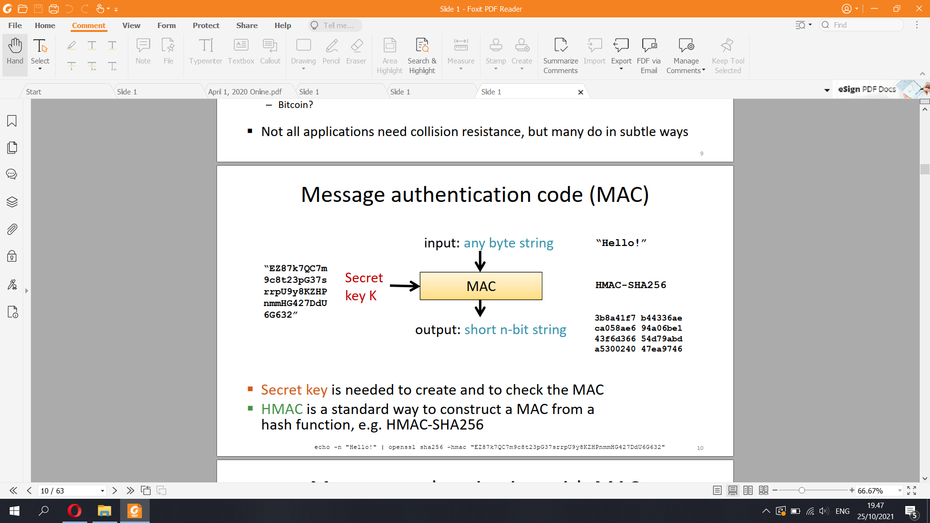

▪ Secret key is needed to create and to check the MAC

▪ HMAC is a standard way to construct a MAC from a

hash function, e.g. HMAC-SHA256

Message authentication with MAC

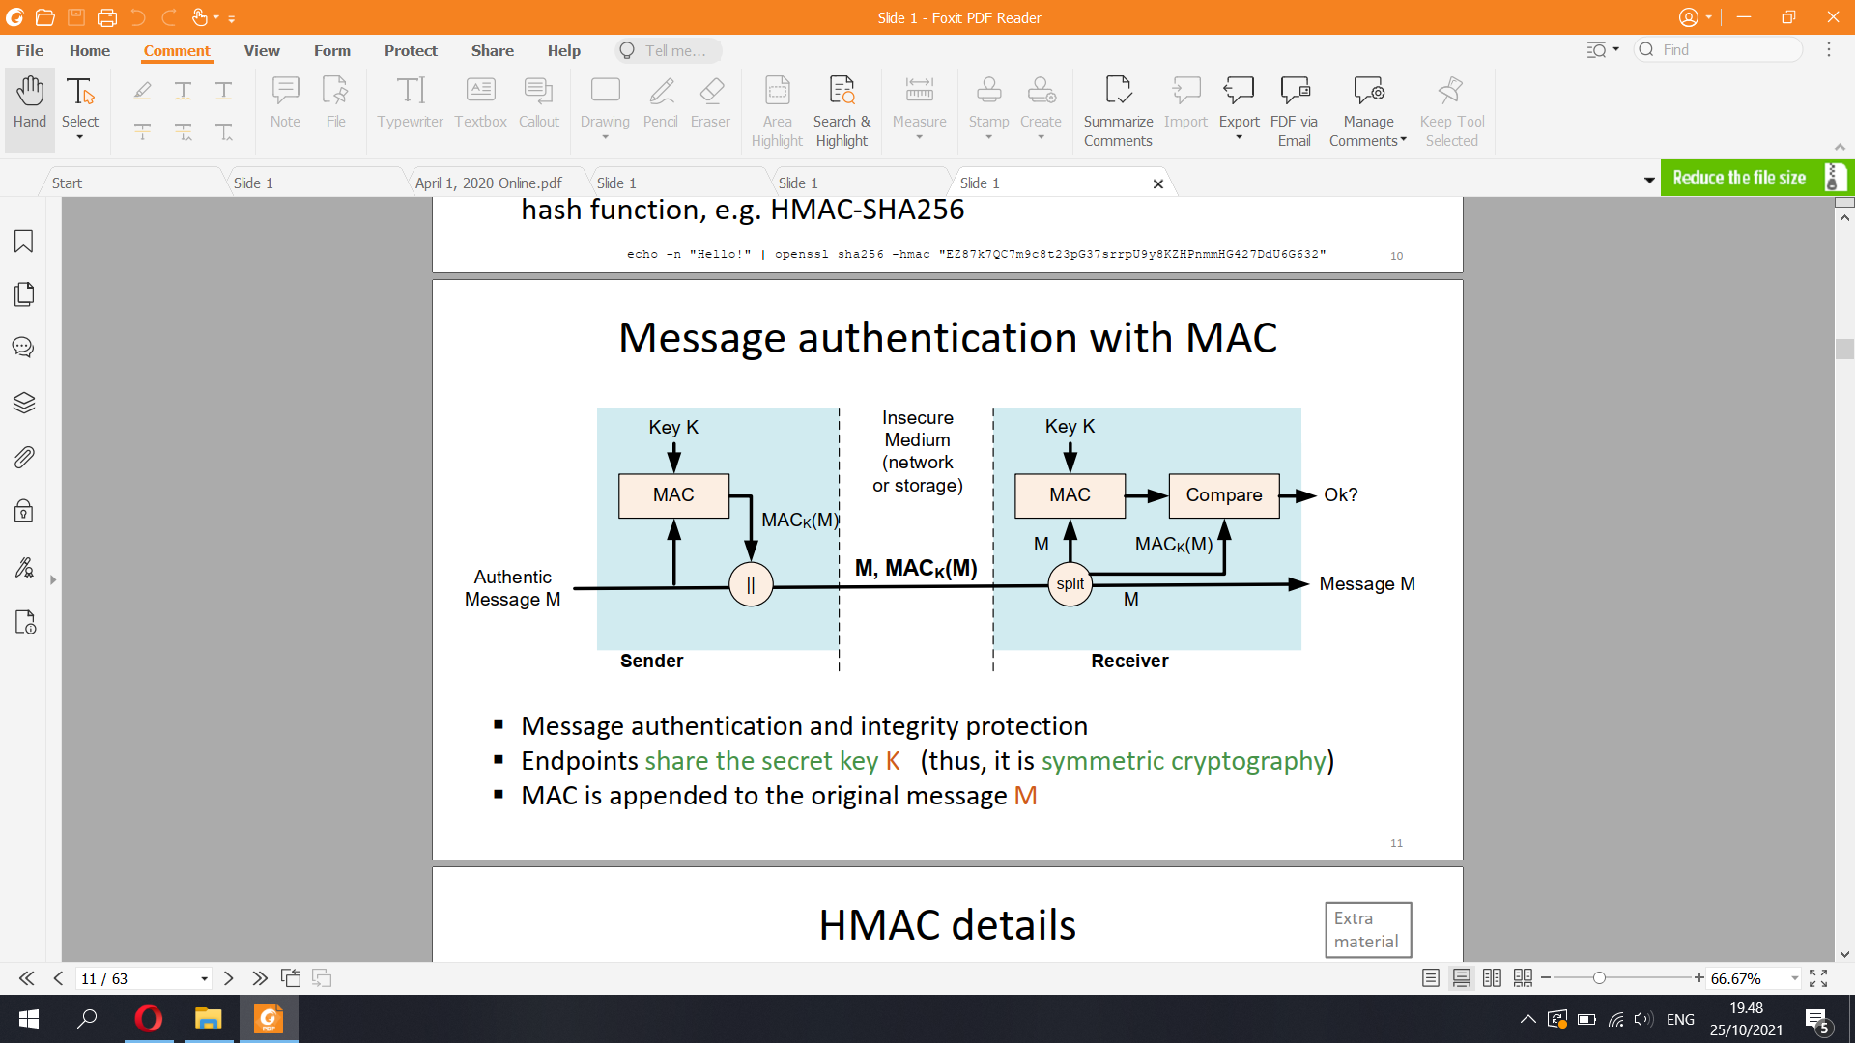

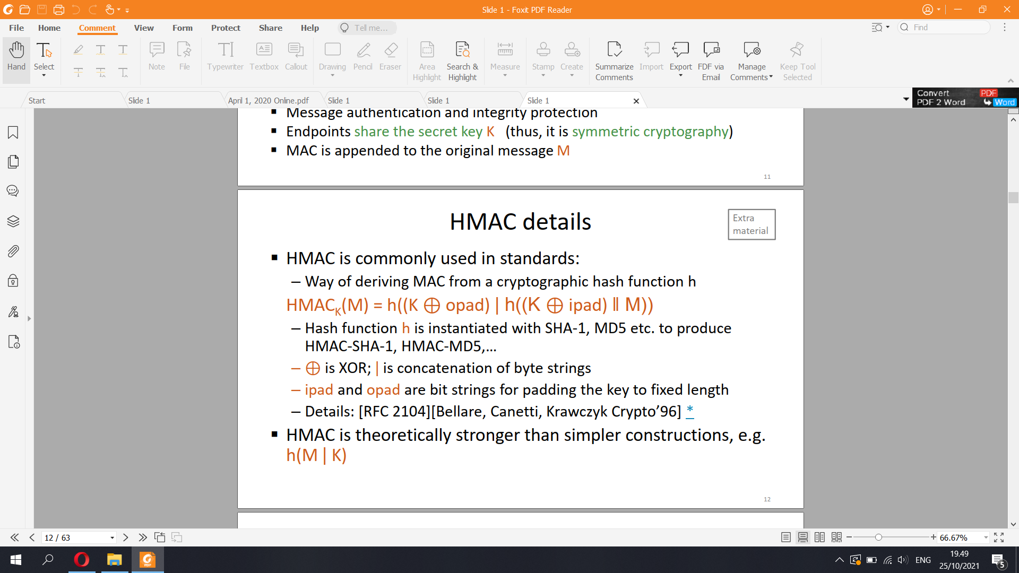

Symmetric encryption

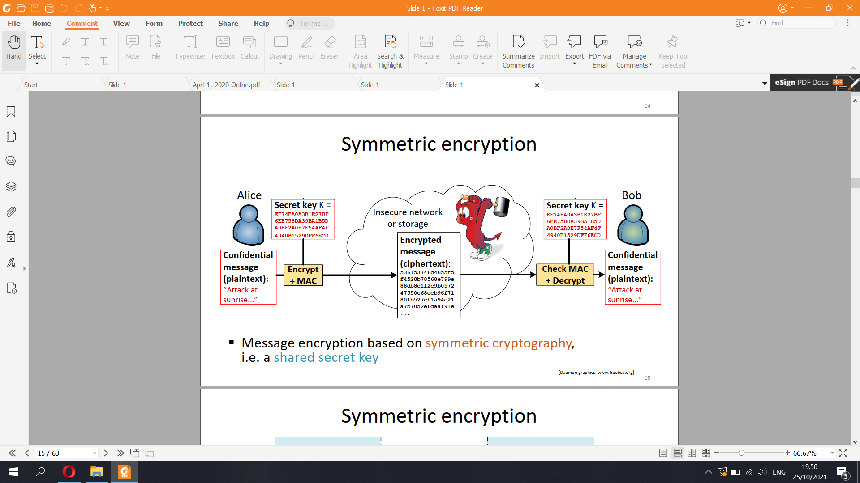

▪ Message encryption based on symmetric cryptography, i.e. a shared secret key

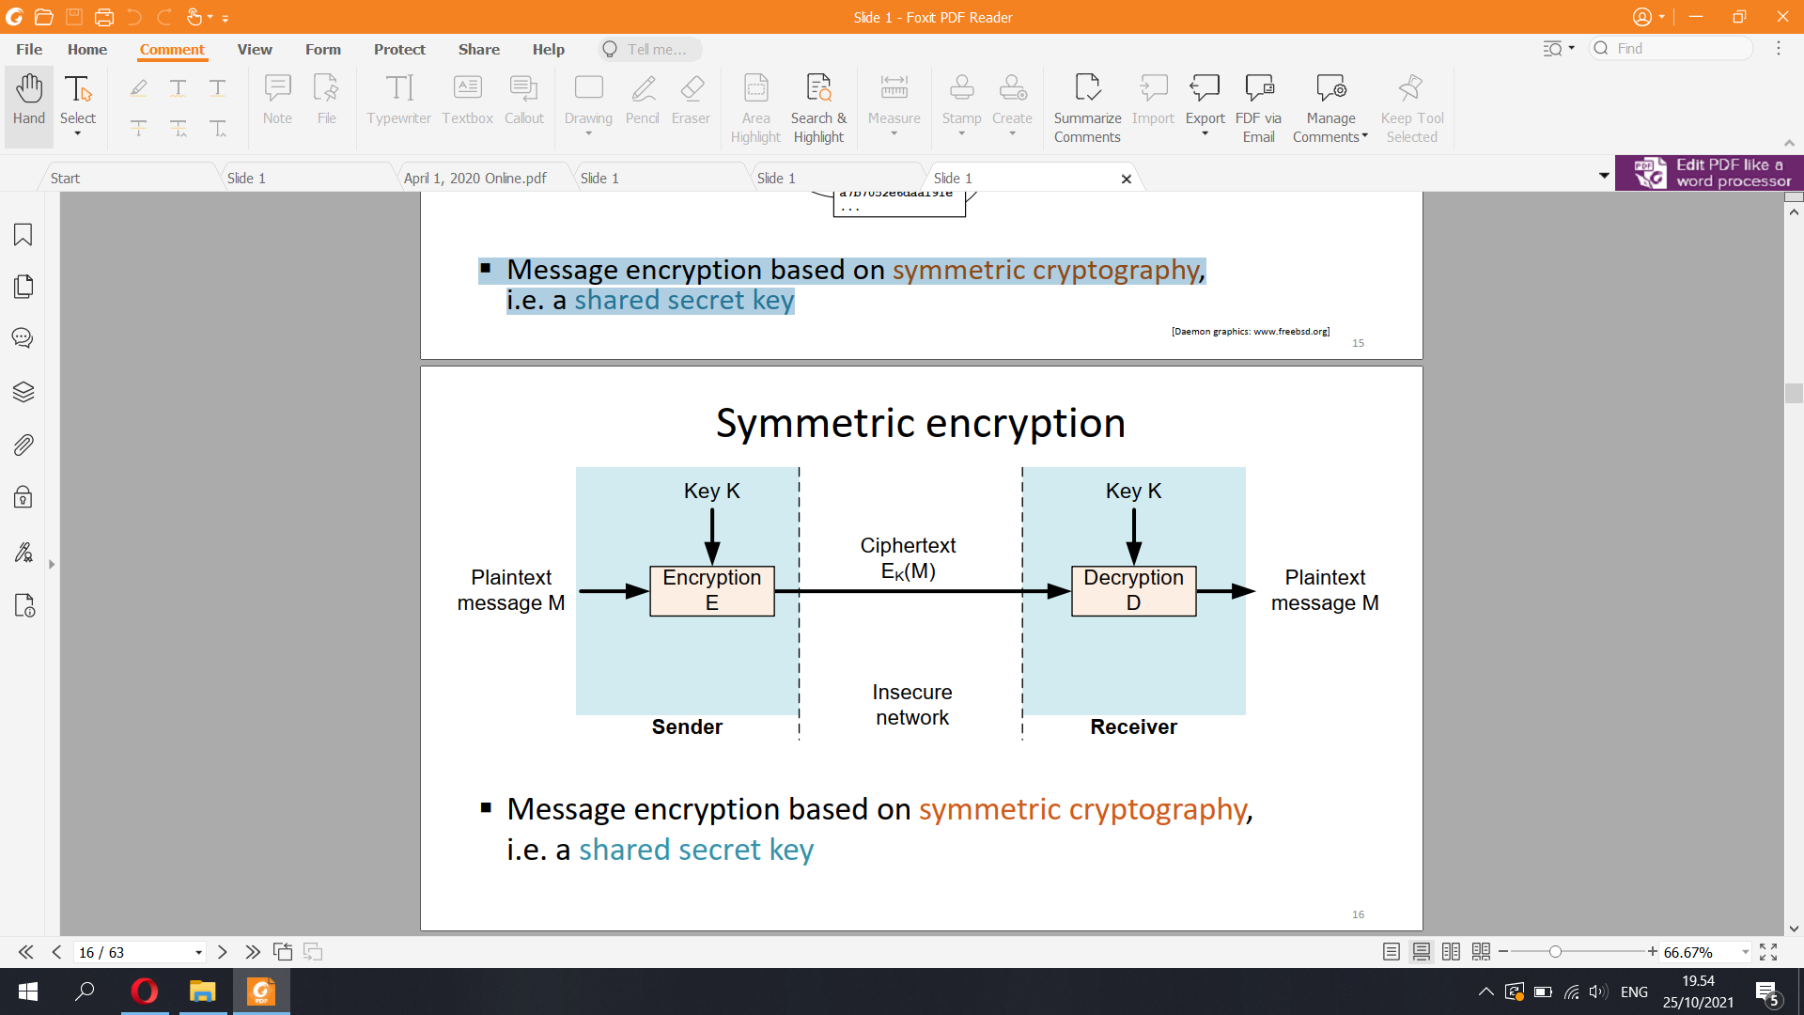

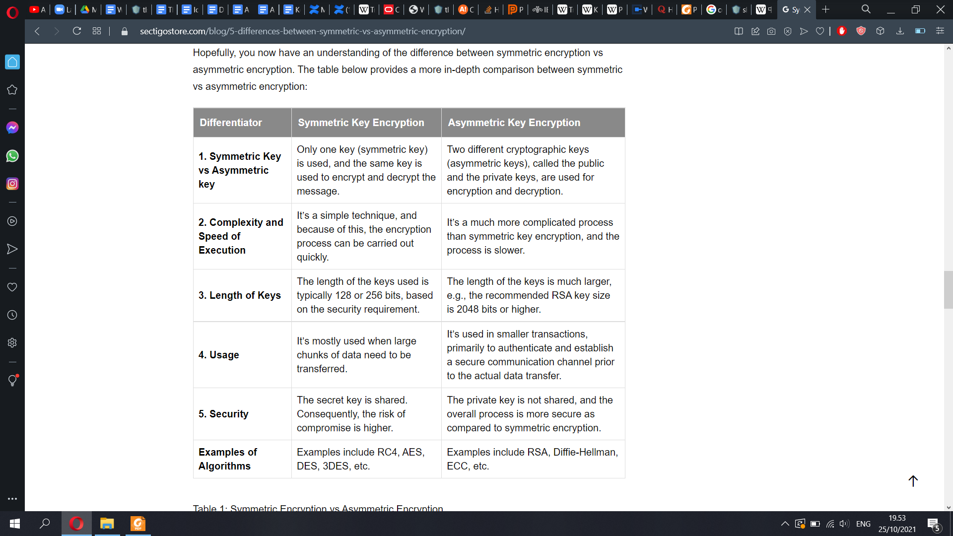

Symmetric encryption

▪ Kerckhoff’s principle: the encryption and decryption algorithms

are public algorithm; only the key is secret

▪ Encrypted message content looks like random bits – unless you

know the key

▪ The key must be shared over a secure out-of-band channel

– a 128…256-bit random number

– sometimes computed from a passphrase with a cryptographic hash

function (should use PBKDF2 to make cracking slower)  
Block cipher and cipher mode

▪ Block cipher is the basic construction block for encryption

– Encryption of a fixed-length block, typically 128 bits

– Examples: AES, 3DES

▪ Cipher mode uses the block cipher as building block for

encrypting messages of any length

– Padding of the message to full blocks

– Initialization vector, so that the same plaintext always produces a

different ciphertext (called salt in OpenSSL commands)

– Example: cipher-block chaining (CBC)

▪ Encryption alone protects secrets, not integrity

– Attacker can usually modify the secret message

– Receiver of the modified secret message usually leaks some

information, e.g. error in message

➔ Always combine encryption with integrity protection

– Encrypt-then-MAC: encrypt with block cipher e.g. in CBC mode, then

compute and append a MAC

– Authenticated encryption modes do encryption and integrity in one

pass, e.g. AES-GCM

21

!

If in doubt, use Authenticated encryption with associated data (AEAD)

Key length (1)

▪ Shared key of ≥ 128 bits is strong, < 80 bits is weak

– To resist brute-force guessing, the secret key must be random with

(almost) even probability distribution

– Quantum cryptoanalysis may require keys of 256 bits in the future

– Q: Why is a secret key of 1000 bits on 1 MB not better than 256?

23

Number of atoms in the earth is less than 1050 ≈ 2166.

Age of the universe 4.3∙1017 ≈ 259 seconds ≈ 289 nanoseconds.

2166 ∙ 289 ≤ 2256 .

→ 256-bit keys definitely cannot be brute-forced

Key length (2)

▪ Brute-force attacks are easy to parallelize; thus, cost should never

be measured in time but in money (EUR, USD, CPU days)

– 1 CPU day = $1 on high-end PC, less on cloud infrastructure

– Q: If NSA has a billion-dollar computer and can break DES encryption keys

in 1 second, how much does it cost for you to break them on Amazon EC2?

▪ Strength of a key derived from passphrase?

K = SHA-256(“verYsekReTT123pasSfraZe”)

– Dictionary attack to guess human-invented passphrases is possible, while

brute-forcing a random 128 or 256-bit key is not

ASYMMETRIC CRYPTOGRAPHY: DIGITAL SIGNATURE

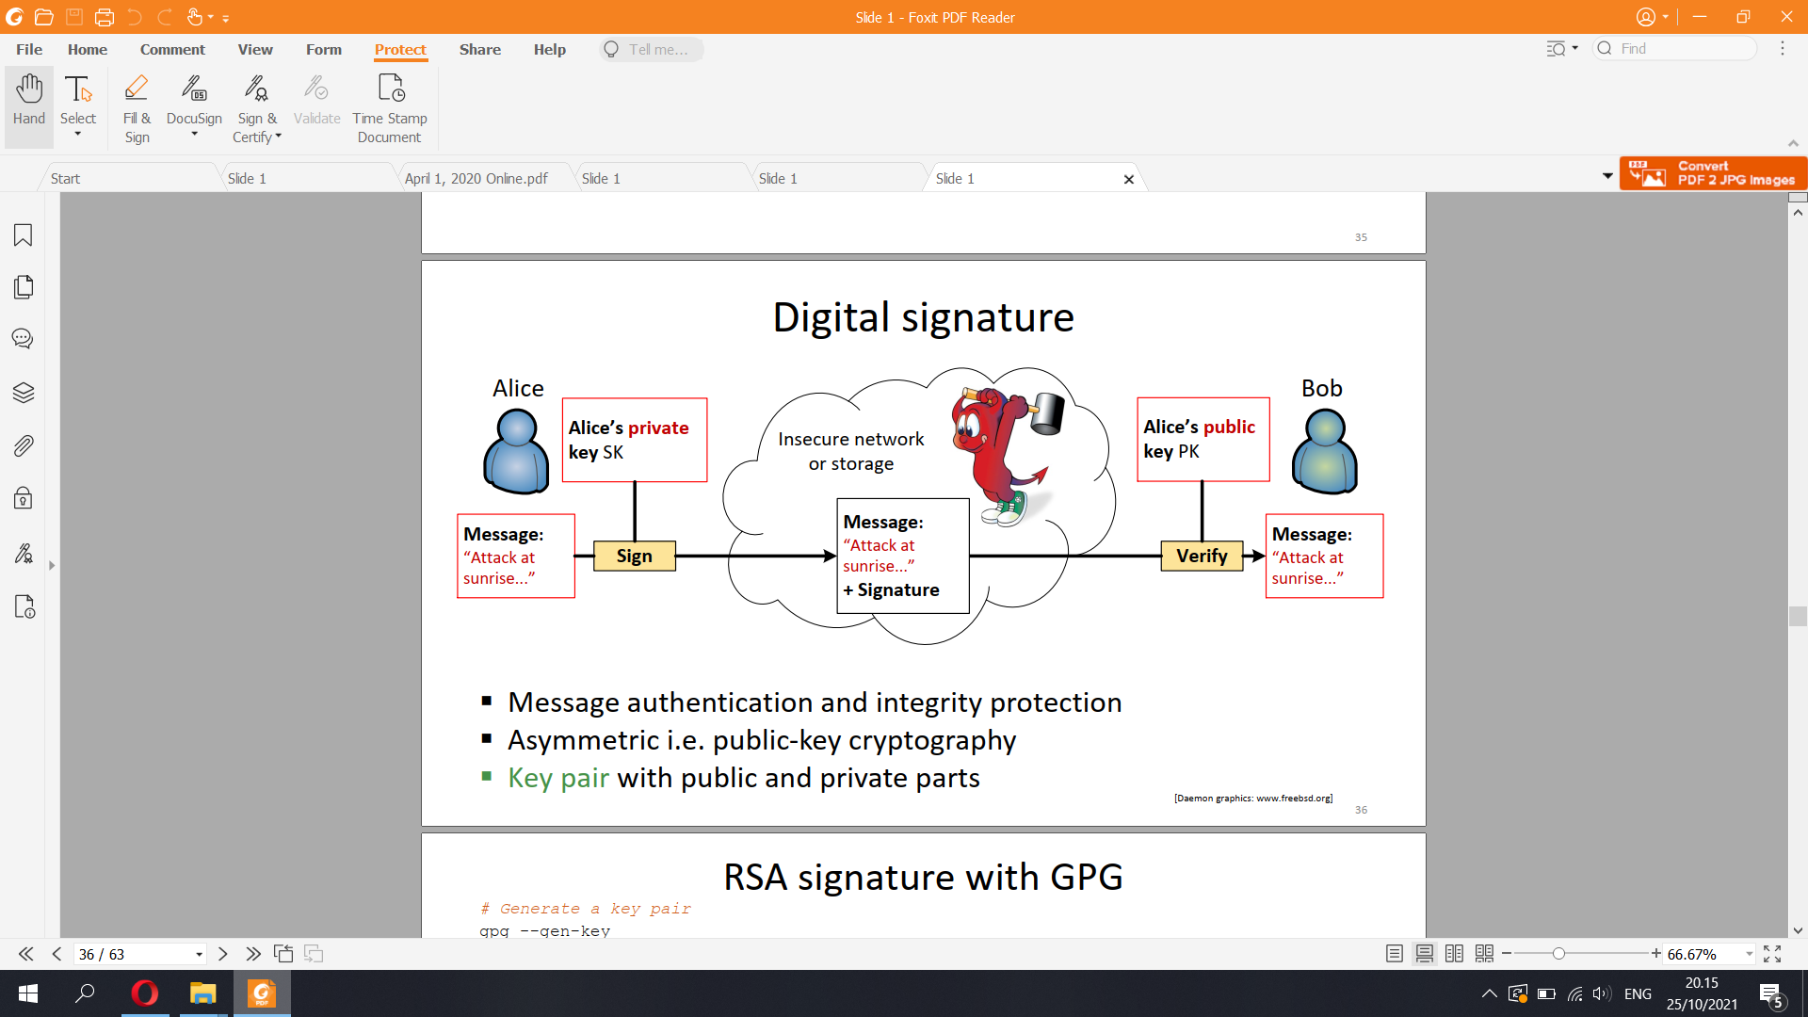

▪ Message authentication and integrity protection

▪ Asymmetric i.e. public-key cryptography

▪ Key pair with public and private parts

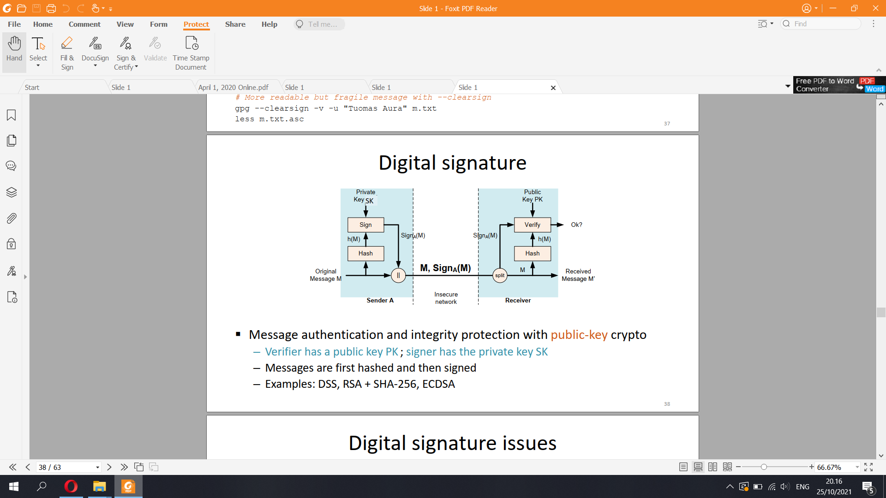

▪ Message authentication and integrity protection with public-key crypto

– Verifier has a public key PK ; signer has the private key SK

– Messages are first hashed and then signed

– Examples: DSS, RSA + SHA-256, ECDSA

Digital signature issues

▪ Always follow strictly the standard when implementing signatures!

There are many subtle points that can go wrong

– Examples: DSA, RSA [PKCS#1]

▪ Signing is not encryption with public key!

– Common misconception because the RSA private key can be used both to

sign and decrypt

▪ Digital signature “with appendix”

– Hash the message, sign the hash

– The signature is usually appended to the actual message but can also be

stored separately

PUBLIC-KEY ENCRYPTION

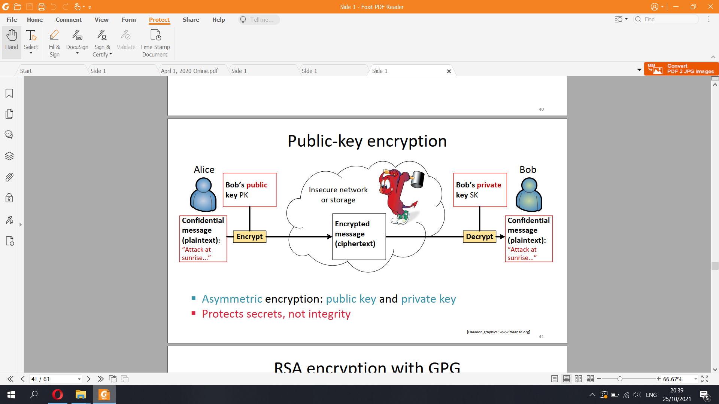

▪ Asymmetric encryption: public key and private key

▪ Protects secrets, not integrity

▪ Message encryption based on asymmetric cryptography

– Key pair: public key and private key

▪ Protects secrets, not integrity

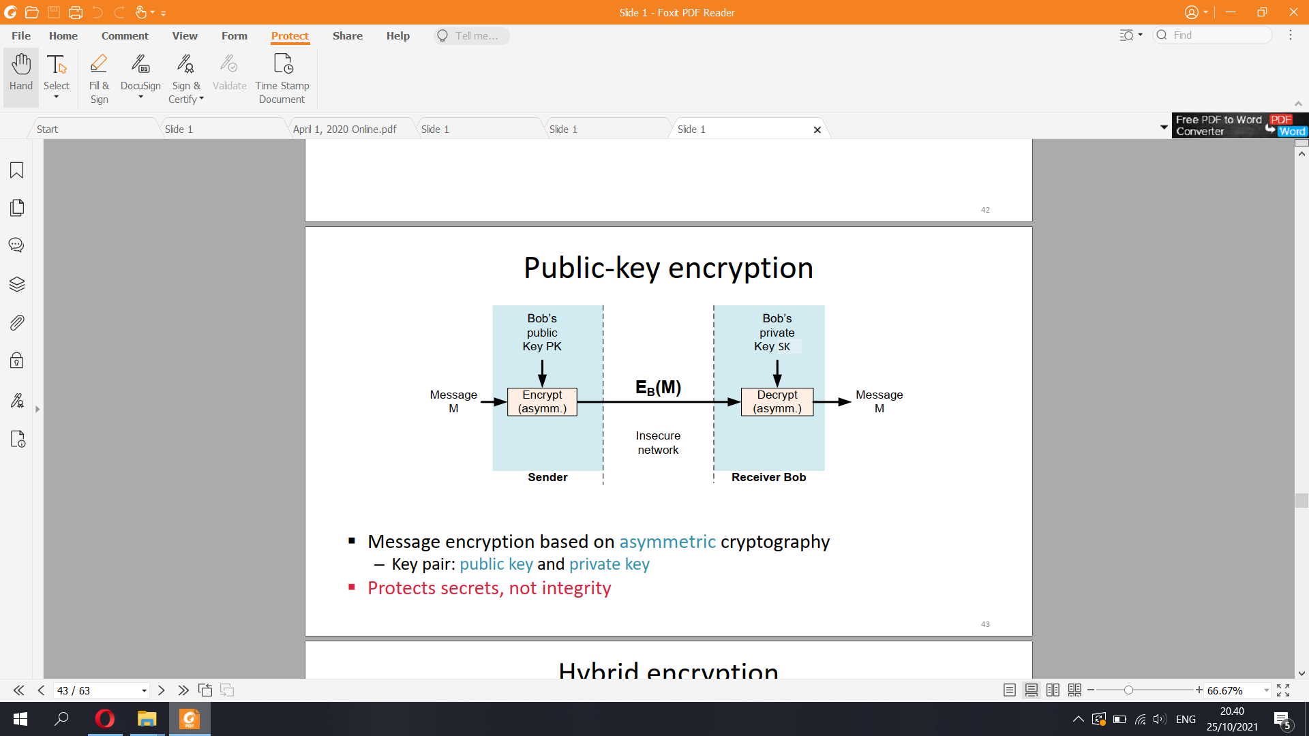

Hybrid encryption

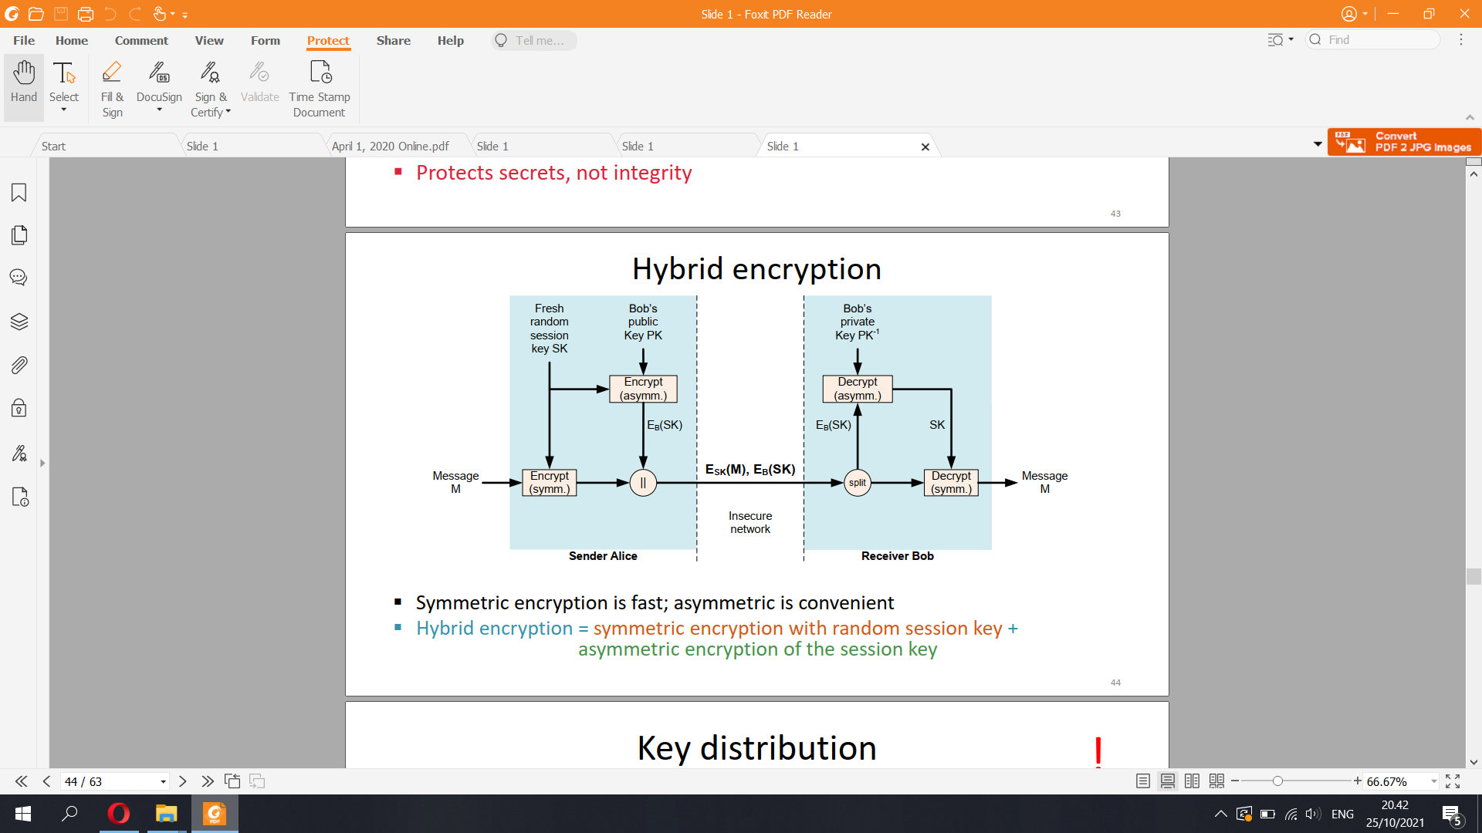

▪ Symmetric encryption is fast; asymmetric is convenient

▪ Hybrid encryption = symmetric encryption with random session key +

asymmetric encryption of the session key

Key distribution

▪ The advantage of public-key cryptography is easier key distribution

▪ Shared secret keys, symmetric cryptography:

– O(N^2) pairwise keys for N participants → does not scale

– Keys must be kept secret → hard to distribute safely

▪ Public-key protocols, asymmetric cryptography:

– N key pairs needed, one for each participant (or 2∙N if different key pairs

for encryption and signature)

– Public keys are public → can be posted on the Internet

Diffie-Hellman key exchange

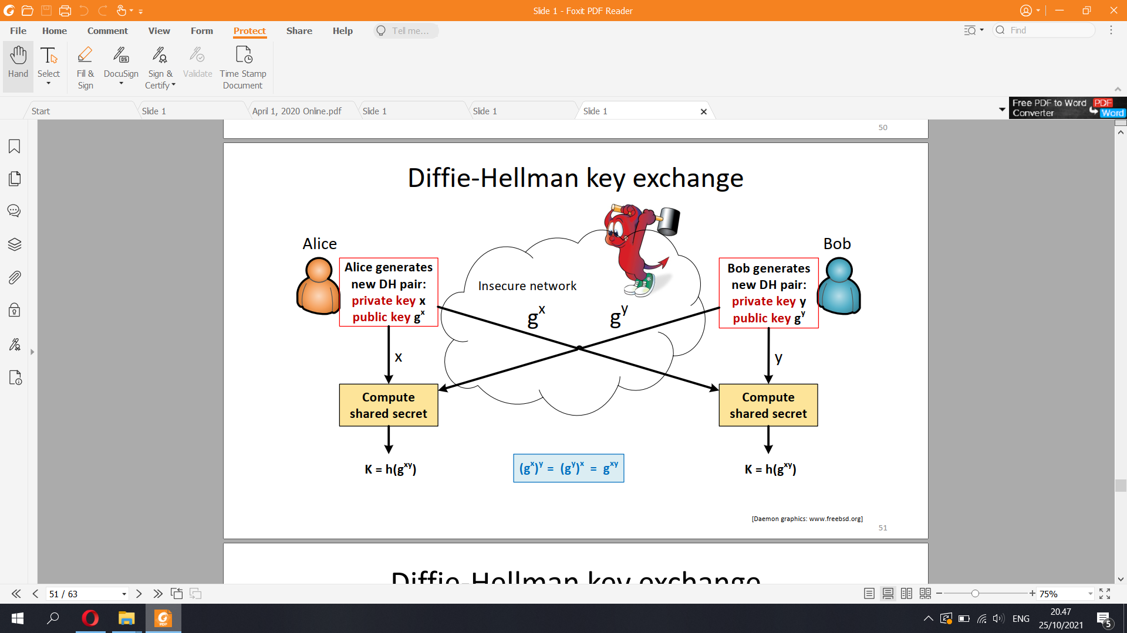

▪ Creating a shared key based on commutative operation, such

as exponentiation modulo p:

(g^x mod p)^y mod p = (g^y mod p)^x mod p

▪ Diffie-Hellman assumption: given g, p, gx and gy, it is infeasible

to solve gxy

– Security depends on the difficulty of the discrete logarithm problem,

i.e. solving x from (gx mod p) when p is large

▪ Elliptic curve Diffie-Hellman uses commutative operations in a

different field

Impersonation attack  
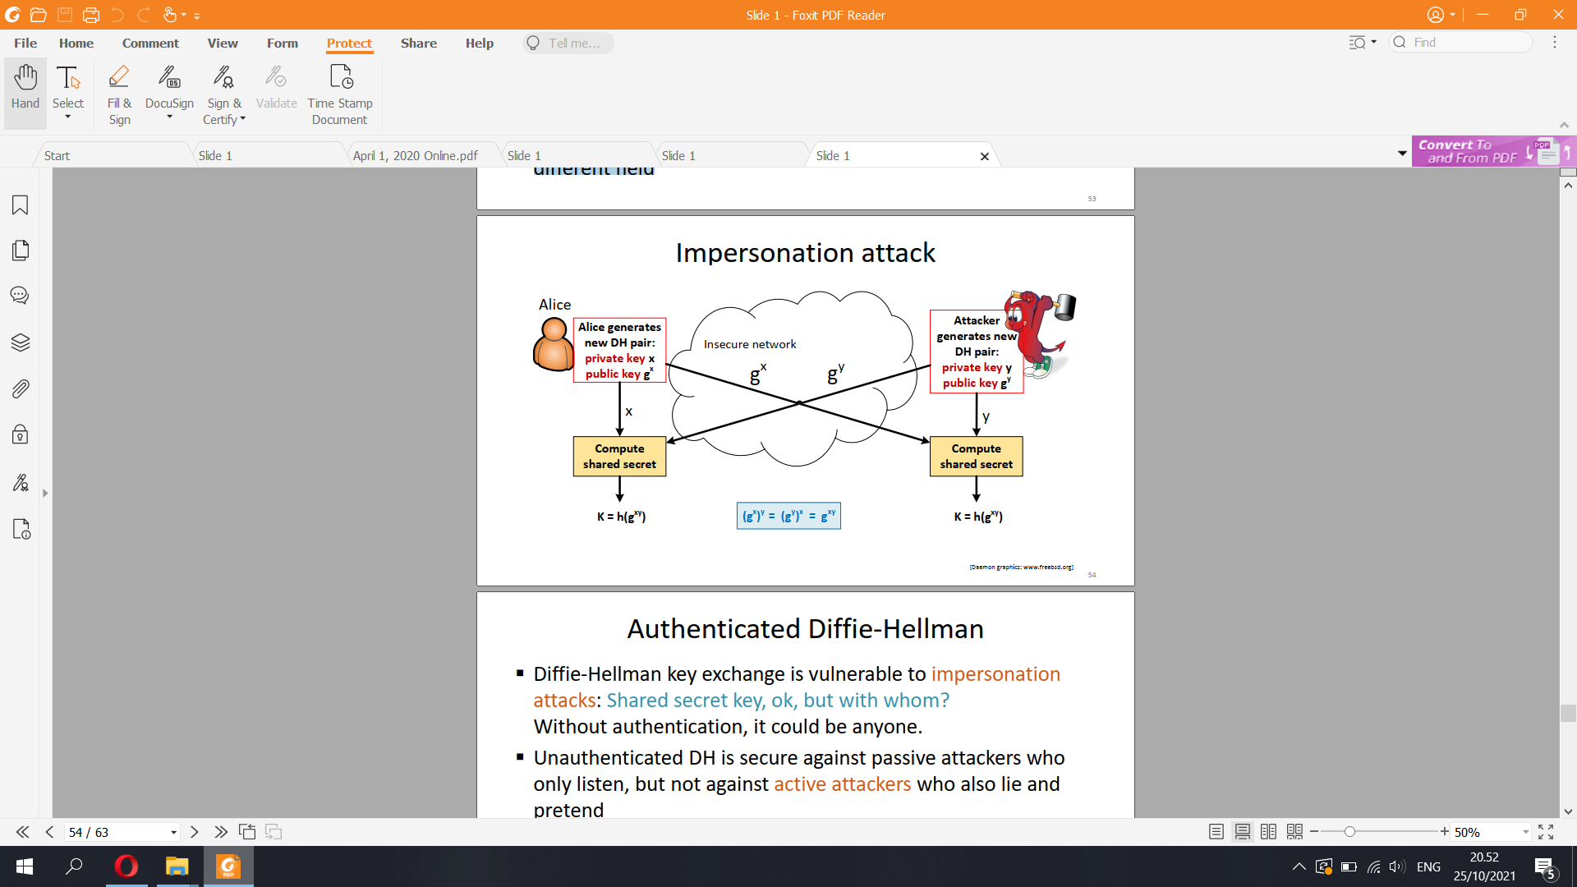

▪ Diffie-Hellman key exchange is vulnerable to impersonation

attacks: Shared secret key, ok, but with whom?

Without authentication, it could be anyone.

▪ Unauthenticated DH is secure against passive attackers who

only listen, but not against active attackers who also lie and

pretend

▪ Solution: authenticate the key-exchange messages

– Sign with public-key signatures

– Compare manually between endpoints

▪ Cryptology viewpoint: requires continuous analysis and improvement

▪ Engineering viewpoint: unbreakable for years if you use strong standard

algorithms and 128..256-bit symmetric keys

– May need to upgrade algorithms every 10 years or so

– Avoid using algorithms in creative ways that are not their original purpose

▪ Weak crypto is worse than no crypto, use strong algorithms and keys

▪ Which algorithms can be trusted?

– Block ciphers have endured relatively well, hash functions require upgrading

– Quantum computers might break public-key cryptography

▪ Almost no absolute proofs of security exist!

57Security vs. cryptography

▪ Cryptography: mathematical methods for encryption and

authentication

▪ In this course, we use cryptography as one building block for

security mechanisms

▪ Remember that cryptography alone does not solve all security

problems:

“Whoever thinks his problem can be solved using cryptography,

doesn’t understand the problem and doesn’t understand

cryptography.”

— attributed to Roger Needham and Butler Lampson

58Message size overhead

▪ Authentication increases the message size:

– MAC or signature is appended to the message

– MAC takes 16–32 bytes

– 4096-bit RSA signature is 512 bytes

– Elliptic-curve signatures (ECDSA) can be 64..128 bytes

▪ Encryption increases the message size:

– In block ciphers, messages are padded to nearest full block

– IV for block cipher takes 8–16 bytes

– 1024-bit RSA encryption of the session key is 128 bytes

▪ Overhead of headers, type tags etc.

▪ Small size increase ok for most applications but can cause problems in some:

– Signing individual IP packets (1500-byte limit on packet size)

– Authenticating small wireless frames

– Encrypting file system sector by sector, but cannot increase sector size by a few bytes to fit in the IV or MAC

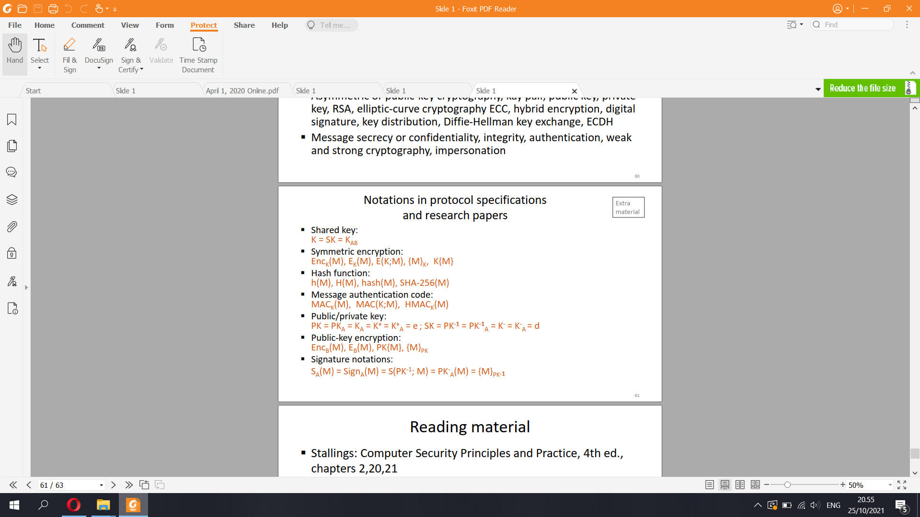

**6) Encrypting stored data**

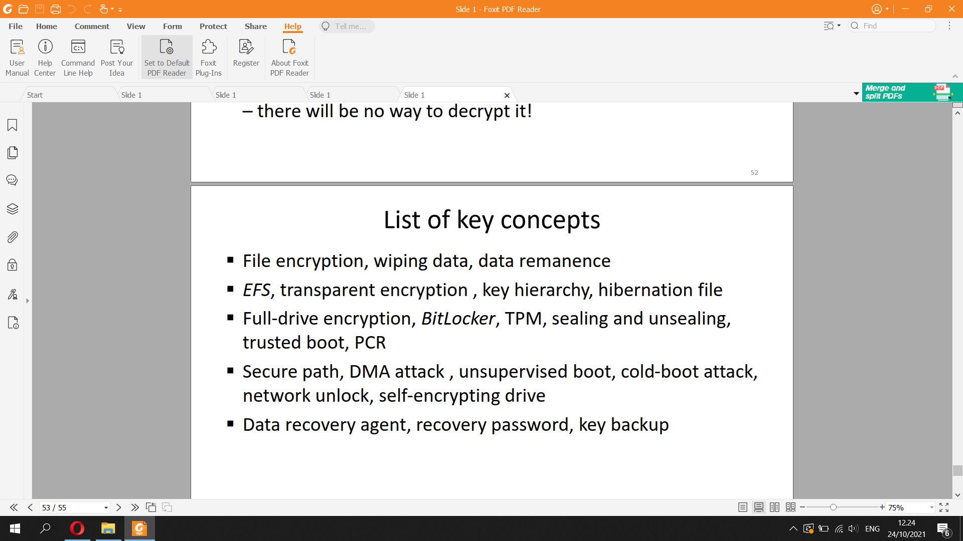

Data encryption

▪ Scenarios:

– lost and stolen notebook computers

– stolen workstations and servers

– decommissioning hard drives

→ Risk of disclosure of confidential data

▪ The obvious solution: encrypt data on drive

3

However, security often conflicts with usability,

reliability and deployability. Also, system design

and implementation may have weaknesses.

Scenarios for data encryption

▪ Lost and stolen laptops

– Contain confidential data and access credentials

▪ Physically compromised servers

– Contain business secrets, customer data and PII

– Unauthorized insiders have physical access

▪ Decommissioned hard drives

– Secure decommissioning is expensive

– Hardware recycling is typically done in the cheapest

and fastest way: no time for secure disk wipe

– Old PCs may be sent abroad for recycling

FILE ENCRYPTIONSimple file encryption

1. User enters

passphrase

2. Passphrase hashed

to produce a key

3. File encrypted with the key

– Symmetric encryption,

e.g. AES in CBC mode

– Integrity check with

HMAC or AES-GCM

▪ Examples: crypt(1), gpg, openssl

Limitations of file encryption

▪ User action needed, and users are lazy

– Automation (scripting) is difficult. How to store passphrase?

▪ Passphrase can be brute-forced

▪ After encryption, what happens to the old plaintext file?

▪ Software creates temporary files and backup copies

– Unencrypted file versions and data fragments may be left on disk

▪ Incompatibility with advanced services:

– Background processing like search indexing

– Cloud storage and sharingDifficulty of deleting files

▪ Deleting a file marks the space free but does not erase data

▪ Overwriting a file does not always erase the old contents

– Unpredictable file system behavior: backups, version history, RAID,

copy on write, journal, bad blocks etc.

– Solid-state disks (SSD) avoid rewriting the same physical blocks

▪ How to reliably delete a file?

Wiping files

▪ Overwriting all free disk space

– Must write pseudorandom data, not just zeros or ones

– Should read and verify after write

– Erases most data, but no 100% guarantee (e.g. SSD overprovisioning

can hide up to 20% capacity)

– Magnetic data remanence on magnetic media

▪ Physical destruction

– Heating magnetic medium above its Curie temperature

– Grinding SSD or disks to fine powder

SSD overprovisioning example

▪ Filling the disk does not overwrite all blocks

▪ Must use built-in secure erase function

10ENCRYPTING FILE SYSTEMWindows encrypting file system (EFS)

▪ Encryption is a file attribute

in NTFS

▪ Enable encryption for a

folder → new files

encrypted from start

▪ Files can be read when the

user is logged in

▪ Encryption and decryption

are transparent to

applications

NTFS (New Technology File System)[1] is a proprietary journaling file system developed by Microsoft

The Encrypting File System (EFS) on Microsoft Windows is a feature introduced in version 3.0 of NTFS[1] that provides filesystem-level encryption. The technology enables files to be transparently encrypted to protect confidential data from attackers with physical access to the computer.

EFS limitations: partial protection

▪ Encrypts contents of specific files and folders

▪ Some data is not encrypted:

– Folder and file names

– EFS-unaware software may create backup copies, temp files

– Registry, system files and logs cannot be encrypted

– Page file can be encrypted but requires policy configuration

– Search index, if you has chosen to index the encrypted files

▪ When encrypting plaintext files, the original file is not wiped:

always create files in an encrypted folder

▪ Hibernation file may store decryption keys: disable hibernation

▪ EFS only on NTFS and FAT; files copied elsewhere are decrypted

15EFS limitations: attacks

▪ Requires strong passwords; otherwise, the password could be

cracked from the password hash stored on the disk

▪ Key logger or hidden camera can capture user password

▪ Malware can steal EFS data when the user is logged in

▪ Attacker with physical access to the computer or its hard disk

can compromise the OS and install a root kit or key logger.

Easiest to configure a malicious data recovery agent (DRA)

Which attacks apply to lost or stolen laptops?EFS and password cracking

▪ EFS security depends on the secrecy of the user password

▪ Password are vulnerable to brute-force cracking

– Password hashes are stored in a database (SAM) on the disk

– Windows NT and LM hashes are fast to compute and use no salt

– Attacker can extract the password hashes

▪ Why is it not sufficient to reset user or admin password?

▪ EFS supports smart cards as a login method

▪ Q: Do EFS and Windows Hello work together?EFS limitations: usability

▪ User must understand what data is encrypted and when

▪ Non-domain users must backup EFS keys or risk data loss

▪ User password needed for decryption

– OS cannot index files when user logs out

– Backups contain encrypted files (do keep your old EFS keys backup!)

– Password reset by admin or special tools may lead to loss of data

▪ Transparent decryption can cause surprises

– Files copied to online storage and other media are decrypted

– Files copied to USB stick (FAT) are converted by default to an encrypted

PFILE, which cannot be opened in another computer

18FULL DISK ENCRYPTION: BITLOCKER

19Full disk encryption

▪ Entire disk is encrypted: protects all information

▪ Usually, user must provide password, key, or physical token at boot

time or to mount the disk; thereafter transparent encryption

▪ Software vs hardware based solutions:

– Security of entirely software-based products depends on the strength of

the password or key

– Tamper-proof hardware prevents brute-force cracking and allows

the use of a short PIN

▪ The main innovation in BitLocker was to use tamper-proof

hardware for unsupervised boot

20Trusted platform module

▪ Trusted platform module (TPM) is a

smart-card-like tamperproof module on

the motherboard or integrated in the CPU

▪ Stores cryptographic keys

– Protects keys against both software and hardware attacks

– Key cannot be stolen, but can it be misused?

▪ Accumulates platform measureme

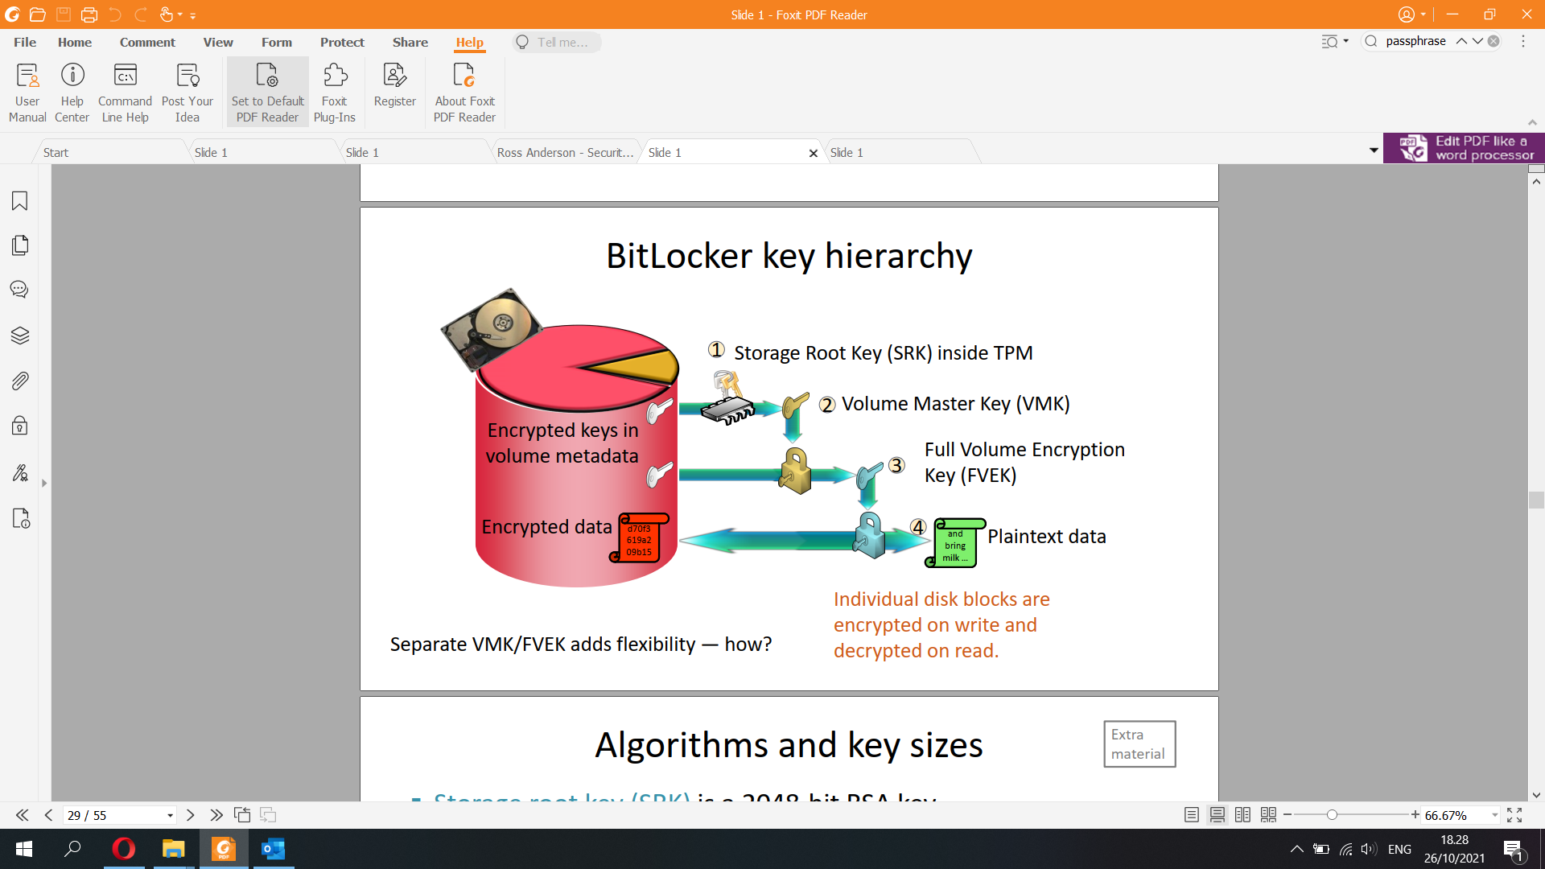

The storage root key is embedded in the Trusted Platform Module (TPM) security hardware. It is used to protect TPM keys created by applications, so that these keys cannot be used without the TPM.

Unlike the endorsement key (which is generally created when the TPM is manufactured), the storage root key is created when you take ownership of the TPM. This means that if you clear the TPM and a new user takes ownership, a new storage root key is created.

Key Protector (KP) (TPM or numerical password)

Volume Master Key (VMK) (encrypted by a key protector and stored on-disk)  
Full Volume Encryption Key (FVEK) (used to encrypt raw data; encrypted by the volume master key and stored on-disk)

BitLocker modes

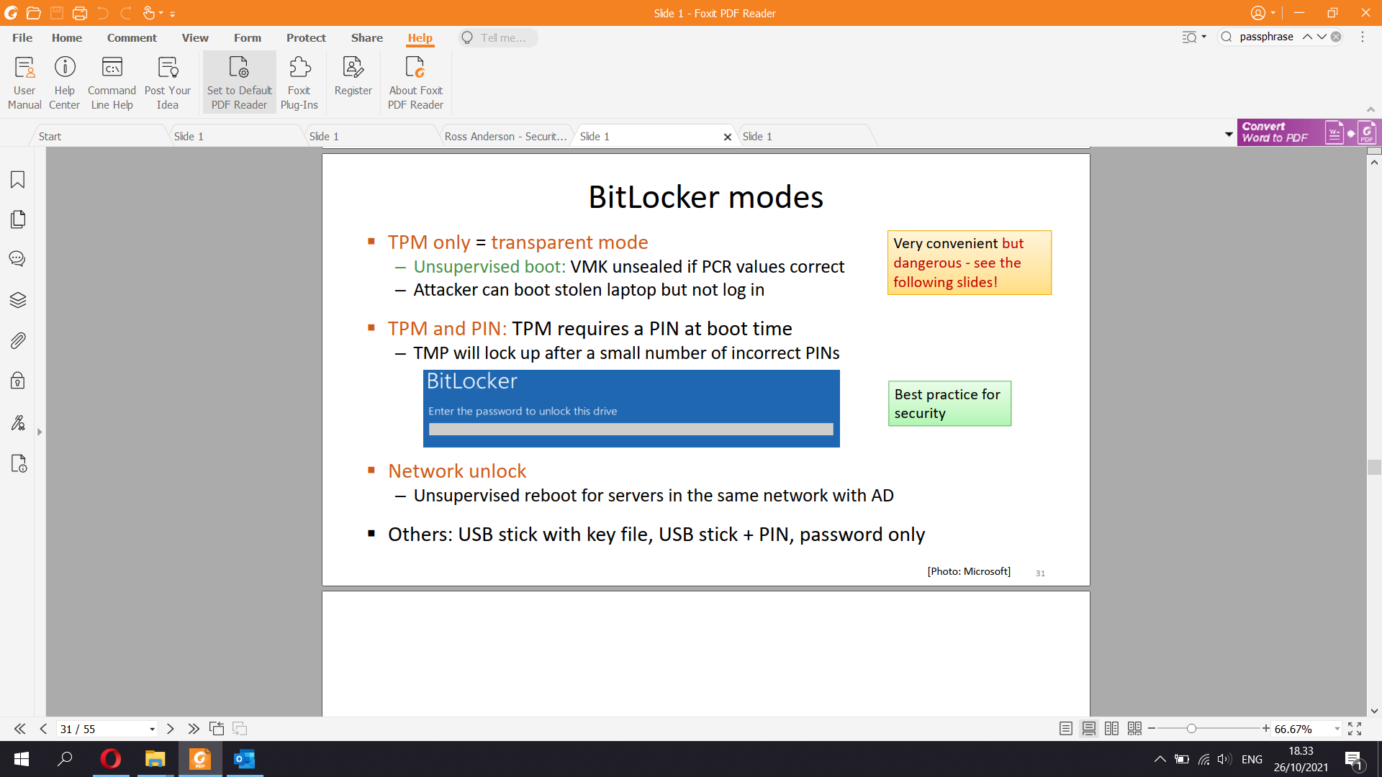

Secure path issues

▪ Hacked hardware can intercept PIN input to TPM

– Hardware key logger, modified keyboard, modified BIOS. Hardware keyloggers are used for keystroke logging, a method of capturing and recording computer users' keystrokes, including sensitive passwords.[1] They can be implemented via BIOS-level firmware, or alternatively, via a device plugged inline between a computer keyboard and a computer. They log all keyboard activity to their internal memory.

– Attacker must have access to the computer twice: first to install the

hardware, then to recover the captured PIN/key

→ Lost and stolen computers are safe because the hacker needs the user to type the PIN, which is not the case as it has already been stolen

▪ Malware could fake the reboot process and ask for the PIN

– Could also steal BitLocker keys from a USB stick

▪ Hidden camera can also capture the PIN

DMA attack

▪ Direct memory access (DMA) enables auxiliary devices to access

main memory directly

– FireWire, PCIe (also Thunderbolt, M.2, ExpressCard) busses

– Hot-pluggable helps attacker

▪ DMA memory dump attack: Attacker connects malicious device to a

DMA port, reads the memory, and recovers the key (FVEK)

▪ Windows 10 disables hot-pluggable PCIe ports when

the screen locked

[Photos: Wikimedia, notebookreview.com] 34Hardware security issues

▪ Communication between the TPM and CPU is vulnerable

– If TPM is on discrete chip, attacker can tap the bus to it. Breaks

security of the TPM-only mode by sniffing the VMK

– Some TPMs are on a separate PCB, making the attack easy [link]

▪ The TPM itself must be secure

– Infineon TPMs had a key-generation bug in 2017 that required

firmware update and generation of a new storage root key [link]

– Sleep mode implementation flaws allow overwriting of PRC values,

which allows attacker to unseal VMK in TPM-only mode [link, link]

35Cold boot attack

▪ Data remanence in main memory:

– After power loss, DRAM memory contents decay in seconds

▪ Cold boot attack (reset attack)

– Reboot into a minimal hacker OS from USB stick

– Rebooting cuts the power only for a fraction of a second

– When power is back, memory contents do not decay any further

– Secret keys can be recovered from memory (possibly with some bit errors)

36

!

Measurements with GDDR2

[Michael Gruhn, Tilo Müller:

On the Practicability of Cold

Boot Attacks, ARES 2013]Cold boot attack: consequences

▪ Attacker with physical access to a running computer

– can break software-based full-disk encryption

– can bypass most OS access controls

▪ Sleeping laptop = running laptop

– Lost and stolen laptops are vulnerable if in sleep mode

▪ BitLocker in TPM-only mode is vulnerable even if

powered down or hibernating

– Attacker can boot it up and then do the

cold-boot attack

37

!Mitigation of cold-boot attacks (1)

Best protection: never given attacker access to a running computer

▪ Disable sleep on the computer, shut down or hibernate instead

▪ Do not leave computer running unsupervised

▪ Set BitLocker to a supervised boot mode (TPM+PIN, TPM+USB)

Weaker protection:

▪ Password-protect BIOS or UEFI and disable USB boot

▪ BitLocker network unlock for non-mobile domain

computers

▪ UEFI secure boot: only allow certified OS loaders

38Mitigation of cold-boot attacks (2)

OS and hardware solutions:

▪ Overwrite memory before reboot (easy to circumvent)

▪ Memory Overwrite Request Control (MOR): UEFI cleans the

memory after reboot

▪ Encrypted main memory in Xbox

▪ Self-encrypting drive: encryption on the disk drive itself;

keys are only briefly in main memory

39Self-encrypting drive

Authentication Key:

sent to the drive, decrypts

the Data Encryption Key

Data Encryption Key (DEK)

never leaves the drive

Encrypted DEK

on the drive

and

bring

milk …

3 4

Plaintext

data

d70f3

619a2

09b15

Encrypted

data

1

Obtain the Authentication Key

e.g. unseal with TPM

2

Performance: offload the

data encryption and

decryption (AES) to

hardware on the drive

Security: mitigates coldboot and DMA

vulnerabilities because

keys are only briefly in the

main memory during boot

-

Encryption built into disk hardware/firmware

Microsoft Encrypted Hard Drive = eDrive = TCG Opal

Attacker could capture

keys on the PCIe/SATA/

SCSI bus during transfer

BitLocker and unsupervised OS update

▪ During software update that requires reboot, BitLocker is

suspended: decryption keys are stored on disk

– Any update script can suspend BitLocker:

▪ Consequence: stolen computer is vulnerable if sleeping or allows

unsupervised boot (TMP only mode)

– Attacker can wait for a software update that reboots the computer,

interrupt the boot process, and recover VMK from the disk

– Attacker may even be able to go to the recovery console

▪ Solution would be to only allow supervised reboot

41

> Suspend-BitLocker -MountPoint "C:" -RebootCount 1So, is BitLocker at all secure?

Current situation seems still this:

▪ If the computer is powered down (or hibernating) and

BitLocker requires supervised boot (TPM+PIN or TPM+USB key), then it is

safe

– Possible to boot up unsupervised, protect data drive D: with TPM+PIN

▪ Running computer, or one that allows unsupervised boot (TPM only), is

vulnerable if the attacker has physical access to it

– Because the keys are in the memory

▪ Firmware and software updates are sometimes needed

to fix implementation flaws

▪ Malware can steak the secrets when the computer is in use

**7) Security Protocols**

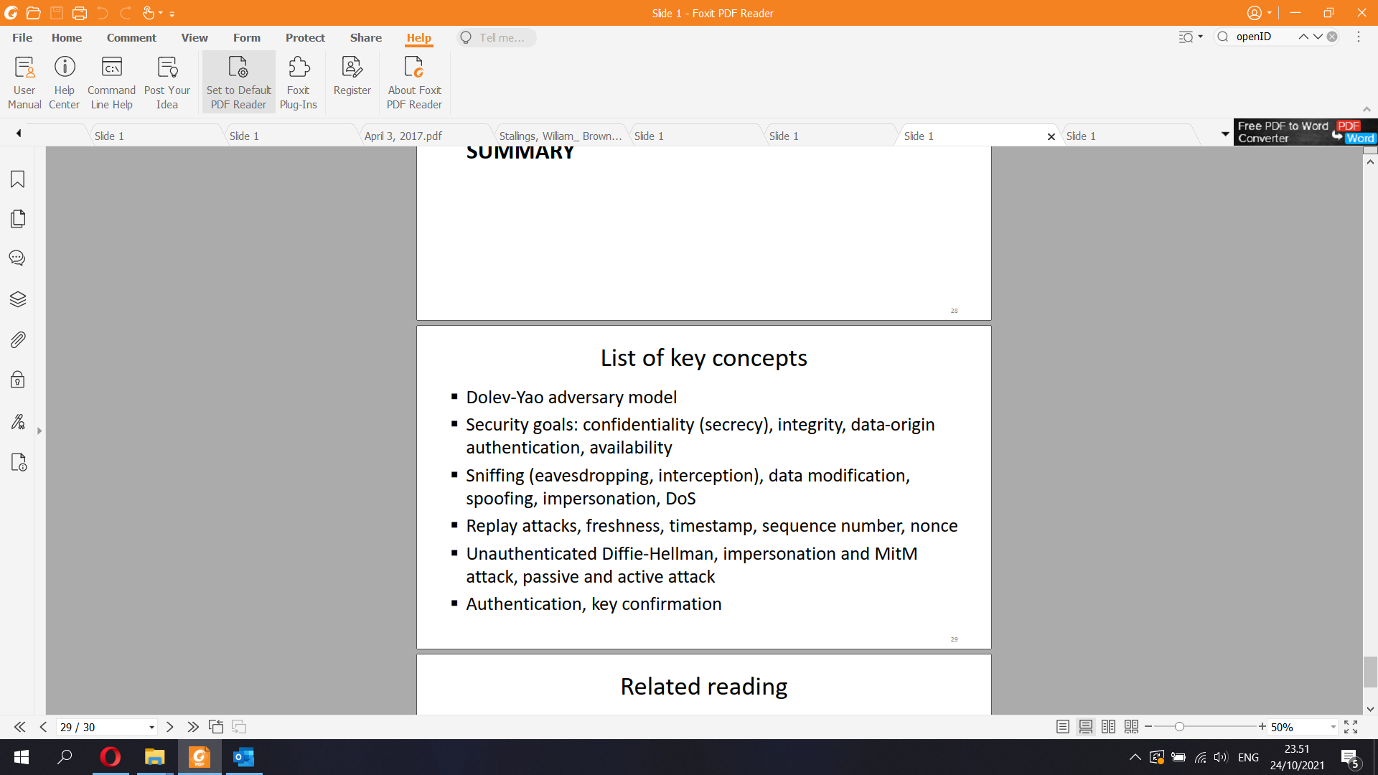

Dolev-Yao adversary model:

▪ Endpoints are trusted; network is the attacker

▪ The network may deliver, delete, modify, and send

fake messages

Network security goals

▪ Data confidentiality: secrets only revealed to intended parties

▪ Data integrity: receiver can detect data modification

▪ Data-origin authentication: receiver verifies who sent the data

▪ Data and service availability: communication successful

▪ Questions:

– Can there be confidentiality without authentication, or authentication without secrets?

– Can there be integrity without authentication, or authentication without integrity?

– Can availability be achieved in the Dolev-Yao adversary model?

5Basic attack types

▪ Data confidentiality

↔ sniffing = eavesdropping = interception = spying

▪ Data integrity

↔ unauthorized data modification = tampering

▪ Data-origin authentication

↔ spoofing or impersonation

▪ Data and service availability

↔ denial of service (DoS)

A replay attack (also known as playback attack) is a form of network attack in which valid data transmission is maliciously or fraudulently repeated or delayed.[1] This is carried out either by the originator or by an adversary who intercepts the data and re-transmits it, possibly as part of a spoofing attack by IP packet substitution. This is one of the lower-tier versions of a man-in-the-middle attack. Replay attacks are usually passive in nature

▪ Replay attack: attacker records the message and resends later

U → D: Command, HMAC(K; Command)

C → D: Command, HMAC(K; Command)

▪ Sequence number prevents replays

– Receiver checks that the number increases and never repeats

In cryptography, a nonce (number once) is an arbitrary number that can be used just once in a cryptographic communication.[1] It is often a random or pseudo-random number issued in an authentication protocol to ensure that old communications cannot be reused in replay attacks

Unauthenticated Diffie-Hellman

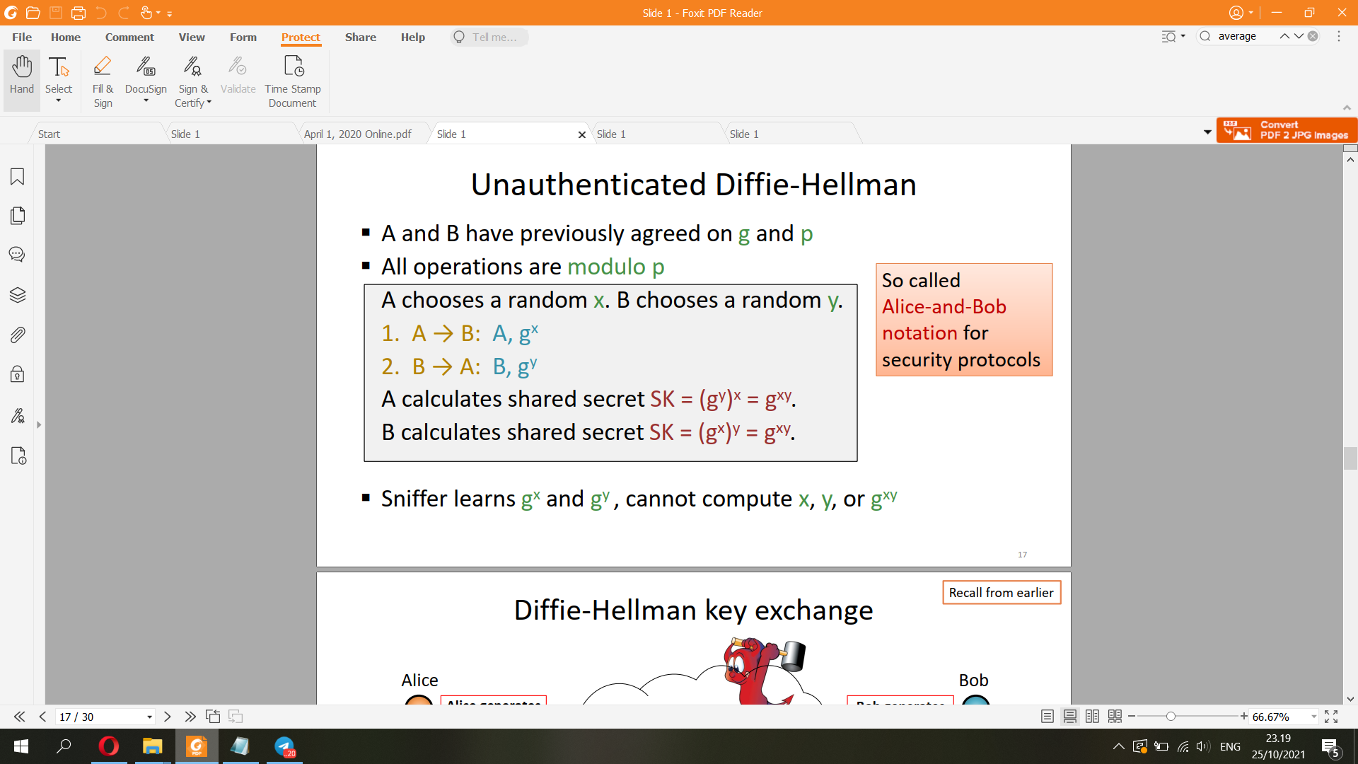

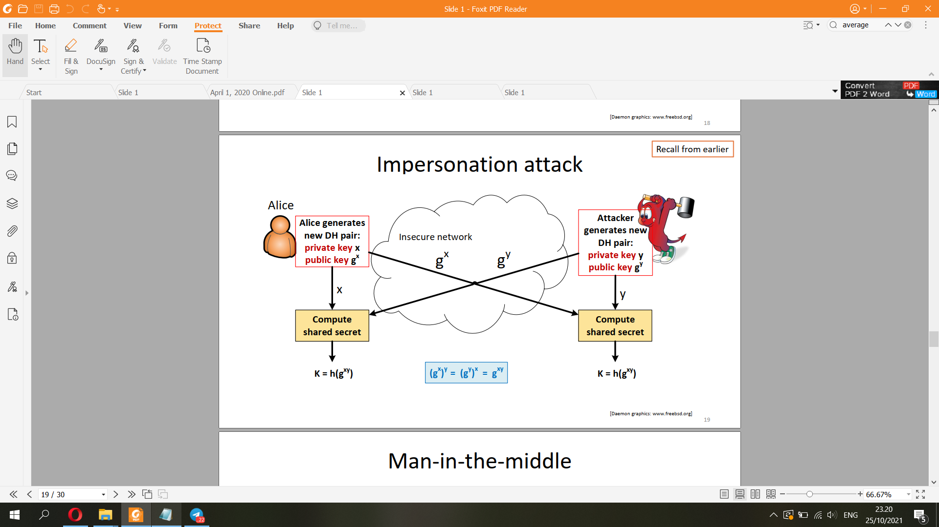

Man-in-the-middle

▪ Unauthenticated Diffie-Hellman is secure against passive sniffing

but insecure against active attackers

=> Authenticated Diffie-Hellman/

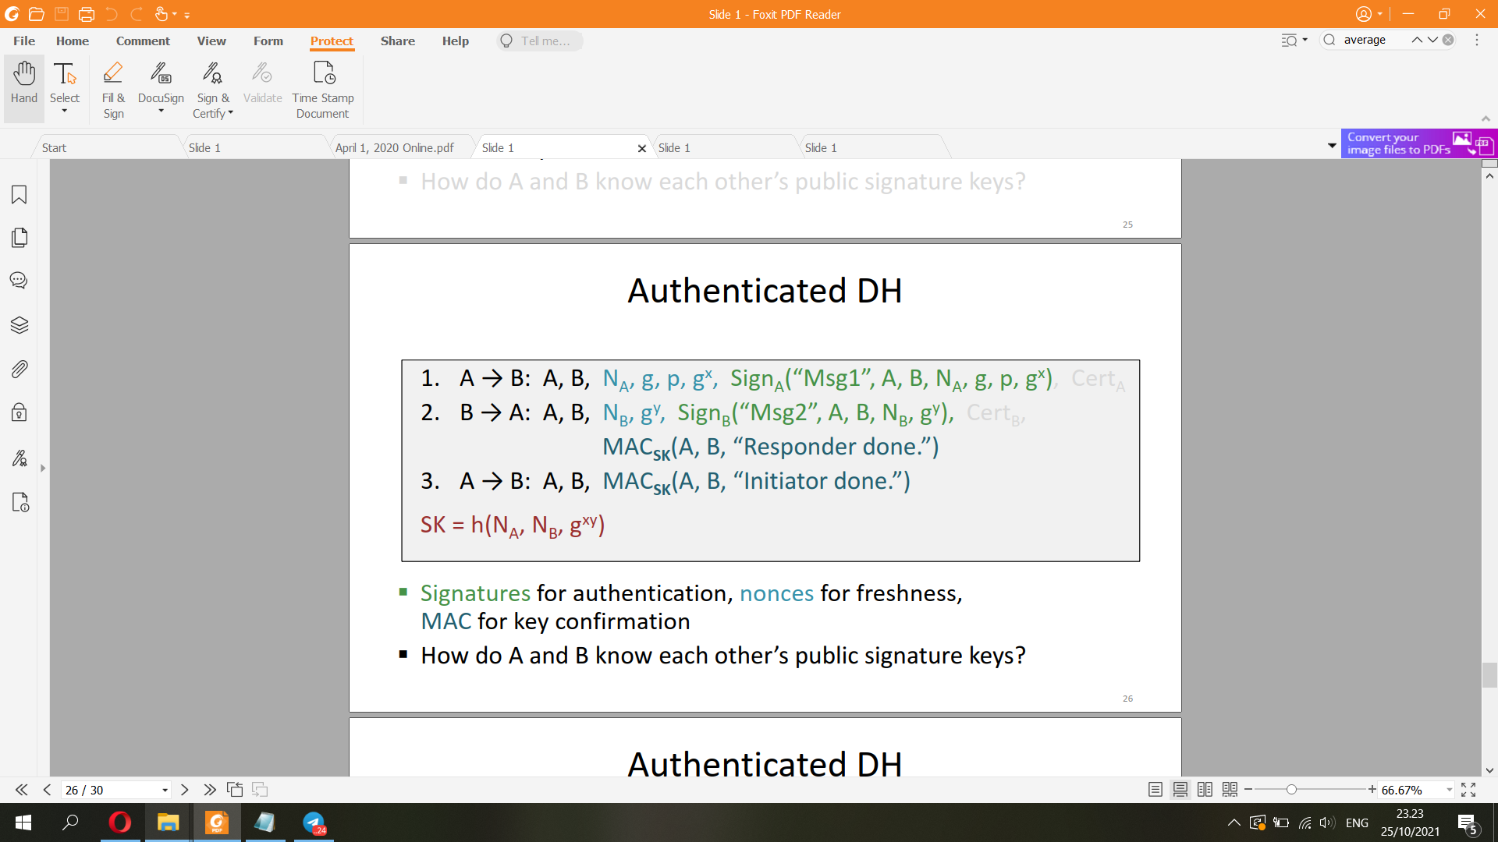

**8) Public Key Infrastructure (PKI) & Transport Layer Security (TLS)**

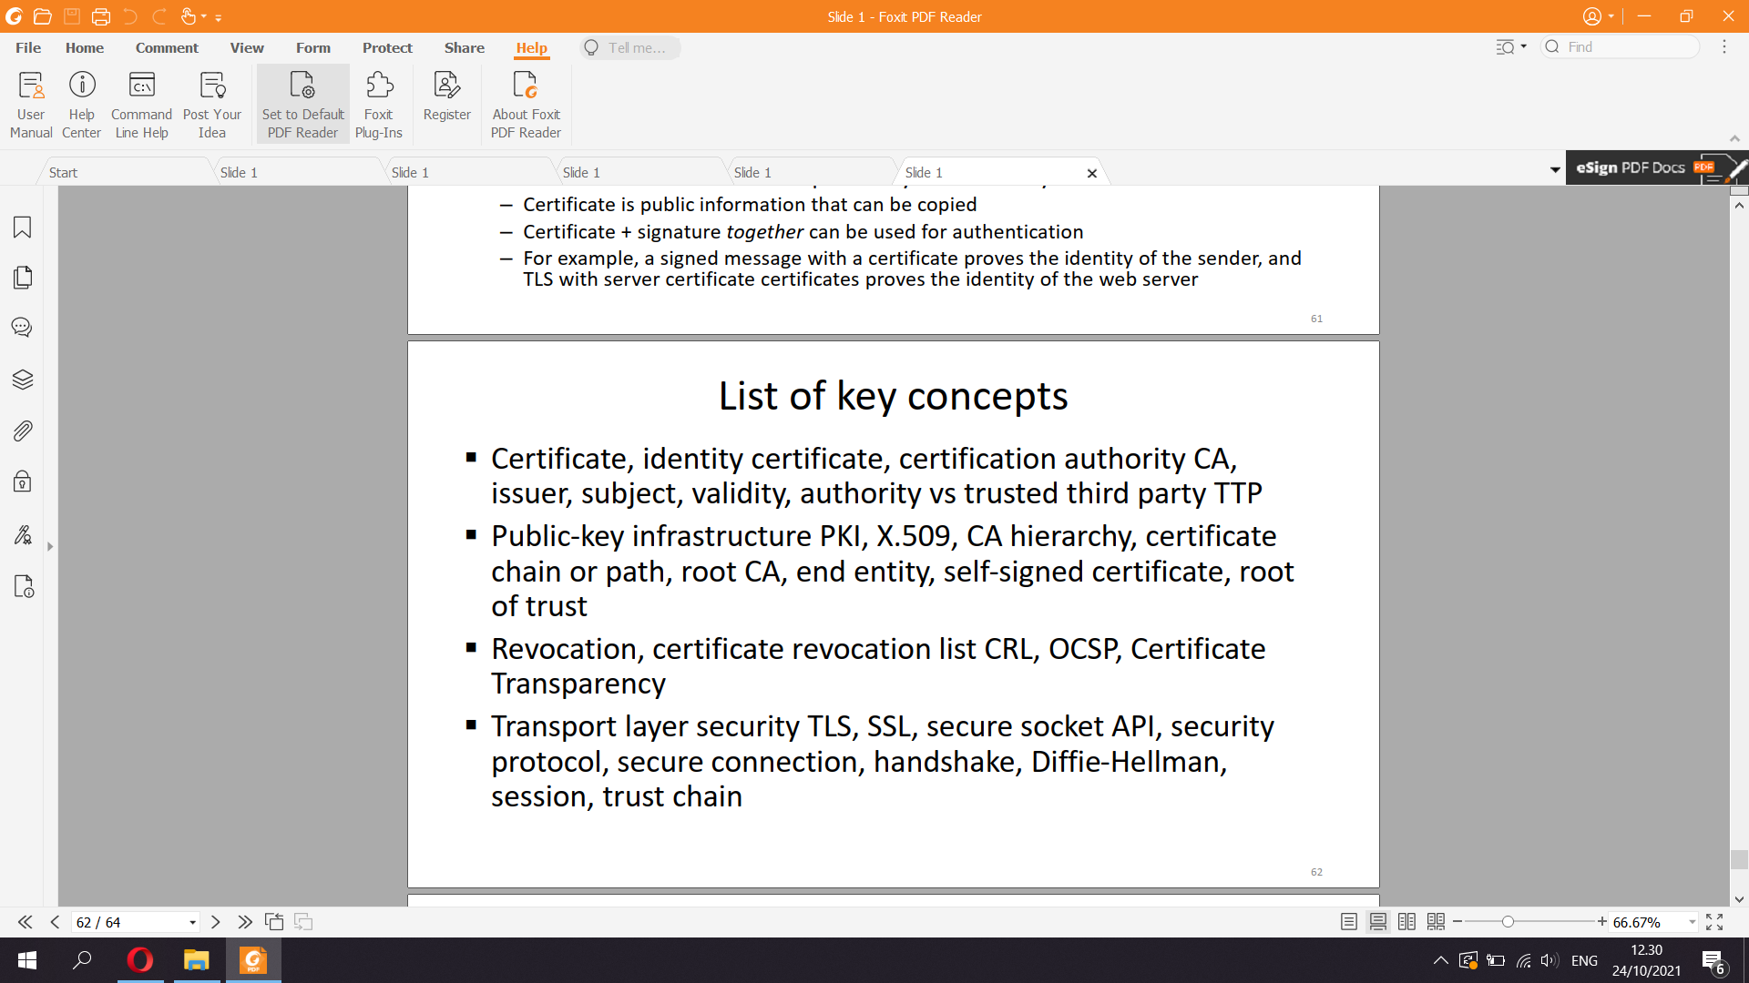

A public key infrastructure (PKI) is a set of roles, policies, hardware, software and procedures needed to create, manage, distribute, use, store and revoke digital certificates and manage public-key encryption. The purpose of a PKI is to facilitate the secure electronic transfer of information for a range of network activities such as e-commerce, internet banking and confidential email

X.509 CERTIFICATES

In cryptography, X.509 is an International Telecommunication Union (ITU) standard defining the format of public key certificates.[1] X.509 certificates are used in many Internet protocols, including TLS/SSL, which is the basis for HTTPS,[2] the secure protocol for browsing the web. They are also used in offline applications, like electronic signatures.

Key distribution problem

▪ How to find out someone’s authentic public key?

▪ Solution: an authority issues identity certificates that bind public keys to names

▪ Certificate is a message signed by the issuer, containing the subject’s name (or identifier) and the subject’s public key

Certificate = SIGNissuer (Name, PKsubject, validity_period)

- Symmetric-key algorithms[a] are algorithms for cryptography that use the same cryptographic keys for both the encryption of plaintext and the decryption of ciphertext. The keys may be identical, or there may be a simple transformation to go between the two keys.[1] The keys, in practice, represent a shared secret between two or more parties that can be used to maintain a private information link.

- In symmetric key cryptography, both parties must possess a secret key which they must exchange prior to using any encryption. Distribution of secret keys has been problematic until recently, because it involved face-to-face meeting, use of a trusted courier, or sending the key through an existing encryption channel. The first two are often impractical and always unsafe, while the third depends on the security of a previous key exchange.

- In public key cryptography, the key distribution of public keys is done through public key servers. When a person creates a key-pair, they keep one key private and the other, known as the public-key, is uploaded to a server where it can be accessed by anyone to send the user a private, encrypted, message…

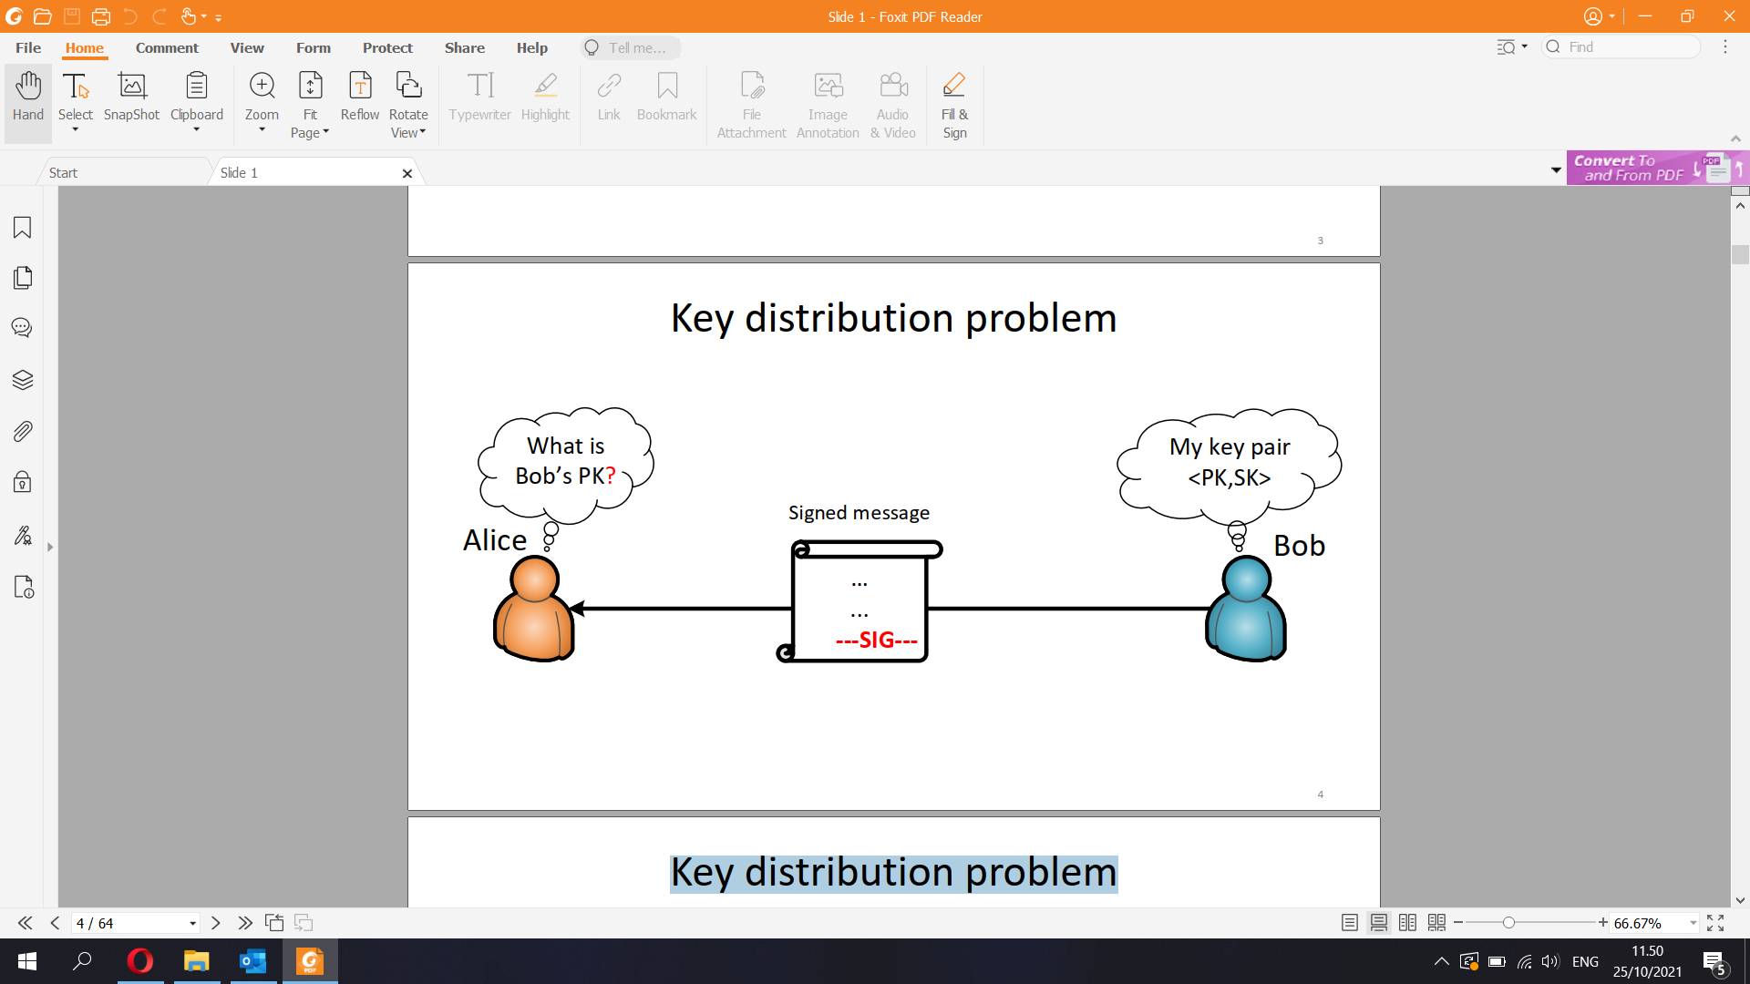

▪ Who would the issue the certificates?

The issuer is typically called certification authority (CA)

▪ Is it an authority or a trusted third party (TTP)?

▪ Will everyone trust/obey the same authority?

▪ CA public key is needed for verifying the certificates.

How does everyone know it?

- X.509 PKI

▪ Public-key infrastructure (PKI):

– ITU-T/ISO X.509 standard, IETF RFC 5280

▪ X.509 certificates are identity certificates: they bind a principal name to a public key

▪ Certification authority (CA) issues certificates

▪ Users, computers and services are end entities

▪ CAs and end entities are both principals

– Each principal has a key pair (public and private signature key)

▪ CA can delegate its authority by issuing a CA

certificate → CA hierarchy

- X.509 CA hierarchy

▪ One root CA

▪ Each CA can delegate

its authority to sub-CAs

▪ All end-entities trust all

CAs to be honest and

Competent

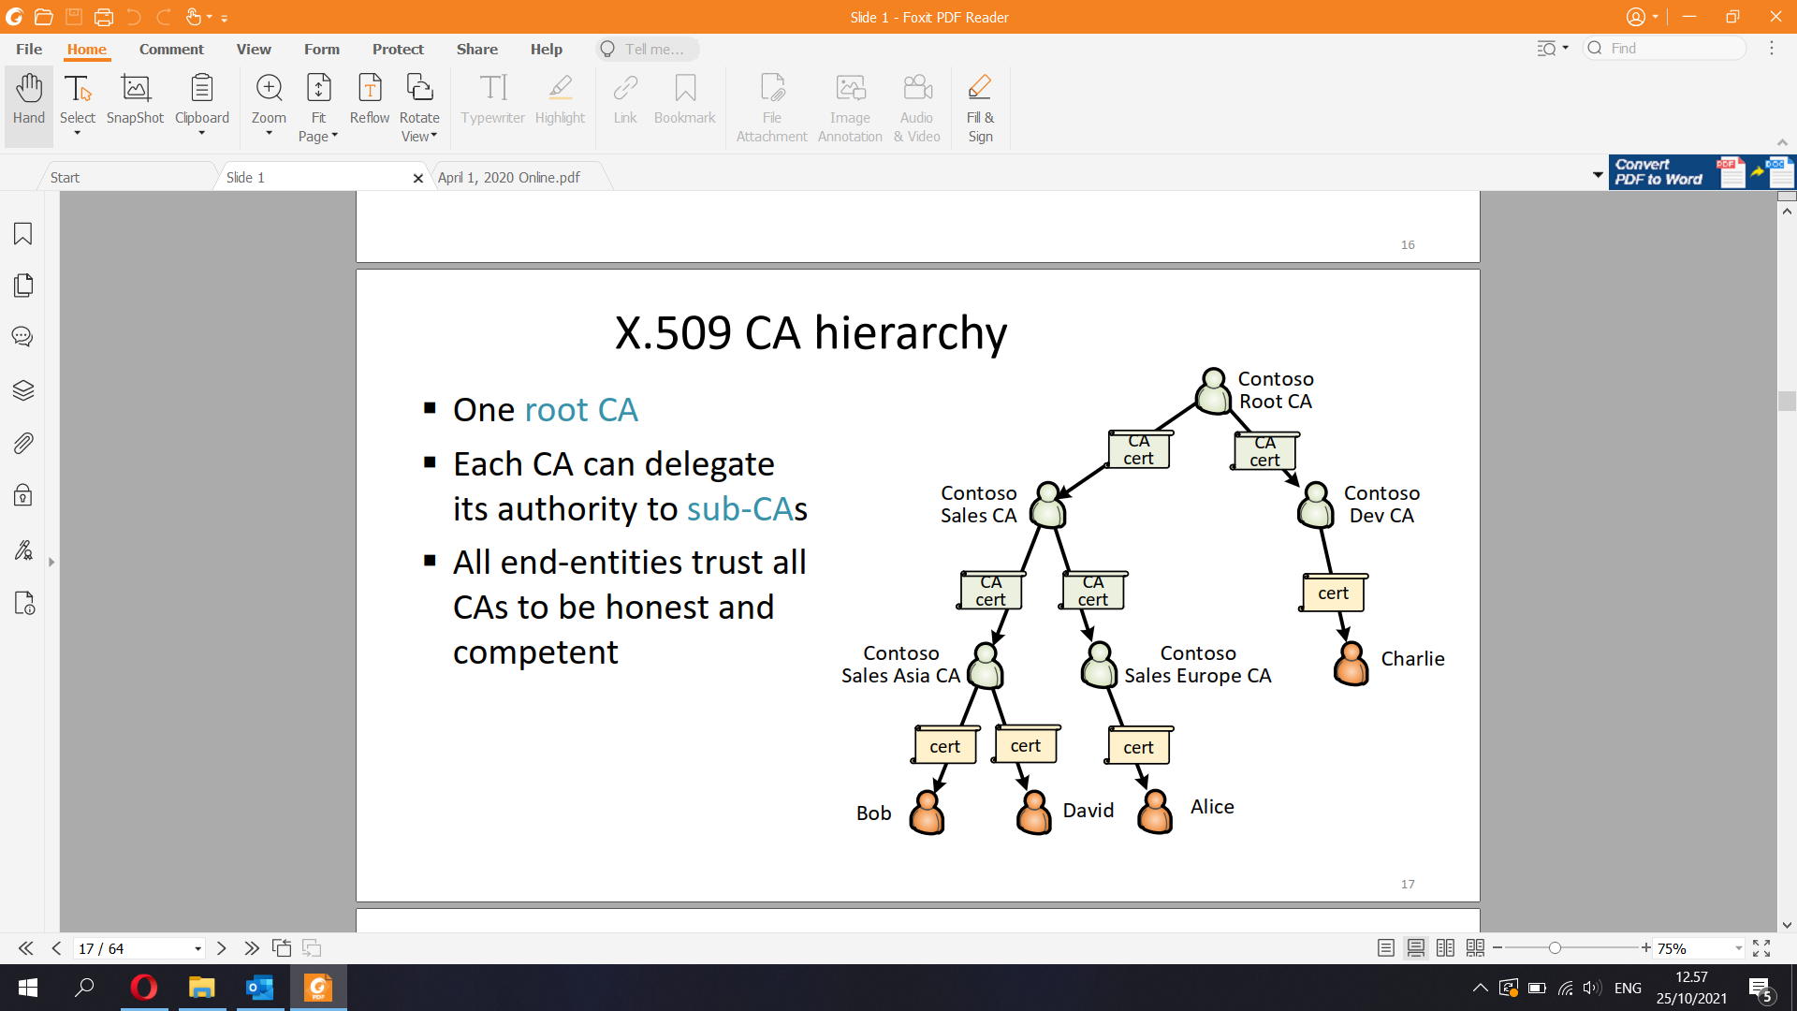

Certificate chain

▪ Alice’s certificate chain (or path):

– Root CA public key

– 2 CA certificates for sub-CAs

– Alice’s end-entity certificate

▪ Root of trust:

– everyone knows and

trusts the root CA’s

public key  
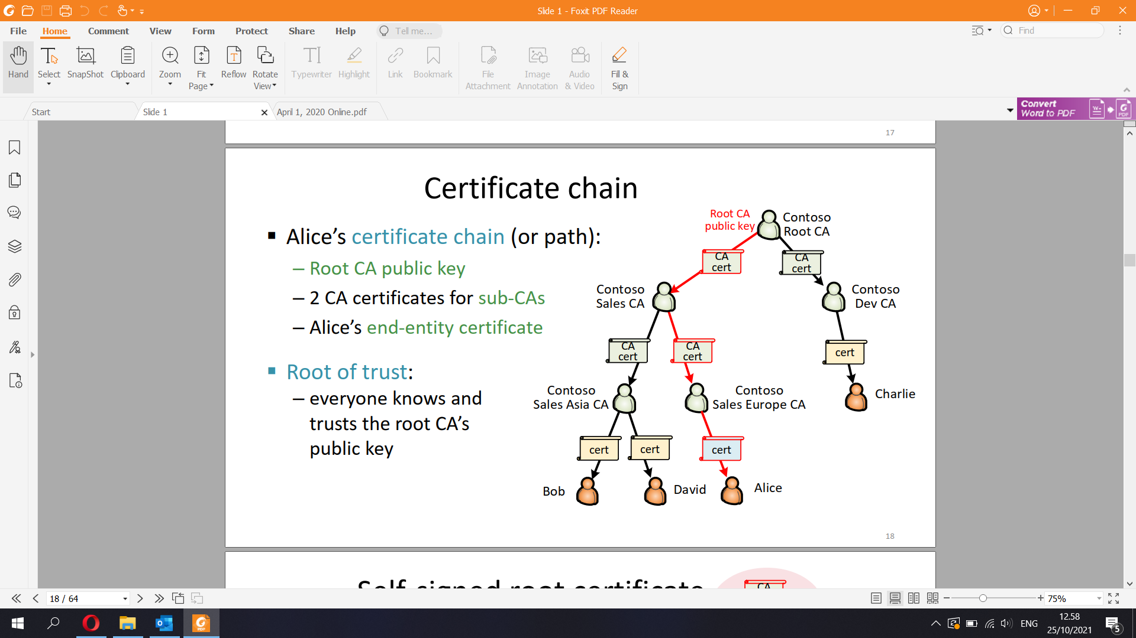

▪ Self-signed certificate

– Issuer and subject keys are the same

– Often included in the certificate chain

– Not really a certificate; just a way to store and communicate the root CA public key

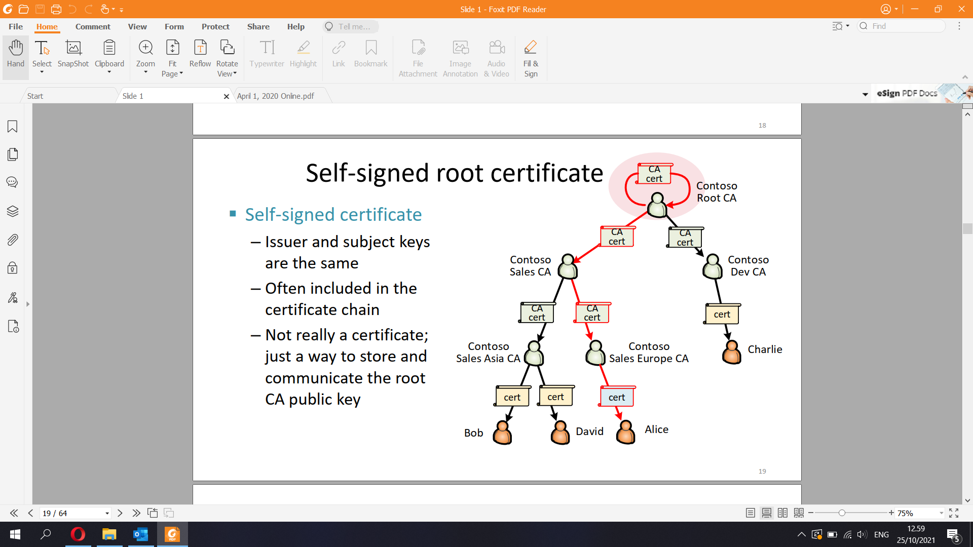

Real-world PKIs

Original X.500 idea: one global CA hierarchy to certify all countries,

organizations, users, computer and services

Reality: many application and organization specific PKIs

▪ Web PKI for certifying web servers

– Many commercial and free root CAs, e.g. Verisign, Telia, Let’s Encrypt

▪ S/MIME for signed (and encrypted) email

– Commercial CAs certify organizational CAs for cross-organization email

▪ Smart-card PKIs

– Bank cards, national identity cards

▪ Organizational PKIs

– Windows domain users, computers and services; user login with

smartcard; internal web pages; VPN and Wi-Fi access; S/MIME email;

Adobe document signing PDF documents

▪ With the help of certificates, it is possible to authenticate the name

or identifier of an entity (e.g. person, web server)

▪ But what is the right name for an entity?

– wwwlogin.tkk.fi, idp.aalto.fi, leakybox.cse.tkk.fi

– George Bush, George W. Bush, George H. W. Bush

– tuomas.aura@aalto.fi, aaura@hut.fi, taura@cse.tkk.fi, aura@cse.tkk.fi

▪ Who decides who owns the name?

– @aalto.fi email addresses, DNS names, Facebook username

▪ Does knowing the name imply trust?

– Is it safe to buy a used bicycle from trustedbikes.fi?

– Should they verify the customer’s name before shipping?

▪ When might CA need to revoke (i.e. cancel) a certificate?

– If the conditions for issuing the certificate no longer hold:

e.g., employee leaves, student graduates, or computer is

decommissioned

– If the certificate was originally issued in error

– If the subject private key has been compromised

– When upgrading cryptographic algorithms

▪ Certificate can be verified offline, but revocation

requires online checks

23

!Revocation list

▪ Certificate revocation list (CRL) = signed list of revoked certificate

serial numbers and a timestamp

▪ Who issues the CRL? How to find it?

– CRL distribution point and issuer may be specified in each certificate

– By default, CRL is signed by the same CA that issued the certificate

▪ Certificate verifier downloads the CRL (or delta) and caches it

– If CRL server is offline, the certificate verification fails

▪ Expired certificates can be removed from the CRL

▪ In X.509, only certificates are revoked, not keys

X.509 CRL fields

▪ Signature algorithm

▪ Issuer — name

▪ This update — time

▪ Next update — time

For each revoked certificate:

– Serial number

– Revocation date — (how would you use this information?)

– Extensions — reason code etc.

▪ SignatureOCSP

▪ Online certificate status protocol (OCSP)

– Request-response protocol for checking certificate status from issuer

– Timestamp and optional nonce for response freshness

C → CA: certificate-id, NC

CA → C: SignCA(certificate-id, certificate status, T, [NC])

▪ CRL vs OSCP

– OCSP implementation simpler and messages shorter

– OCSP server learns which web pages the client is accessing

- The RSA algorithm is an asymmetric cryptography algorithm; this means that it uses a public key and a private key (i.e two different, mathematically linked keys). As their names suggest, a public key is shared publicly, while a private key is secret and must not be shared with anyone

- Save certificate into a file and pretty print:

% openssl x509 -in cert.pem -noout -text

Viewing certificates with OpenSSL

# Download the certificate chain

S=idp.aalto.fi && echo | openssl s_client -connect $S:443 -servername

$S -CApath /etc/ssl/certs/ -showcerts > chain.tmp

# Parse the certificates into separate files

cat chain.tmp | awk '/-BEGIN CERTIFICATE-/ {b=1} {if (b) print >

"cert"(i+1)".pem"} /-END CERTIFICATE-/ {i++; b=0}'

# Prettyprint the host certificate

openssl x509 -text -noout -in cert1.pem | less

# Prettyprint the certificate chain

ls cert?.pem | xargs -n1 openssl x509 -text -noout -in > pretty.txt

▪ Identity proofing = checking subject identity before certification

▪ Commercial web certificates:

– Typically, email to registered domain owner verifies the ownership

– Extended validation certificates had a stronger identify proofing

process – but discontinued because users do not notice the difference

▪ Let’s Encrypt uses the ACME protocol for automated certificate

management:

– Before issuing the certificates, CA challenges the server admins

to prove that they control the web server or DNS zone

- X.509 certificate fields

Mandatory fields:

▪ Version

▪ Serial number — together with Issuer, uniquely identifiers the

certificate

▪ Signature algorithm — for the signature on this certificate; usually

sha1RSA; includes any parameters

▪ Issuer — name (e.g. CN = Microsoft Corp Enterprise CA 2)

▪ Valid from — usually the time when issued

▪ Valid to — expiry time

▪ Subject — distinguished name of the subject

▪ Public key — public key of the subject

Common extension fields:

▪ Key usage — bit field indicating usages for the subject key (digitalSignature,

nonRepudiation, keyEncipherment, dataEncipherment, keyAgreement, keyCertSign, cRLSign,

encipherOnly, decipherOnly)

▪ Subject alternative name — email address, DNS name, IP address, etc.

▪ Issuer alternative name

▪ Basic constraints — (1) is the subject a CA or an end entity, (2) maximum length of

delegation to sub-CAs after the subject

▪ Name constraints — limit the authority of the CA

▪ Certificate policies — list of OIDs to indicate policies for the certificate

▪ Policy constraints — certificate policies

▪ Extended key usage — list of OIDs for new usages, e.g. server authentication, client

authentication, code signing, email protection, EFS key, etc.

▪ CRL distribution point — where to get the CRL for this certificate, and who issues CRLs

▪ Authority info access — where to find information about the CA and its policies

Secure web site (https)

HTTPS connections are encrypted and authenticated to prevent sniffing and spoofing  
TLS in the protocol stack

▪ TLS implements cryptographic encryption and authentication for TCP connections

– Secure socket API for applications

▪ TLS 1.3 is the latest standard

– SSL was TLS’ historical predecessor

▪ DTLS for UDP

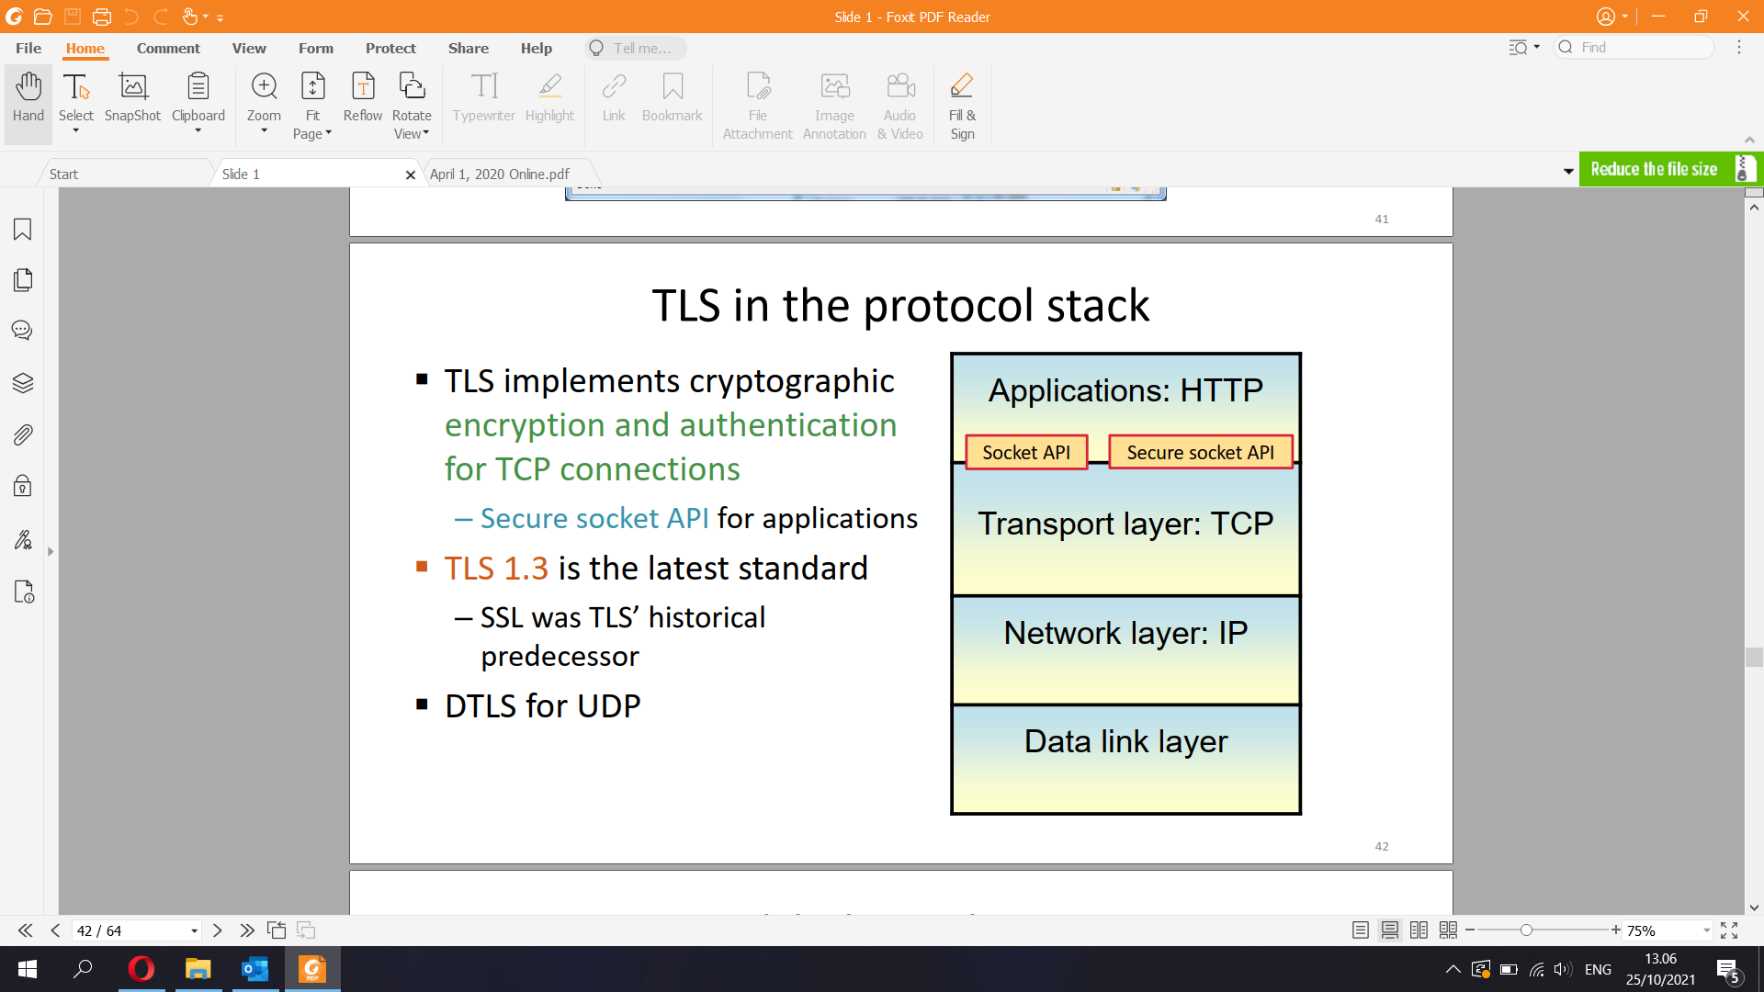

▪ Two stages of a typical network security protocol:

– Handshake = authenticated key exchange creates a shared session key

– Session protocol protects the confidentiality and integrity of the session data with symmetric cryptography and the session key

▪ TLS handshake

– Client and server create a shared secret key with Diffie-Hellman

– Server authenticates to the client with a certificate chain and signature

– Client authentication optional, usually left to the application layer

▪ TLS session protocol uses symmetric encryption and HMAC to protect the application data

Trust chain

▪ In the handshake, browser receives a certificate chain from the server

▪ Browser checks that the chain start with a (usually self-signed) certificate

that is in its trusted CA list

▪ Browser checks the certificate chain:

– Verifies the signature on each certificate using the subject public key of the

certificate above

– Checks that all but the last certificate are CA certificates

– Many other details, e.g. validity time, CRL/OCSP, key usage, constraints

– Checks that certificate appears in CT log

▪ If the certificate chain is valid, the last certificate binds together

the host name and public key of the server

– Public key is used for server authentication in the TLS handshake

– Host name shown to user in the browser address bar

!Certificate checking details

Certificate verification is quite complex and difficult to implement correctly:

1. Browser has a list of self-signed certificates for trusted root CAs, and it may have lists of certificates for trusted sub-CAs and servers.

2. In the TLS handshake, the browser may tell the server which root CAs it recognizes.

3. The browser receives a certificate chain from the server.

4. Browser checks the validity of the certificate chain backwards (“upwards”) from the end-entity-certificate towards the root:

A. There must be exactly one end-entity certificate at the bottom of the chain. The other certificates in the chain must be CA certificates.

B. Issuer of each certificate must match the subject of the CA certificate above it.

C. The browser verifies the signature of each certificate with the subject public key of the certificate above, i.e., from the issuer’s CA certificate.

D. Browser checks for certificate revocation from the OCSP server or CRL of if the certificate specifies these.

E. Browser checks that the certificate is in a CT log.

F. There may be constraints in the certificates, which must also be checked. Name constraint limits the authority of a CA to specific names, usually a

domain suffix. The name in the end-entity certificate must match all the name constraints in the certificate chain.

G. The browser must recognize and process all critical extension fields in the certificates, but it may ignore non-critical extensions. (For example, name

constraint and key usage are critical extensions, but CLR distribution point and Certificate Transparency timestamps are non-critical.)

If a trusted certificate is found, stop going up the chain and move to the next step. On the other hand, if the root of the chain is

reached and no trusted certificate is found, the chain verification fails.

5. Browser checks that the certificate has been issued for the right purpose: extended key usage field of the end-entity certificate must

specify TLS server authentication.

6. Browser checks that the host name in the browser’s address bar or requested URL matches the subject name of the end-entity

certificate. (Subject name matching rules are pretty complex, too. There can be many names and wildcards in the certificate.)

7. Browser uses the subject key from the end-entity certificate to authenticate the server in the TLS handshake (authenticated key

exchange).

8. The session key created in the handshake is used to encrypt and authenticate data between the browser and server for the duration

of the TLS session.

→ This process proves that the web page shown in the browser comes from the server whose name is in the address bar.

TLS session protocol

▪ After the handshake, data is protected with the session

protocol

▪ Data confidentiality is protected with symmetric encryption,

e.g. AES in CBC mode

▪ Data integrity is protected with message authentication codes

(MAC)

▪ Secret session keys for encryption and authentication in each

direction are derived from the master_secret  
▪ Cryptography turns a security problem into a key distribution

problem

▪ PKI turns a key distribution problem into a naming problem

– How do I know the name of the server/client/user that I need to

talk with?

– Does a name (or identifier) uniquely identify the intended entity?

– Who is the authority that assigns or certifies names?

60Avoiding common mistakes

Some facts to avoid surprisingly common misconceptions:

▪ Certificate is NOT “encrypted with the CA private key”

– There is no encryption or secrets in the certificate

– The certificate is signed with the CA private key and verified with the CA public key

▪ Certificates are NOT retrieved from the CA on demand

– Instead, the subject stores the certificate chain for the validity period (e.g., one year)

and presents it to verifiers

– However, the verifier retrieves the certificate revocation list on demand and then caches

it (e.g., for a day), or the verifier queries the OCSP server on demand

▪ The certificate alone does NOT prove anyone’s identity

– Certificate is public information that can be copied

– Certificate + signature together can be used for authentication

– For example, a signed message with a certificate proves the identity of the sender, and

TLS with server certificate certificates proves the identity of the web server

**9) Electronic Identity**

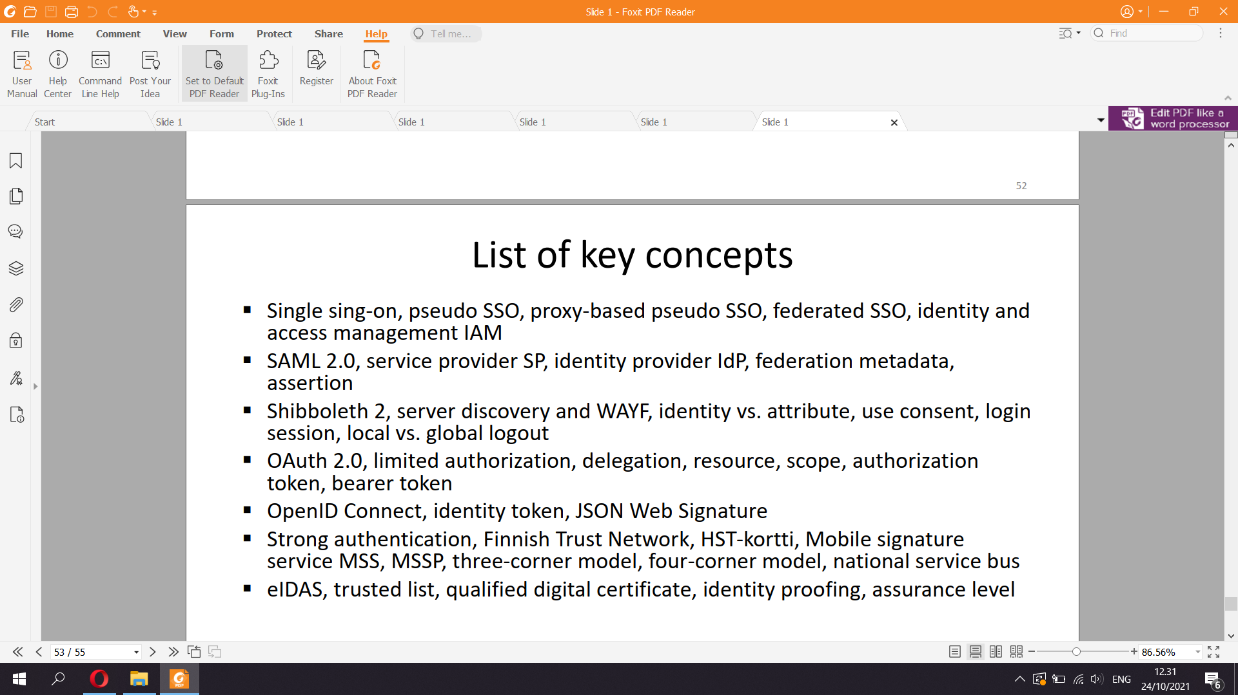

Single sign-on (SSO)

▪ One authentication credential for many services. Why?

▪ For users:

– Fewer accounts and passwords to remember

– More convenient service access

– Lower risk from old, forgotten accounts

▪ For intranet and extranet services within an organization:

– Central user management within organization

▪ For public web sites:

– Outsourcing credential provisioning and authentication

– Tracking web users for advertising

WEB SINGLE SIGN-ON WITHIN ORGANIZATION

SSO has a long history

▪ Organizational and federated SSO:

– Kerberos v5 (1993), GSSAPI, Windows AD (2000)

– SAML 1.0, 1.1, 2.0 (2002-2005)

– Shibboleth 1.3 (2005), 2.0 (2008) based on SAML

Shibboleth is a single sign-on log-in system for computer networks and the Internet. It allows people to sign in using just one identity to various systems run by federations of different organizations or institutions. The federations are often universities or public service organizations.

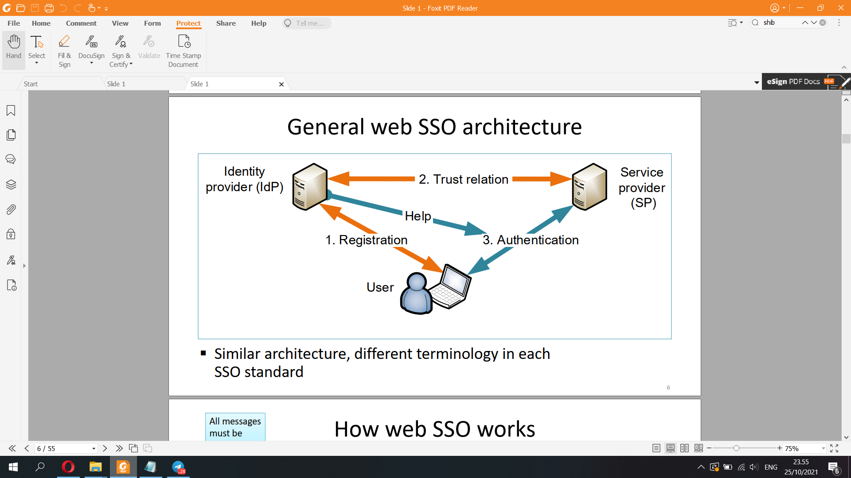

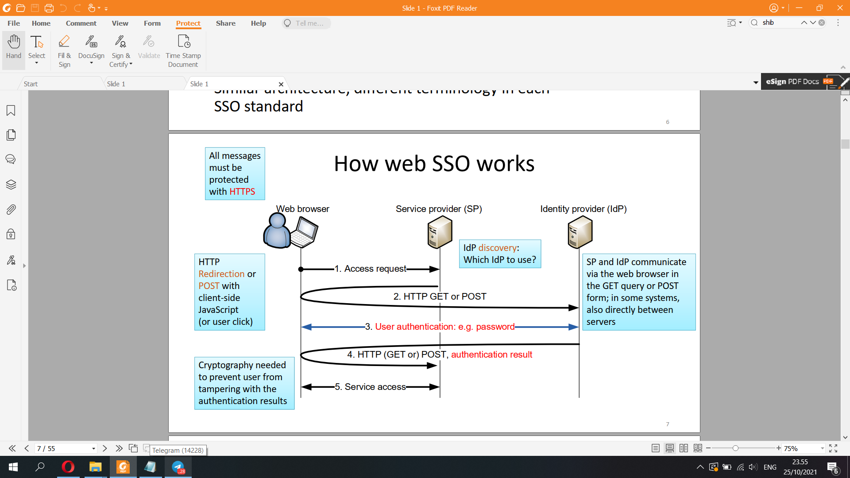

SAML 2.0 architecture  
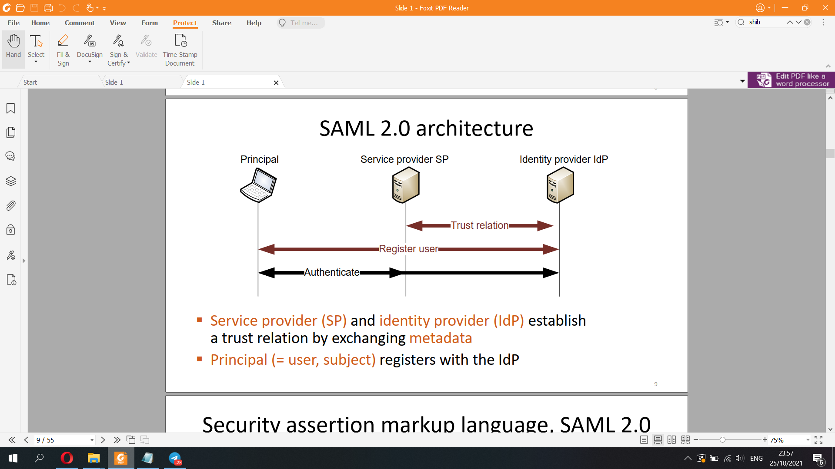

SAML 2.0

▪ SAML is a complex family of specifications:

– Assertions are statements by IdP about a principal, in XML

– Protocols define message flows for requesting assertions

– Bindings define message transport over HTTP, SOAP etc.

– Profiles define useful combinations of the above

– Metadata defines trust relations

– So many possible combinations that SAML implementations are

generally not interoperable

▪ For web SSO, SAML web browser SSO profile

– Bindings: redirect, post, artifact

SAML web browser SSO profile

▪ IdP-initiated or SP-initiated SSO:

– User first logs into the IdP, or first connects to SP

▪ Bindings to HTTP messages

– Redirect: message from SP to IdP is sent in GET URL via user’s

browser, with help of HTTP redirection

– POST: message between SP and IdP is sent in an HTTP form via user’s

browser

– Artifact: reference number sent as redirect, and the actual message

retrieved directly from the sender (artifact = random number)

SAML web browser SSO profile

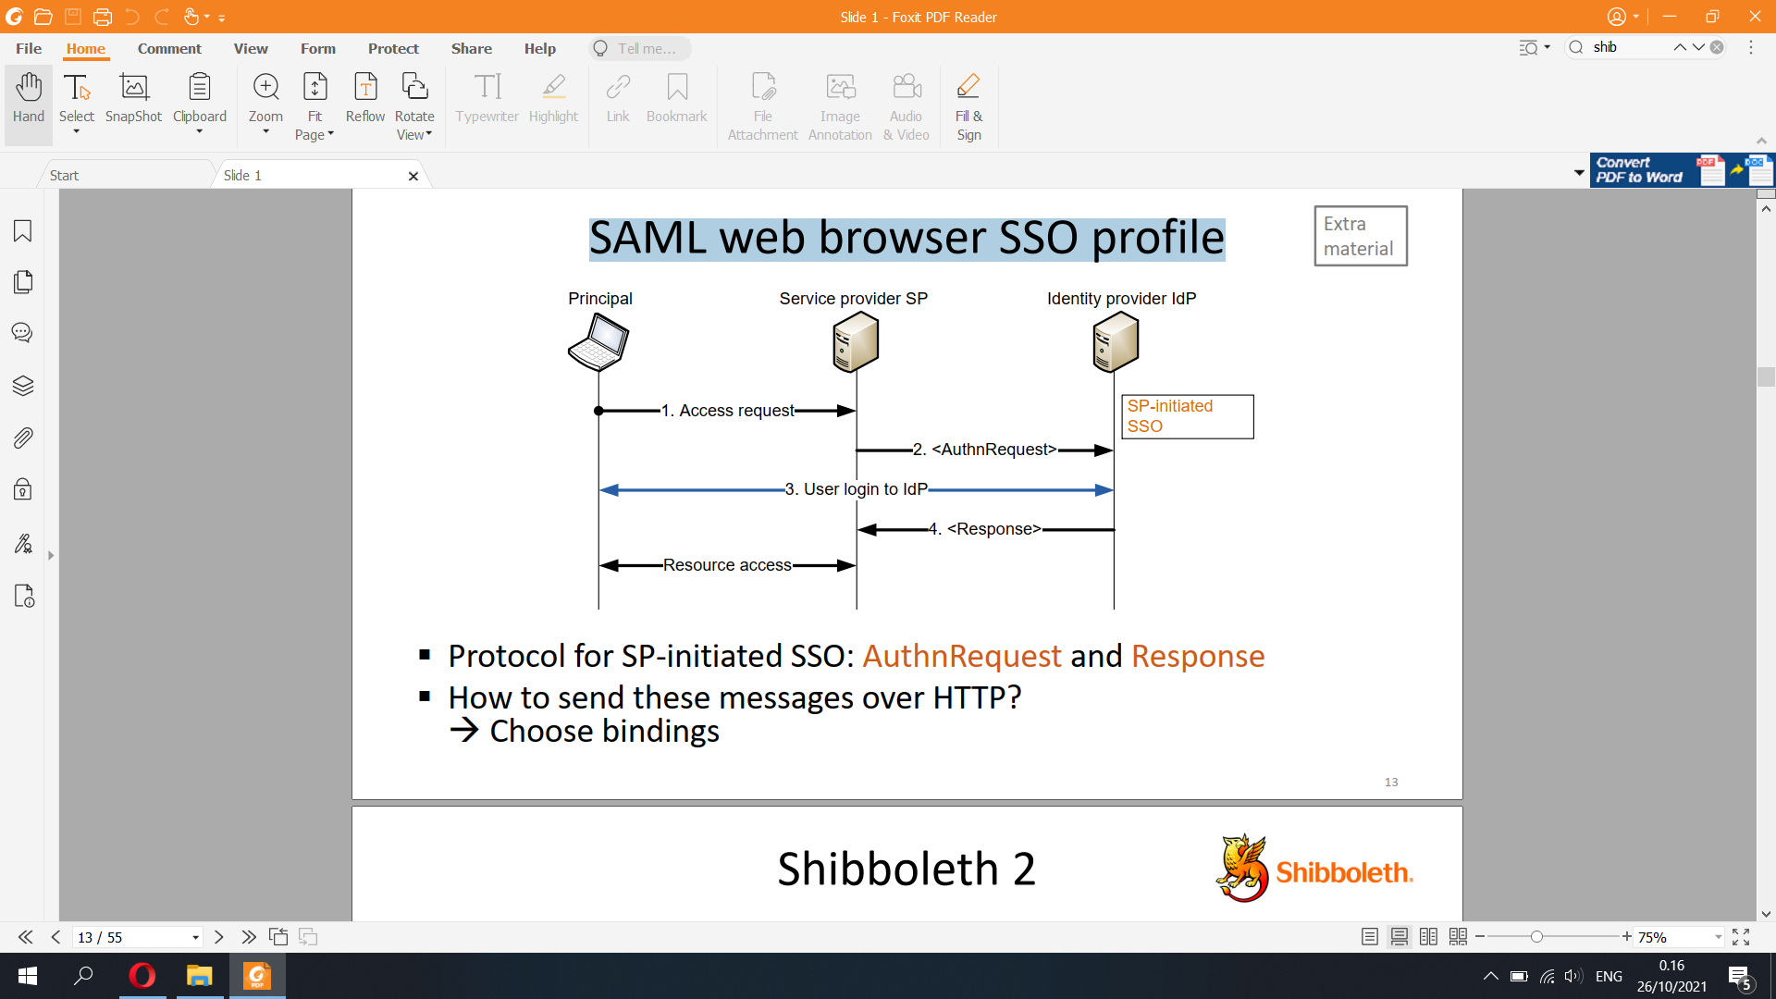

Shibboleth 2

▪ Open-source implementation of SAML 2.0

– SAML web browser SSO profile

– Used by research and educational institutions

Shibboleth federation

▪ Federation is a group of IdPs and SPs that

– share metadata (including public keys) in one signed file

– agree on an attribute schema for assertions

– agree on a CA for TLS

– have a service agreement that sets out rules for the federation

▪ Examples: HAKA federation, eduGAIN

▪ When authenticating, where are you from (WAYF) page

for IdP selection

Shibboleth protocol

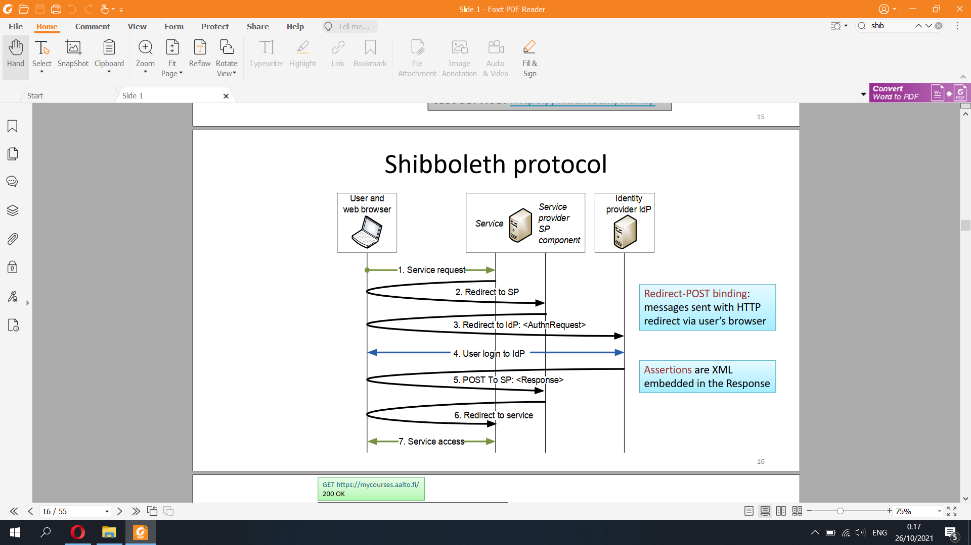

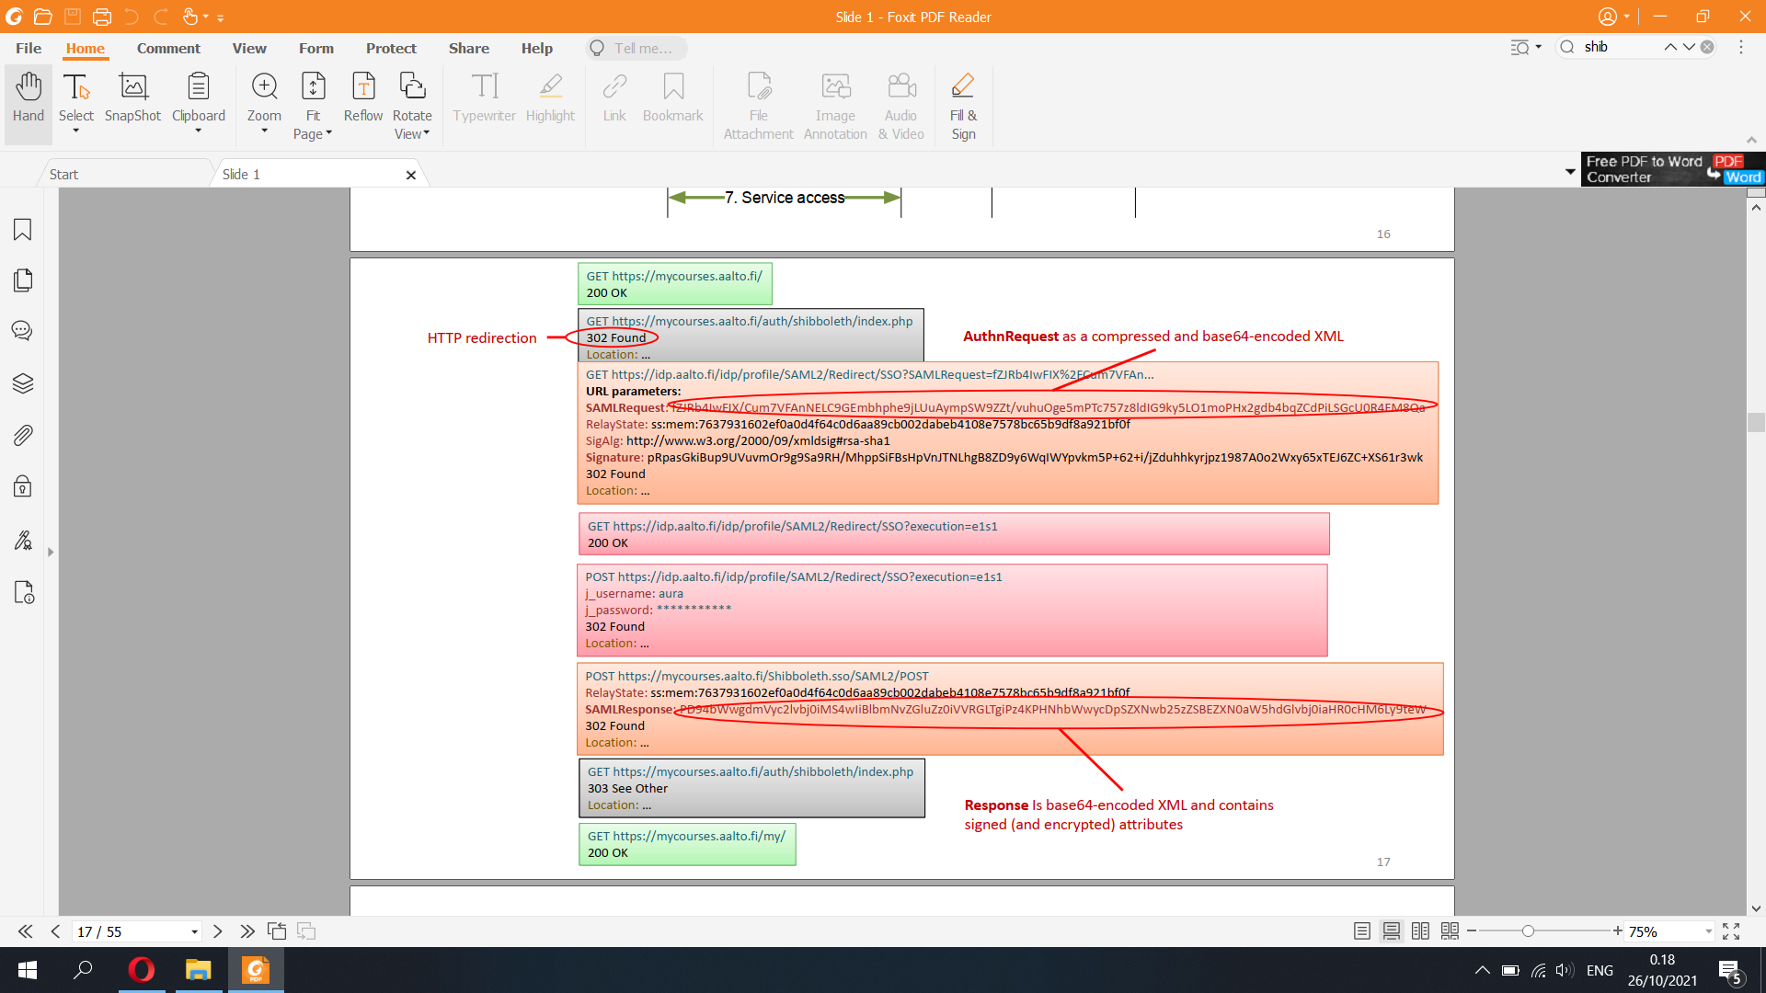

Shibboleth security

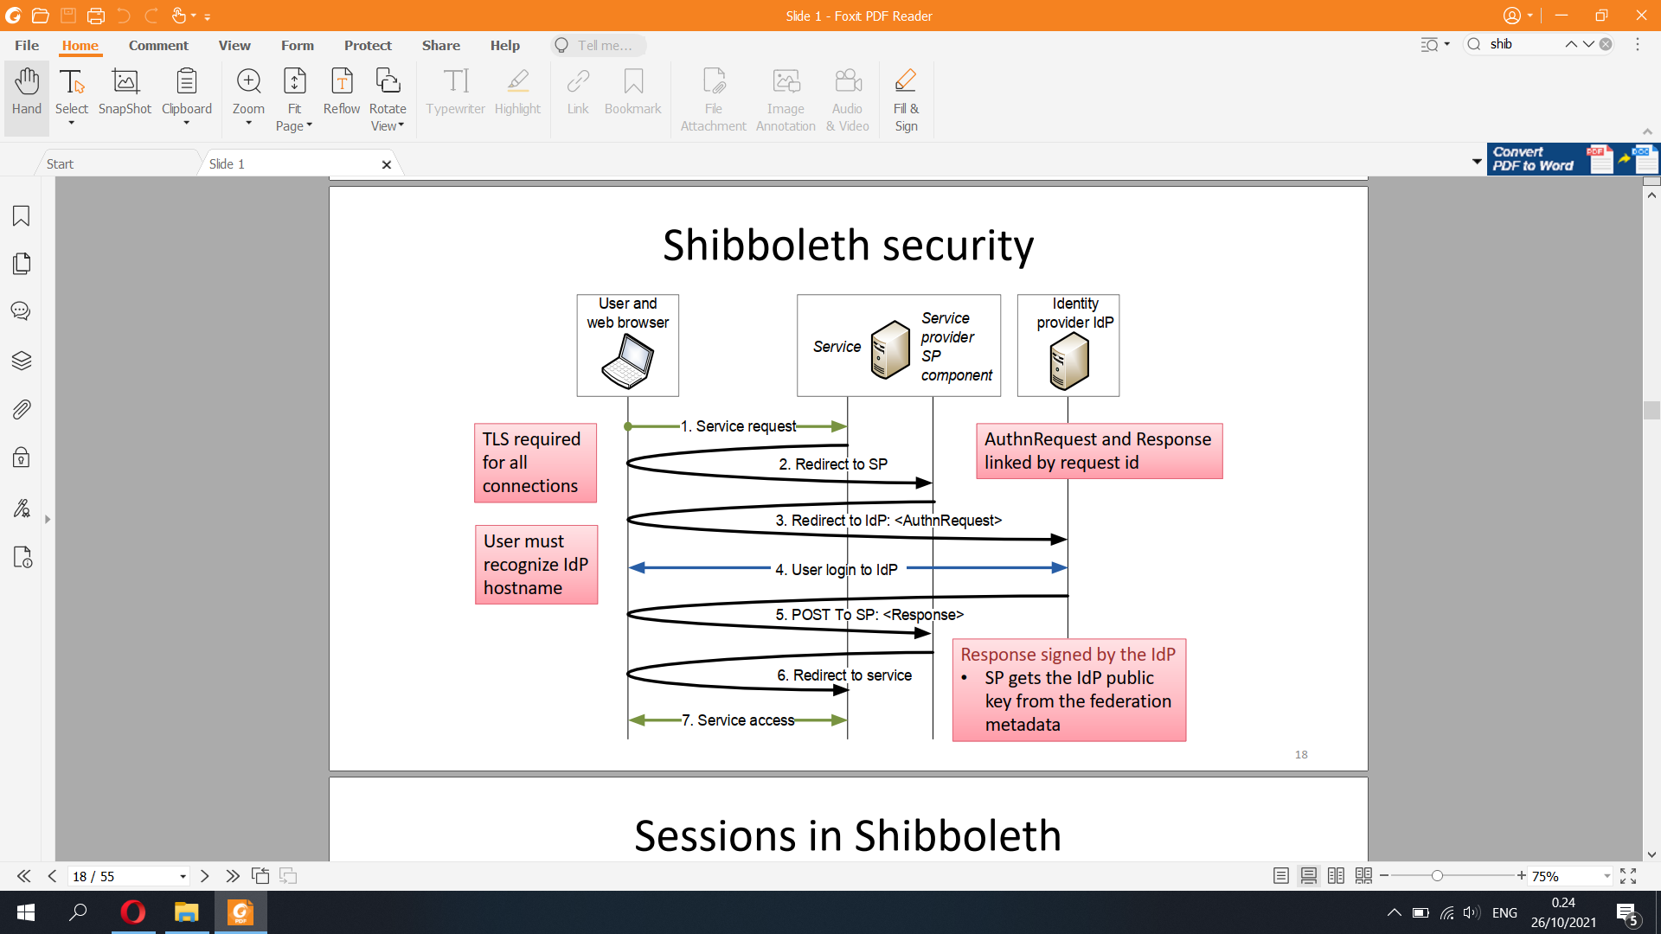

Sessions in Shibboleth

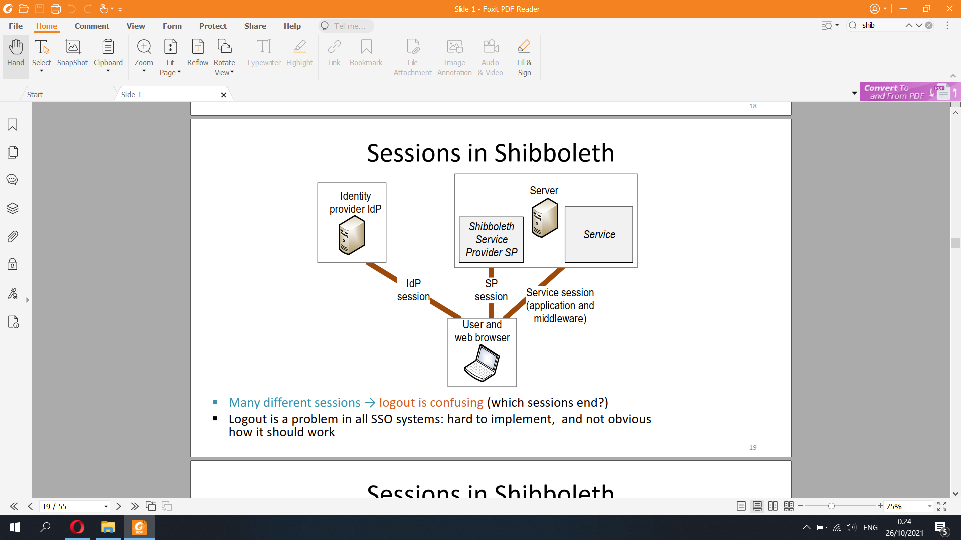

Sessions in Shibboleth

▪ Shibboleth implements two kinds of sessions:

– IdP session between browser and the IdP implemented with IdP cookies

→ user only needs to type in password once

– SP session between browser and the SP component with SP cookies

▪ Additional application sessions:

– Applications and web-application frameworks implement sessions using cookies

or with fields in URLs or web forms

▪ No single logout

– Logging out of SP does not usually log the user out of the IdP

→ can log back to SP without password

– Logging out of IdP does not log the user out of SPs

– Logging out of one SP does not log the user out of other SPs

– Application sessions complicate the situation further

→ Shibboleth logout behavior is difficult to understand

k-anonymity is a property of a data set, usually used in order to describe the data set’s level of anonymity. A dataset is k-anonymous if every combination of identity-revealing characteristics occurs in at least k different rows of the data set.

OAuth 2.0

▪ OAuth was designed for authorization (i.e., delegation)

– User authorizes a web app, mobile app, or another online service

service to access their data in an online service

▪ Examples:

– Authorize a website or app to update Facebook for you

– Authorize continuous integration tool to monitor a GitHub repository

▪ Standardized by IETF (RFC 6749, RFC 6750)

– App developers can use a well-designed, secure protocol

– No interoperability: many incompatible ways to implement

OAuth 2.0 authorization

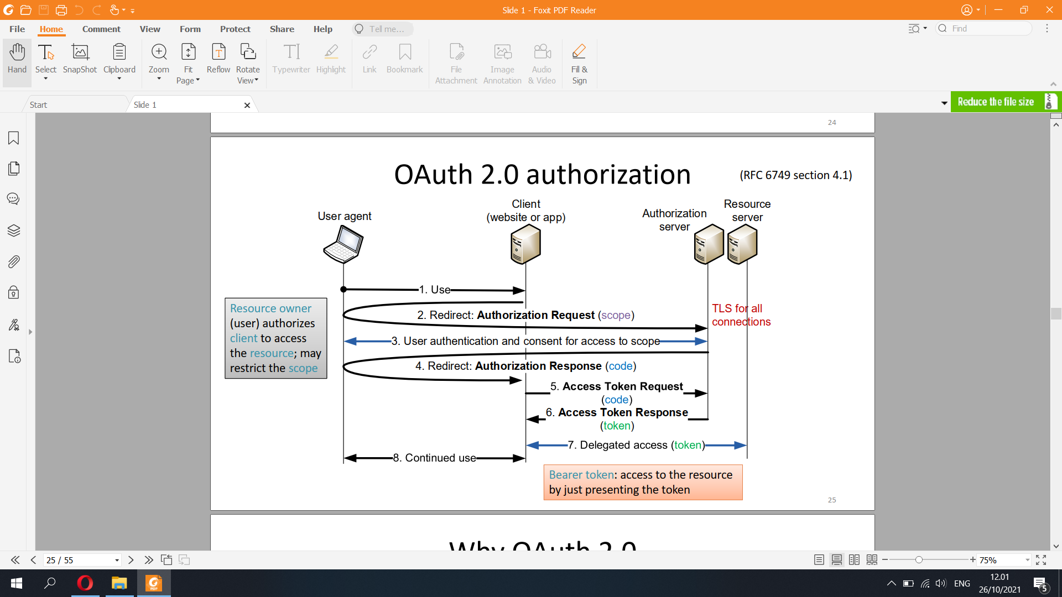

ID Tokens vs Access Tokens

The ID Token is a security token granted by the OpenID Provider that contains information about an End-User. This information tells your client application that the user is authenticated, and can also give you information like their username or locale.

You can pass an ID Token around different components of your client, and these components can use the ID Token to confirm that the user is authenticated and also to retrieve information about them.

Access tokens, on the other hand, are not intended to carry information about the user. They simply allow access to certain defined server resources. More discussion about when to use access tokens can be found in Validate Access Tokens.

What to Check When Validating an ID Token

The high-level overview of validating an ID token looks like this:

Retrieve and parse your Okta JSON Web Keys (JWK), which should be checked periodically and cached by your application.

Decode the ID token, which is in JSON Web Token format

Verify the signature used to sign the ID token

Verify the claims found inside the ID token

Using OAuth for authentication?

▪ The message flow in OAuth looks like OpenID or SAML → services were

tempted to use OAuth also for authentication

– User would prove its identity by delegating access to a (dummy) resource

associated with the user account

▪ In principle, this was a bad idea:

– OAuth access token enables client to access a resource on the service provider

– The client in OAuth does not know or care who gives it the token, as long as the

token works for accessing SP

– The protocol does not prevent the client from sharing the token with others, e.g.,

subcontractors or server instances

→ Malicious client can impersonate user to other clients

▪ Authentication based on OAuth has now been standardized as OpenID

Connect, which prevents the token forwarding attack

– http://openid.net/developers/specs/

OpenID Connect

▪ Authentication built on OAuth 2.0, JavaScript, REST APIs, JSON

data formats

– OAuth access token is replaced with id token, which is not a bearer

token; the token is bound to the specific relying party (OAuth client)

▪ Implementations are usually not interoperable

– Many options: MAC with pre-shared key between OP and RP

vs. JSON Web Signature on messages

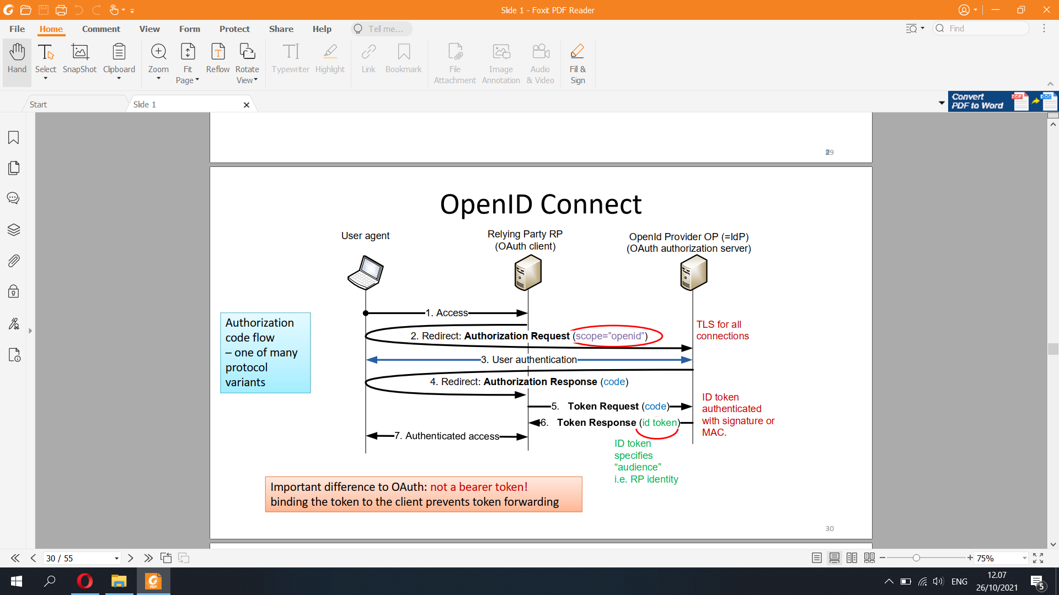

What does “open” mean?

▪ Original OpenID gave freedom to the user:

– Anyone could become an identity provider

– User could choose any identity provider

– Services supposed to accept any identity and IdP chosen by the user

– Worked on any web browser without proprietary software (originally

even no JavaScript or TLS)

▪ OpenID Connect is not open in any sense

– No interoperability between competing implementations

– Web sites decide which IdPs they support

31

Extra

materialCommon features of Internet SSO

▪ Authentication

– RP learns user identity (username or some other id)

▪ Attribute attestation

– IdP tells RP further information about the user

▪ Authentication-server discovery

– WAYF page, or automatic way to resolve the user identity to IdP address

– For automatic discovery, user identifiers must be globally unique,

e.g., name@domain or URL

▪ Client registration

– Many IdPs allow creation of new accounts online

– Difficult to combine with proper identify proofing

▪ Authorization

– User delegates access rights to a client app or to another service

– Best implemented as a separate step from identity authentication: e.g.,

OpenID Connect for authentication + OAuth 2.0 for delegating access rights

STRONG ELECTRONIC IDENTITY

33For comparison

▪ Passport and identity card are traditional methods for

authenticating a person

– Photo and signature

▪ Biometric passport (ICAO9303)

– Chip contains all the same information as printed passport (name, birth

date etc.)

– Biometric data: photo and fingerprint

– Electronic signature for authenticity

▪ Access to passport chip for authorized readers only

– Active authentication with signature optional and designed for

authentication only

→ Cannot be used online

34Strong authentication

▪ Goal: online authentication equivalent to checking national

identity card or passport

▪ Is it needed?

– Services are moving to the web, and strong authentication is required

by law for access to government services and personal information

– Saves travel and customer service cost in the initial id check for new

users, e.g., buying an insurance or enrolling to university

– Increasing trust in online commerce (?)

35Strong authentication regulation

▪ European eIDAS regulation

– Implemented in Finnish law: Laki vahvasta sähköisestä

tunnistamisesta ja sähköisistä luottamuspalveluista

https://www.finlex.fi/fi/laki/ajantasa/2009/20090617 (617/2009, updated 2016)

▪ Two-method authentication, any two of:

– something you know (password or PIN code)

– something you have (physical token)

– something you are (biometrics)

▪ Identity proofing in person or electronically

36Finnish Trust Network (FTN)

▪ Regulated electronic authentication network:

1. Identification means providers (banks,

mobile operators, population register)

2. Identification broker services

3. Electronic services

– Identification means providers must work

with all approved brokers (at regulated price)

– Electronic service chooses one broker

– Supervised by Finnish Transport and

Communications Agency (Traficom)

▪ Protocol between broker and identity means

provider is OpenID Connect or SAML2

– Identification means provider is the OpenID provider (IdP); broker is the relying party

▪ Protocol between electronic service and broker is typically also OpenID Connect

– Electronic service forwards the browser to broker, broker forwards to IdP

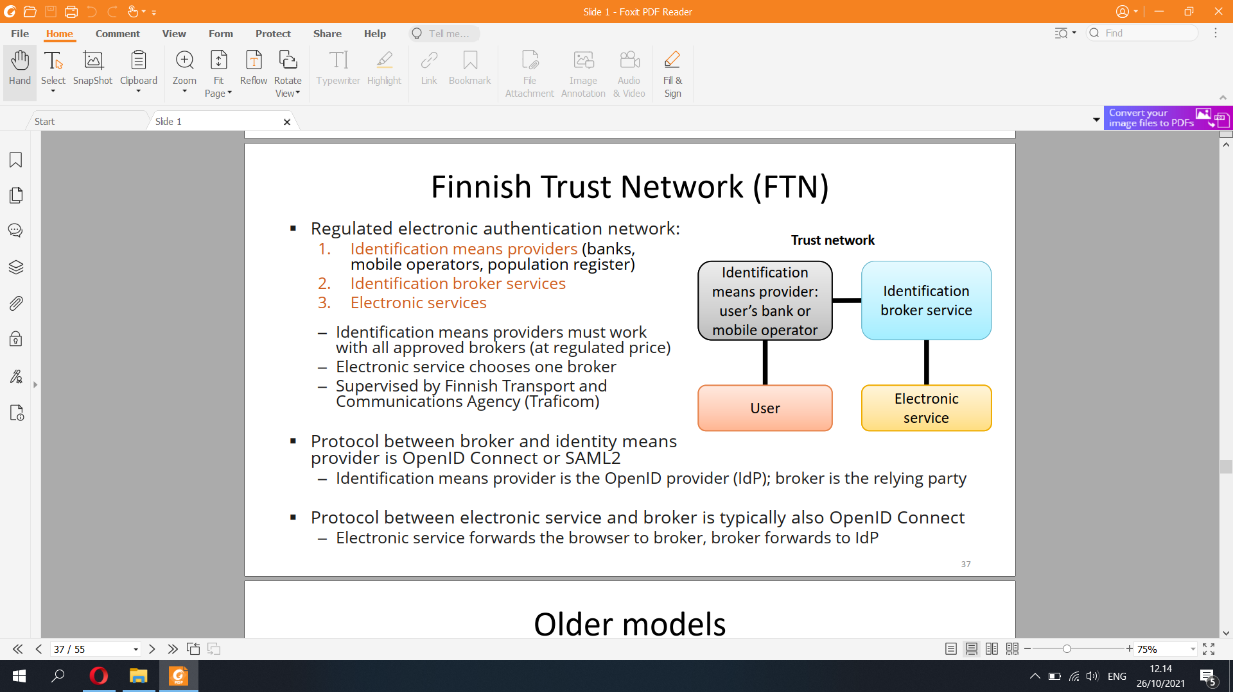

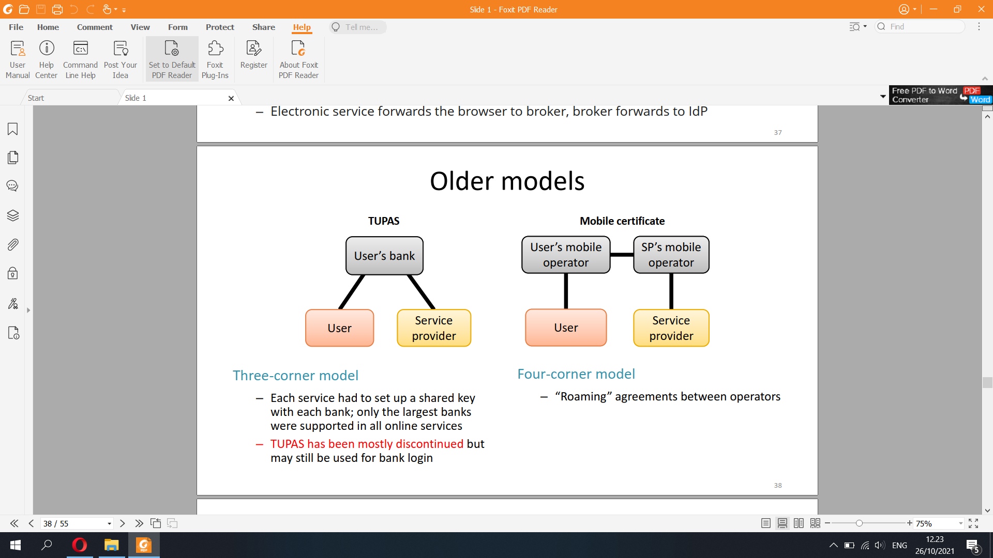

Finnish electronic identity card

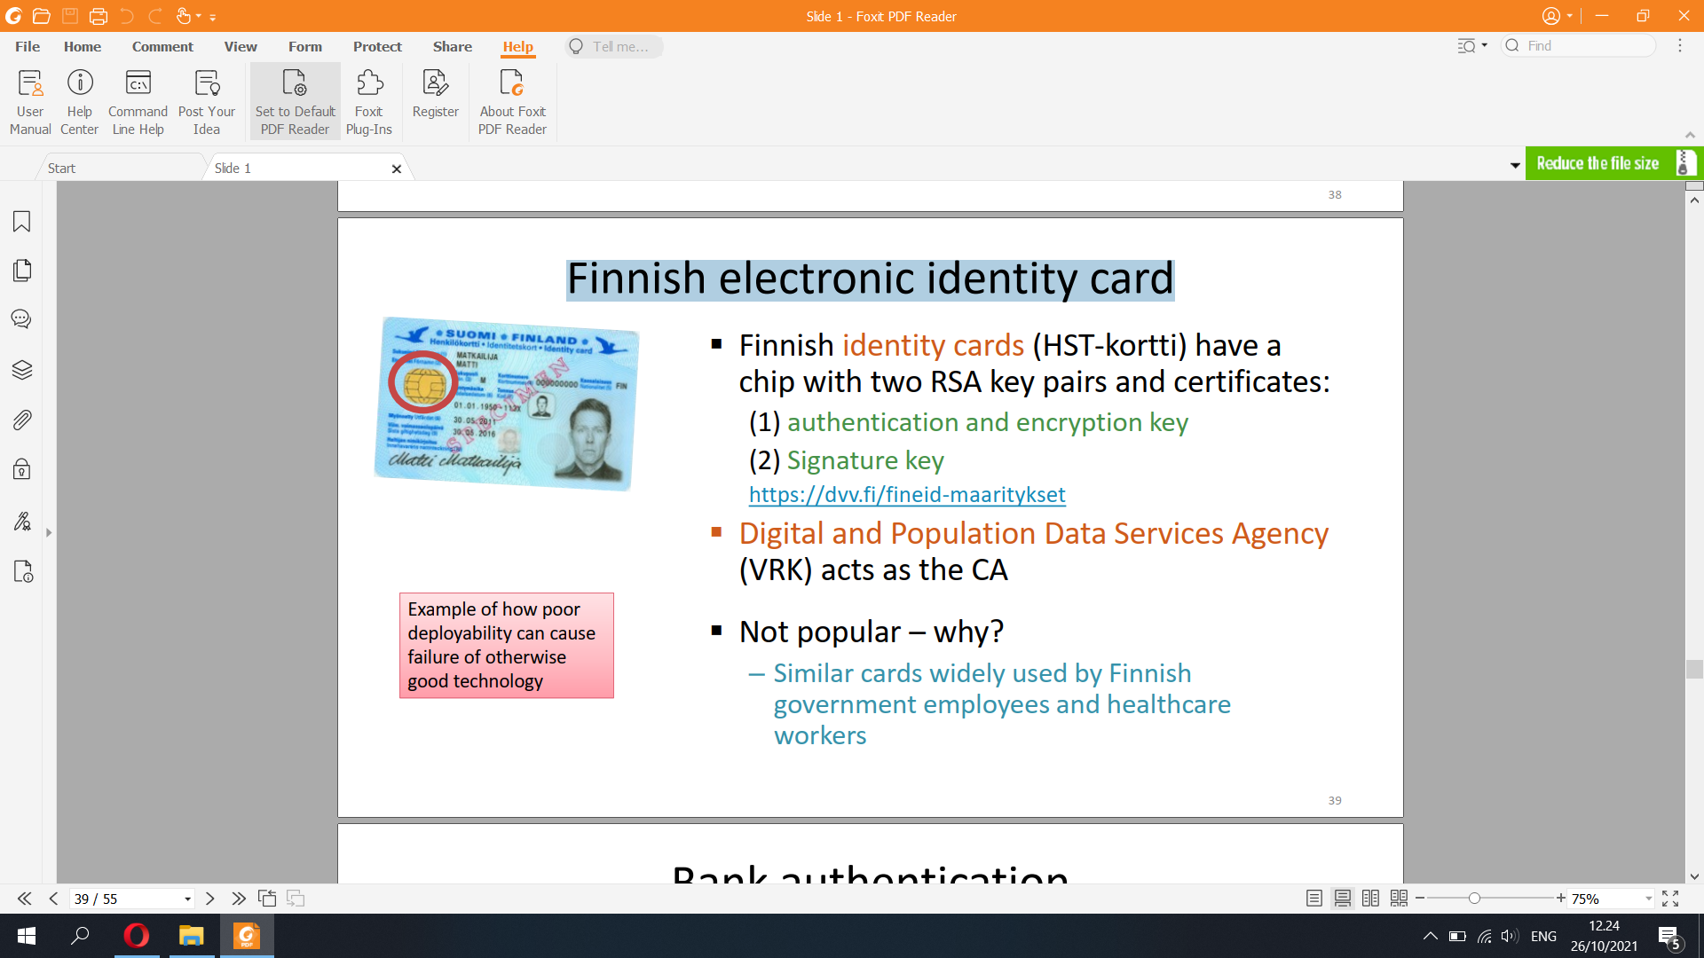

Bank authentication

▪ Banks used to have one-time code lists

▪ Now a mobile app where you approve

the transaction

– More secure because it cannot be copied

and user without the PIN code

– Less secure if you use the phone also for banking and other service

access. The phone becomes a single point of failure:

if the phone OS is hacked, the hacker can capture the PIN

and tamper with the service access from an apps or browser?

Mobile signature service (MSS)

▪ Signature key on the mobile-phone SIM

– Used for strong authentication, potentially also document signing

– Protocols depend on a mobile signature service provider (MSSP)

– ETSI standard, <https://mobiilivarmenne.fi/>

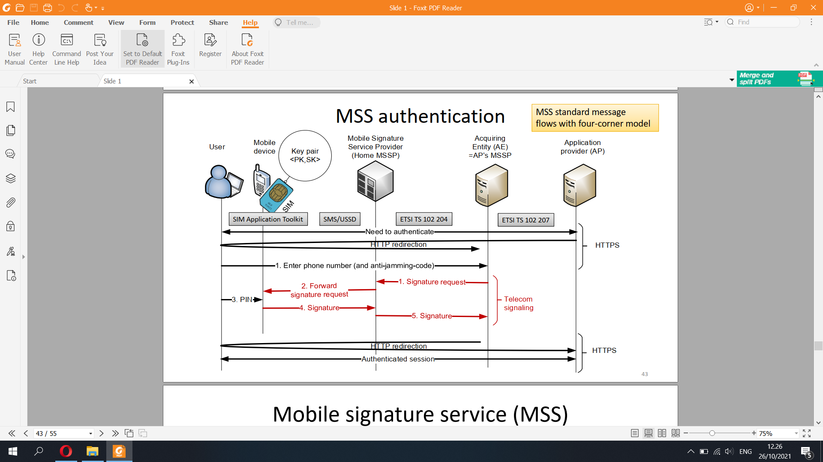

Mobile signature service (MSS)

▪ Advantages: everyone has a SIM card, and operators have 24/7

service for revocation

▪ “Signature keys are in your own pocket”

– However, signatures can only be requested via the operator’s mobile

signature service provider (MSSP)

▪ Deployment and adoption has been slow

– Requires identity proofing, i.e., verification of the subject identity

before issuing the certificate

– Operators want a fee for every transaction

44Identity proofing

▪ Identity proofing, i.e., verifying the subject identity before

issuing the certificate

– Electronic identify card: in person at police office

– Banks: in person at the bank, government issued identity document

required

– Mobile signature: in person at operator shop, or online with bank

Credentials

AUTHENTICATION TO GOVERNMENT SERVICES

46KaPA

▪ Integrating all the strong authentication methods to all

services is a lot of work

▪ Suomi.fi -palveluväylä (Suomi.fi data exchange layer)

– Enterprise service bus for government services

– Design based on Estonian X-road

– Includes common electronic identification for public online services

– Ministry of Finance, implementation by Population register (VRK)  
European eIDAS regulation

▪ Goal: Cross-border access to government online services in EU

– https://esignature.ec.europa.eu/efda/home/

▪ Technology-agnostic regulation

▪ Electronic identification (eID)

– Cross-border acceptance of national id schemes

– Assurance levels: low, substantial and high

▪ Electronic trust services (eTS)

– Electronic signature, electronic seal, time stamp, electronic delivery

service, website authentication

▪ EU Trusted List: list of trust service providers that issue (or

subcontract issuers of) qualified digital certificates

Implementing eIDAS in Finland

▪ Traficom registers identification and trust services in Finland

▪ Digital and Population Data Services Agency, Digi- ja

väestötieto virasto* is the only qualified trust service provider

on the trusted list

– Qualified certificates, signatures, timestamps, registered delivery

services, web site authentication

▪ Other strong electronic identification services (banks and MSS)

are not qualified  
Corporate IAM

▪ Federated identity and authentication is not sufficient:

– Need to configure access permissions for users in the services

– Need to monitor and audit access control state in the system

– Need to revoke access rights

▪ Identity and access management (IAM) systems

– Define roles and groups for the organization

– Enable centralized role assignment, revocation and monitoring

▪ Example:

– student enrolls to university, then becomes employee, then graduates, finally

leaves employment

▪ Typical implementation: central IAM server, and an IAM agent at each

supported service

→ more expensive to develop and deploy than federated authentication; better

overall picture and effective revocation

**10) Threat Analysis**

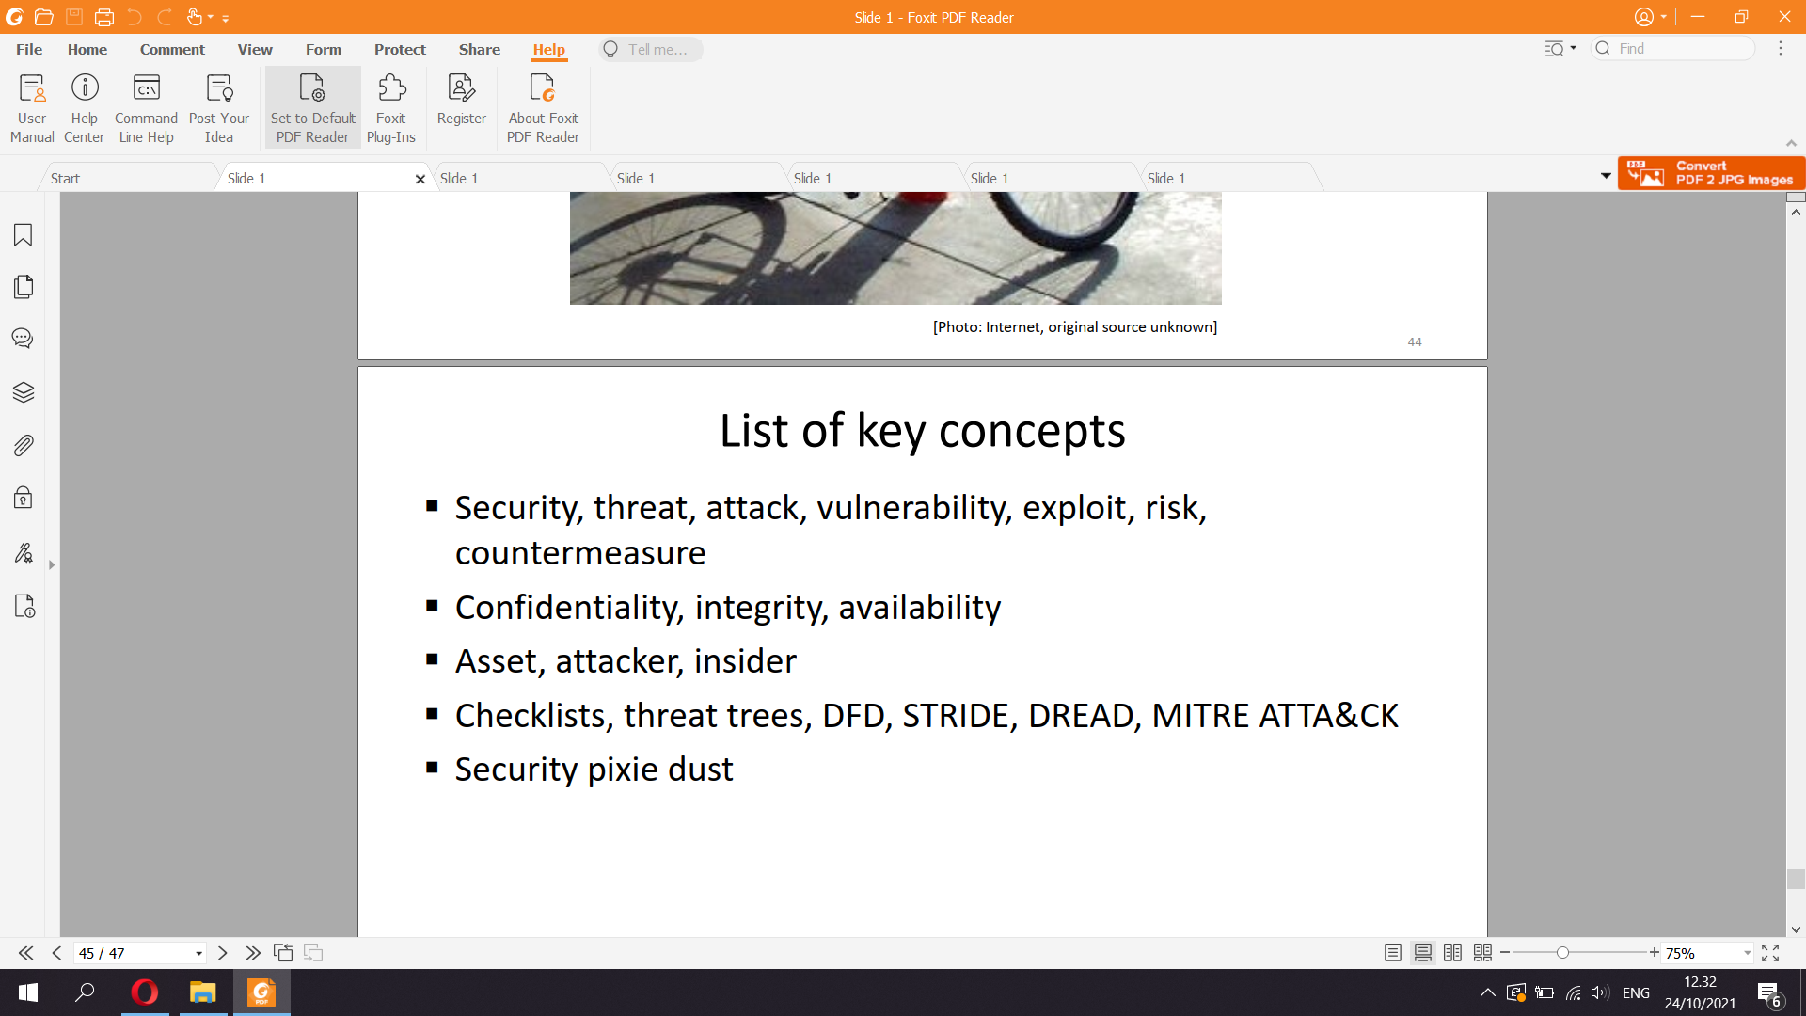

What is security

▪ When talking about security, we are concerned about bad

events caused with malicious intent

– Security vs. reliability?

▪ Security is a non-functional property of a system

– Comparable to quality; difficult to verify and measure

▪ Security is a moving target

– The adversary is intelligent and creative; creates new threats

– When will crime finally end?Some security terminology

▪ Threat = bad event that might happen

▪ Attack = intentionally causing the bad thing to happen

▪ Vulnerability = weakness in an information system that enables

attacks

▪ Exploit = implementation of an attack

▪ Risk = probability of an attack × damage in euros6

Security Goals

▪ Confidentiality, Integrity, Availability “CIA”

– Confidentiality — protection of secrets

– Integrity — only authorized modifications

– Availability —service works, business continuity

▪ Examples: web server, customer data

▪ Many security goals are not covered by CIA:

– Access control — only authorized use of resources

– Privacy — control of personal data and spaceSome goals not covered by CIA

▪ Authentication for access control and accountability

▪ Correct accounting, fair payment

▪ Content protection

▪ Protection of services and infrastructure

in a hostile environment (e.g. Internet)

▪ Anonymity, freedom of expression

▪ Control and monitoringWho is the adversary?

▪ We divide the world into good and bad sides

– Honest parties vs. attackers; red vs. blue; trusted vs. untrusted

– Good ones follow the specification, bad ones do not

▪ Multilateral security: must consider all different partitions of

the participating entities to good and bad

▪ Often, we only care about some attackers, not all

– Who would you not want to see your Telegram messages?

8Typical attackers

▪ Typical attackers:

– Curious individuals

– Friends and family

– Dishonest people — for personal gain, making and saving money

– Hackers, script kiddies — for challenge and reputation

– Companies — for business intelligence and marketing, industrial espionage

– Organized criminals, rogue countries — for money and power

– Governments and security agencies — NSA, SVR RF, GCHQ, DGSE, etc.

– Military SIGINT — strategic and tactical intelligence, cyber defense

▪ Insiders are often the greatest threat

– Employee, administrator, service provider, customer, family member

9THREAT ANALYSIS

10Viewpoints to threat analysis

Different viewpoints to threat analysis:

▪ Assets

– What has value and how could it be lost?

– What are the business objectives? What could put them at risk?

▪ Potential attackers and their motivation

– Who could do something bad and why?

– Start by enumerating the actors and stakeholders the system

– Insiders are often the greatest threat

11

! !Viewpoints to threat analysis

▪ Engineering

– How does the system work? What are the system components and

processes? How could they fail?

– Draw system architecture, data flow diagram, etc. Analyze potential

vulnerabilities in each component

▪ Countermeasures

– Are there known ways to prevent or mitigate attacks?

– What security protections have been deployed

or suggested? Why or why not?

– Is the purpose of security mechanism understood?

Are they effective?

12

!Viewpoints to threat analysis

▪ Checklists, lessons learned, best practice guidelines

– What can experience and past mistakes teach us?

▪ Compliance

– Are there regulatory, contractual or standards compliance requirements?

▪ Risks analysis methodology

– How likely are the threats and how much damage

would they cause?

13

Threat analysis requires both security and domain expertiseWhat I find most productive

▪ Given a system or product

1. Understand the system architecture, operation, and business

2. What assets are there that could be lost or damaged?

3. Who are the actors in the system? Why might they break rules?

4. What are the threats and potential attacks against the assets? What

vulnerabilities might there be? Gather and organize ideas iteratively.

5. Prioritize threats based on the risk and cost of mitigation

▪ Focus on understanding and intelligent analysis,

not on a formal process or structure

STRIDE

▪ Idea: model the system as data flow diagram (DFD) and analyze

each component separately

**▪ Threats considered in STRIDE:**

**– Spoofing vs. authentication**

**– Tampering vs. integrity**

**– Repudiation vs. non-repudiation, accountability**

**– Information disclosure vs. confidentiality**

**– Denial of service vs. availability**

**– Elevation of privilege vs. authorization, access control**

STRIDE

**▪ Model the software system as a data flow diagram (DFD)**

**– Data flows: network connections, RPC**

**– Data stores: files, databases**

**– Processes: programs, services**

**– Interactors: users, clients, services etc. connected to the system**

▪ Also mark the trust boundaries in the DFD

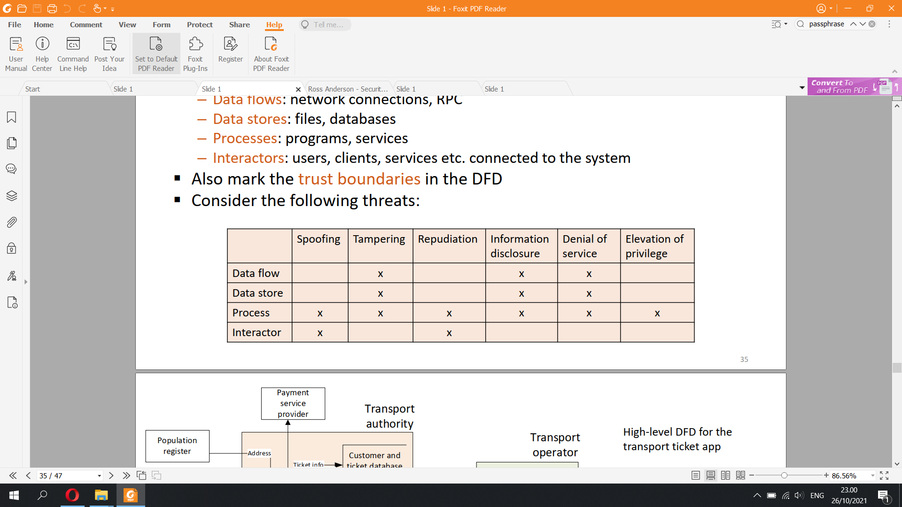

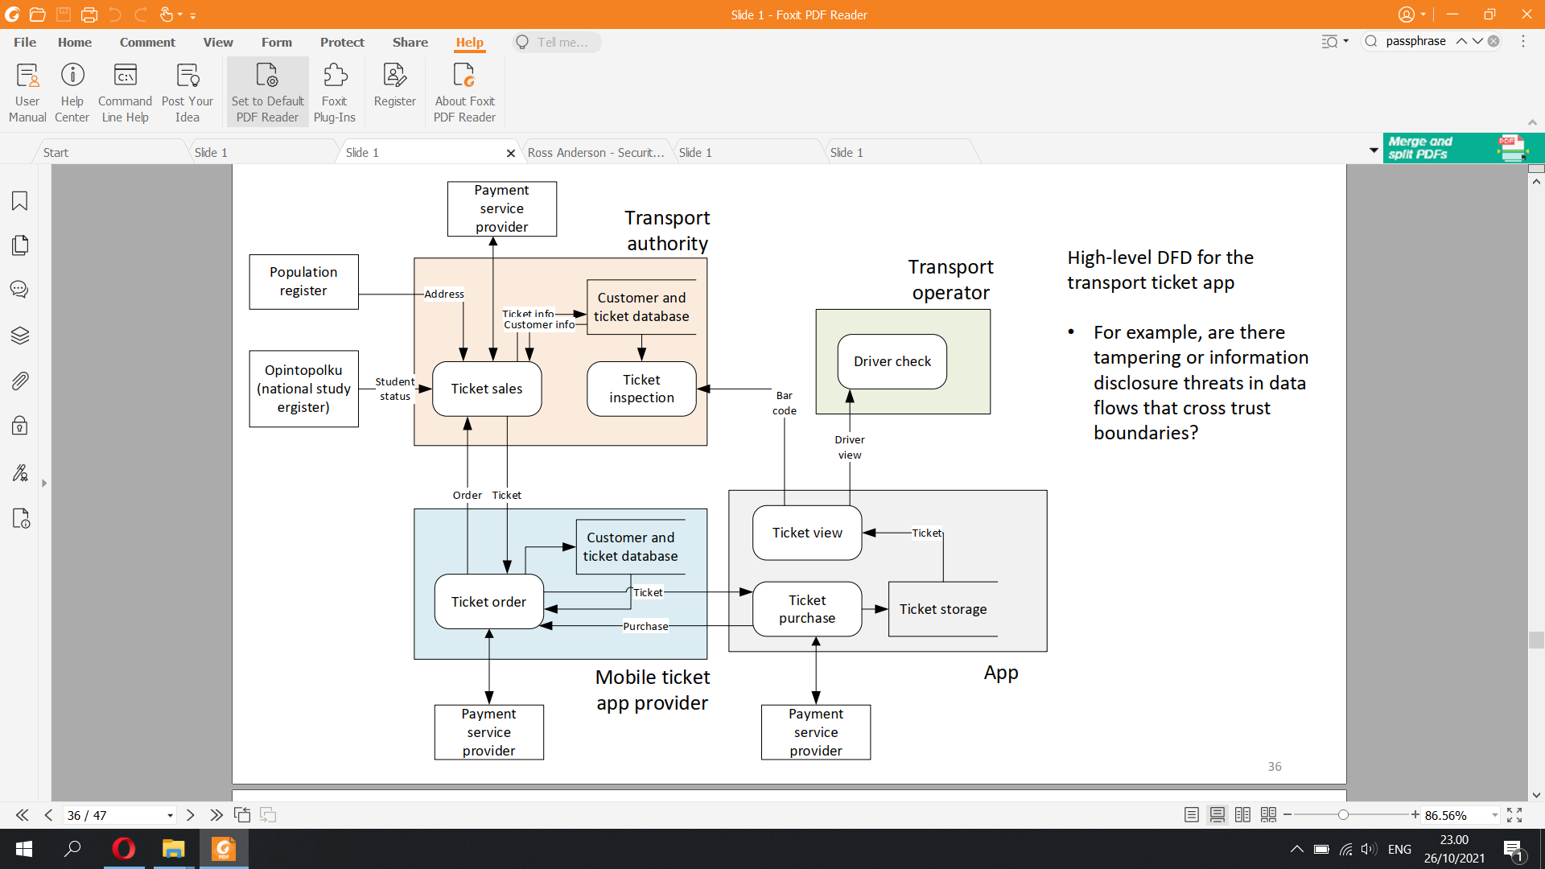

Risk assessment

▪ Risk assessment is very subjective; many definitions:

**Risk = probability of attack × damage in euros**

Risk ∈ { low, medium, high } × { low, medium, high }

0 < Risk < 1

▪ Numerical risk values tend to be meaningless:

– What does risk level 0.4 mean in practice?

▪ Usually difficult to assess absolute risk but easier to

prioritize threats

38DREAD risk assessment model

▪ Designed to complement STRIDE, no longer widely used

**▪ In DREAD, risk has many dimensions:**

**– Damage: how much does the attack cost to defender?**

**– Reproducibility: how reliable is the attack**

**– Exploitability: how much work to implement the attack?**

**– Affected users: how many people impacted?**

**– Discoverability: how likely are attackers to discover the vulnerability?**

Also suffers from the use of arbitrary numerical scales

MITRE ATTA&CK

▪ Conceptual framework for threats against enterprise

information systems: https://attack.mitre.org/

– Separate matrices for industrial control systems and mobile apps

– Tactics (attack phases), which consists of techniques

▪ Common vocabulary for discussion threats and attacks

▪ The systematic threat analysis methods help but there is

no guarantee of finding all or even the most important threats

▪ You need to understand the system: technology, architecture,

stakeholders and business model

▪ Attackers are clever and invent new threats; systematic threat

analysis often enumerates old threats

▪ Always start by considering assets and potential attackers, not

system implementation details or security mechanisms

Security “pixie dust”

▪ Security mechanism are often used without a good reason

– For example, encryption does not in itself make the system secure

▪ If there is no clear explanation why some security mechanism

is used, ask questions:

– What threats does it protect against?

– What if we just remove it? (always a good question)

– Is there something simpler or more suitable?